CSS GENDER STUDIES
T4QA
The Question Answers
Topic 4 · Gender and Development — every past question answered as a model
WHAT THIS DOCUMENT GIVES YOU
◆ All sixteen CSS questions on Topic 4 (2016–2026) and the three short notes, answered in full — the heaviest topic in the paper
◆ An answer map for every answer — each branch a numbered heading
◆ The command words and limbs of every question decoded
◆ Model answers of 1,000–1,300 words (notes 550–650) with evidence inside every heading
◆ Why each answer scores — what the examiner rewards
Federal Public Service Commission · CSS Competitive Examination · Optional paper, 100 marks
Written for CE-2027 onwards · Record: CE-2016 to CE-2026 · Facts current to September 2026

Contents
HOW TO BUILD THE CONTENTS
The contents list below fills itself in. When Word asks "This document contains fields that may refer to other files. Update the fields?", click Yes.
If it does not ask: right-click the grey contents area → Update Field → Update entire table → OK. On a Mac, Control-click the same area. Or press Ctrl + A, then F9 (Windows), to update every field at once. Repeat after any edit, before you export to PDF.

Right-click here and choose Update Field to build the contents.

How to Use These Answers

What is in this document
Table 1 · The questions answered in this document (T4).
No. | Question | Year · Q | Family
1 | Critically review the Gender and Development approaches: (i) Women in Development (WID), (ii) Women and Development (WAD), and (iii) Gender … | CSS 2016 · Q8 | WID, WAD and GAD
2 | 'Powerful forces of globalization have highlighted various gender issues across cultures and throughout the globe.' Discuss by quoting examp… | CSS 2017 · Q6 | Globalisation and gender
3 | Gender and development | CSS 2017 · Q8(b) | WID, WAD and GAD
4 | In the last two decades, globalization has had a huge impact on the lives of women in developing nations, including Pakistan. What are the i… | CSS 2018 · Q6 | Globalisation and gender
5 | Gender Strategic Needs and Gender Practical Needs | CSS 2018 · Q8(a) | Practical and strategic gender needs
6 | Explain the relevance of Modernization Theory and Dependency Theory to gender equality. Critically analyze the subordination of women in mod… | CSS 2019 · Q4 | Modernisation (and dependency) theory; Gender analysis of development theories
7 | The process of globalization has connected nations worldwide and made the world a global village, yet it has also increased inequalities acr… | CSS 2019 · Q5 | Globalisation and gender
8 | Structural Functionalism | CSS 2019 · Q8(c) | Structural functionalism
9 | How did the colonial era influence the status of women in the subcontinent? | CSS 2020 · Q3 | Colonial and capitalist perspectives of gender
10 | Modernization Theory blames internal cultural factors for women's subordination in the developing world. Discuss and elaborate the statement… | CSS 2021 · Q6 | Modernisation (and dependency) theory
11 | Critically analyze the various approaches to women's development, focusing on Women in Development (WID), Women and Development (WAD), and G… | CSS 2021 · Q7 | WID, WAD and GAD
12 | What are the capitalistic perspectives of gender? Explain. | CSS 2022 · Q7 | Colonial and capitalist perspectives of gender
13 | Discuss in detail the gender critique of Structural Adjustment Policies (SAPs). | CSS 2022 · Q8 | Gender critique of Structural Adjustment Policies
14 | Write a detailed note on the colonial and capitalistic perspectives of gender. | CSS 2023 · Q6 | Colonial and capitalist perspectives of gender
15 | Write a note on the colonial and capitalistic perspectives of gender. Throw light on the thesis that development is the new name of colonial… | CSS 2024 · Q3 | Colonial and capitalist perspectives of gender
16 | Give a critical gender analysis of development theories. | CSS 2024 · Q5 | Gender analysis of development theories
17 | Critically evaluate the concept of 'gendered globalisation', focusing on World-System Theory and how the globalisation of capitalism has cre… | CSS 2025 · Q3 | Globalisation and gender; Gender analysis of development theories
18 | Critically analyze Women in Development (WID) and Gender and Development (GAD) models. Discuss their basic principles and limitations in add… | CSS 2025 · Q7 | WID, WAD and GAD
19 | Climate change has gendered impacts. Drawing on feminist environmentalism and ecofeminist perspectives, critically analyse how recent floods… | CSS 2026 · Q5 | Gender, climate change and ecofeminism

How every answer is built
1. The question, exactly as set, with its year and number.
2. The answer map — a mind map whose centre states what the question asks, part by part. Every branch is one numbered heading of the answer, and every point on it is a short phrase that makes complete sense on its own — so the map alone tells the examiner the whole argument. Draw a quick version in the margin of your answer book before you write.
3. Decoding the question — the command words and what each part demands.
4. The model answer — 1,000 to 1,300 words (550 to 650 for a short note), the length a strong candidate can write in about thirty minutes. It is built in two levels: main headings 1, 2, 3… taken from the question's own words, and sub-headings i), ii), iii)… under them. The introduction always has a simple definition and the argument. Each sub-heading answers one point in a short paragraph with the key words in bold. Every answer has at least one figure besides the answer map (a comparison, flow, cycle, pyramid, Venn, spectrum or mapping), a Pakistan angle and a balanced conclusion.
5. Why this answer scores — what the examiner rewards in it.
EXAMINER'S EYE · "CRITICALLY" IS THE COMMAND WORD OF TOPIC 4
Almost every question here says "critically review", "critically analyse", "critical gender analysis" or "critically evaluate". Notice the pattern in the answers below: every theory or approach gets (1) what it says, (2) what it says or assumes about women, (3) its gender critique, and (4) a Pakistani example. Notice also how the same material — Boserup, Mies, Elson, Moser, Kabeer, Wallerstein — is re-cut for each question. The near repeats (WID/WAD/GAD in 2016 and 2021; colonial and capitalist perspectives in 2023 and 2024) are answered separately to show how to fit old knowledge to new wording.

Answer 1 · A Critical Review of WID, WAD and GAD (CSS 2016)
AT A GLANCE · CSS 2016 · Q8 · 20 MARKS
Critically review the Gender and Development approaches: (i) Women in Development (WID), (ii) Women and Development (WAD), and (iii) Gender and Development (GAD).

The answer map
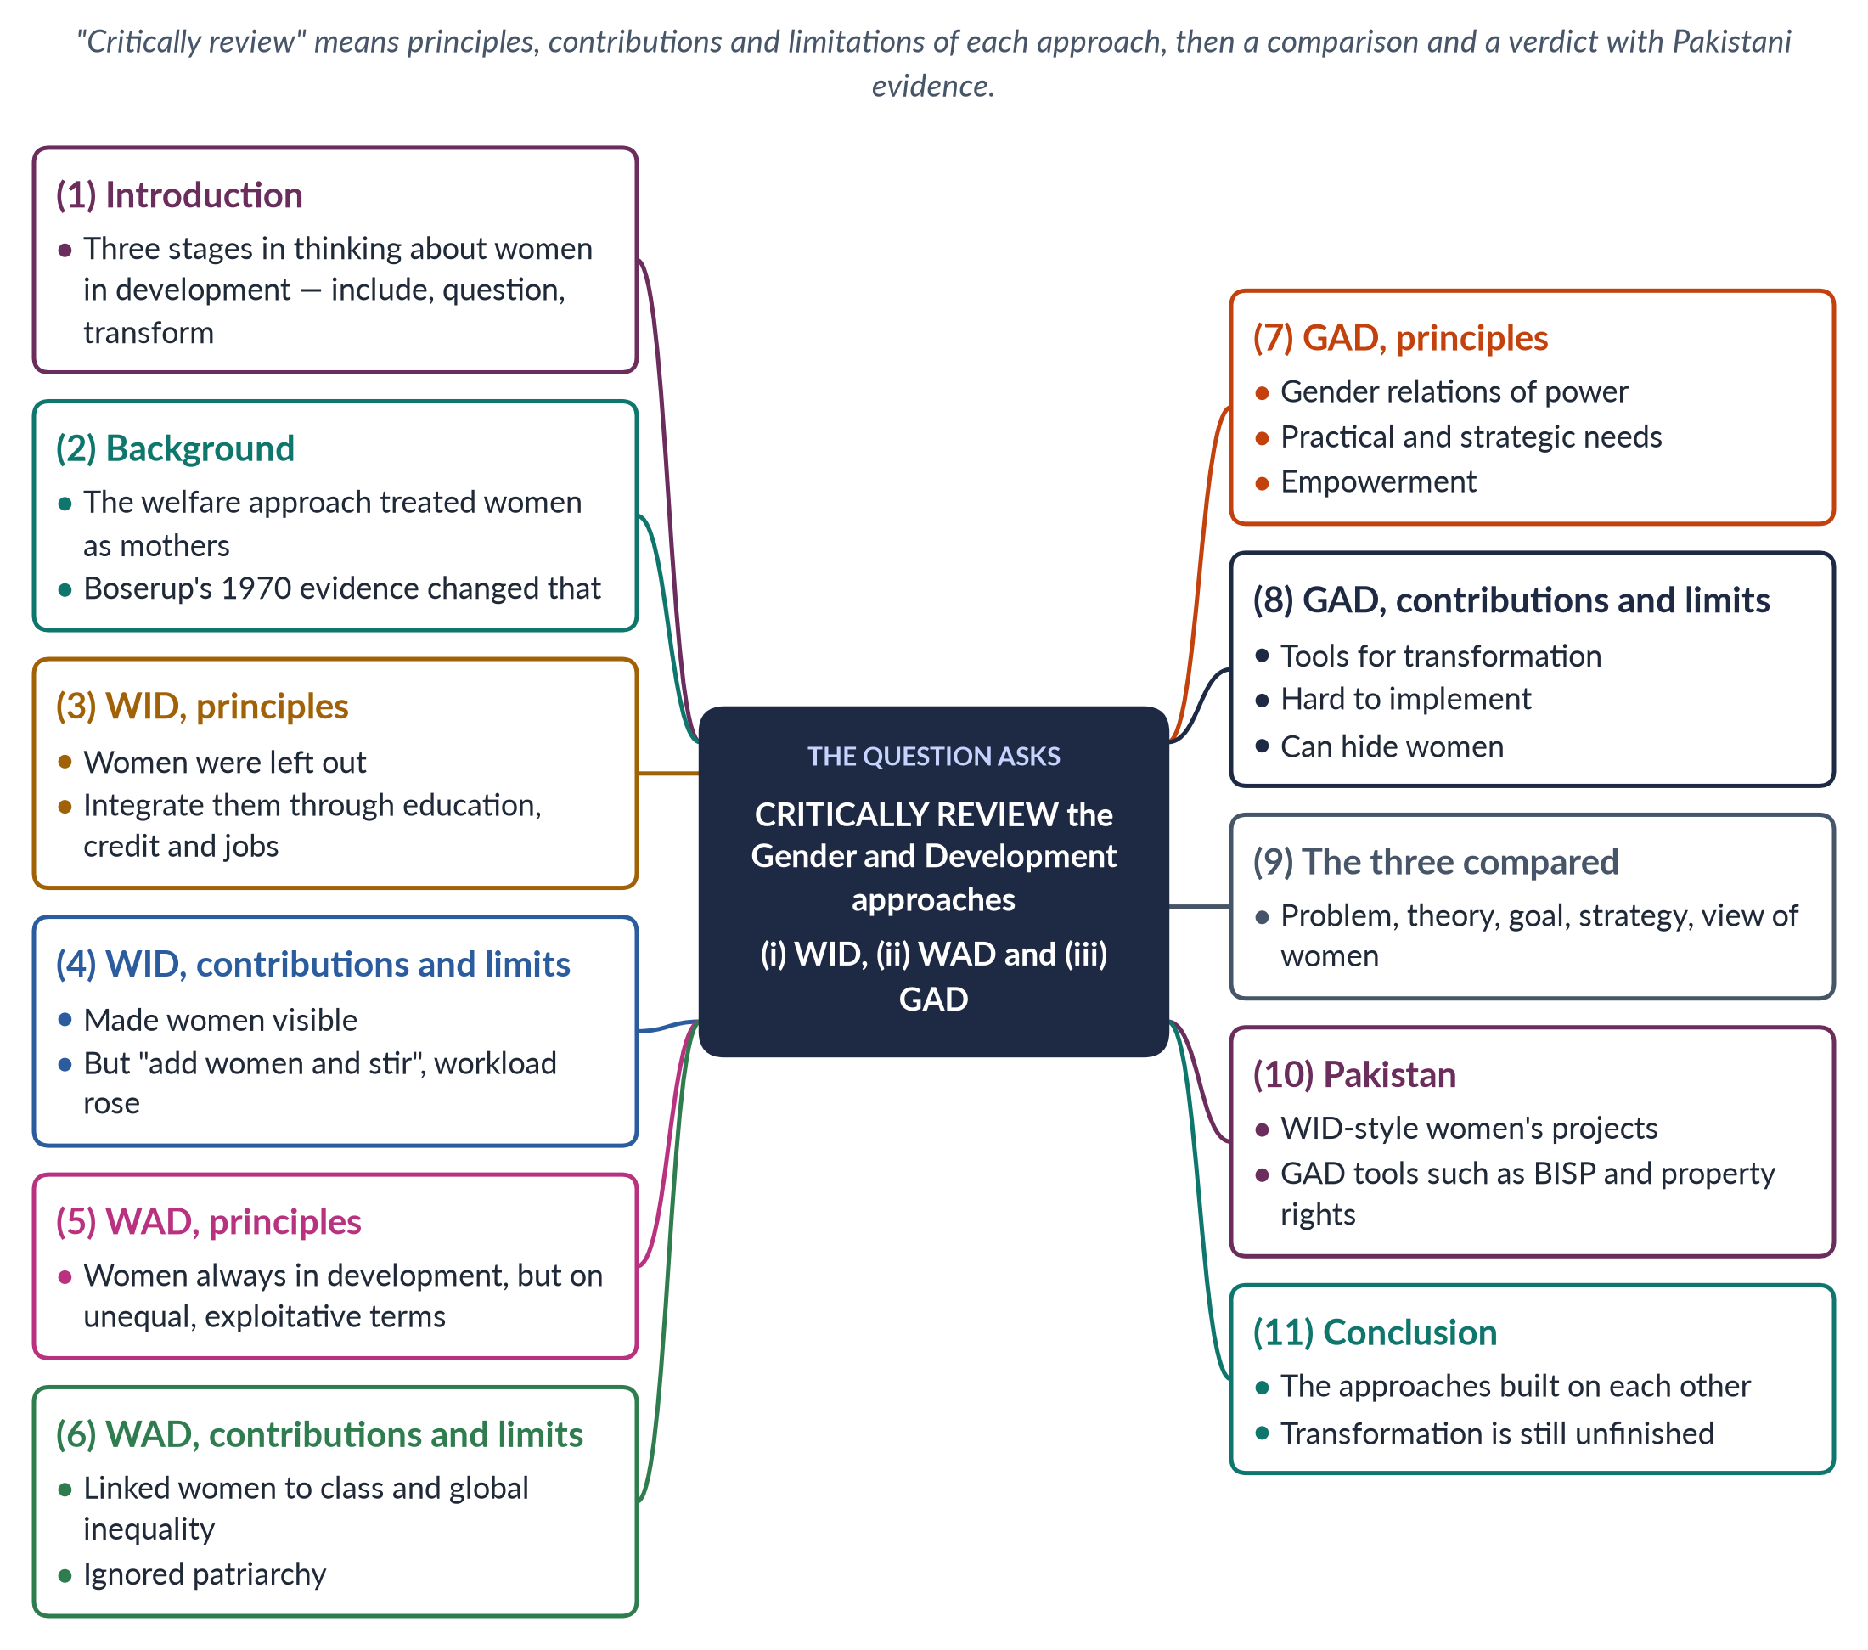
Figure 1 · The answer map: every branch is one numbered heading of the model answer below.

Decoding the question
"Critically review" asks for a balanced judgement: for each approach give its origins, principles, contributions and limitations, then compare them and reach a verdict. Three approaches in one answer means about a quarter of the space for each, plus a comparison and Pakistan. A comparison table or figure is almost essential.

The model answer

1. Introduction

i) Definition
Gender and development is the study and practice of how development policies affect women and men differently, and how they can promote equality. Three approaches have dominated it: Women in Development (WID), Women and Development (WAD) and Gender and Development (GAD).

ii) The argument
The three form a sequence of deepening critique. WID asked for women to be included in development; WAD asked what kind of development women were being included in; GAD asked how to transform the power relations between women and men. Each corrected the last, but none has fully achieved its aims.

2. Background: from welfare to WID

i) The welfare approach
Until about 1970, development planners assumed that growth would benefit women automatically through their husbands. Women appeared only as mothers — the targets of food aid, nutrition and family-planning programmes.

ii) Boserup's evidence
Ester Boserup's Woman's Role in Economic Development (1970) showed that women were major farmers, especially in Africa, and that colonial and development policies had given land, technology, training and credit to men. Development was marginalising women. Her book launched WID.

3. WID — principles

i) Origins
The term was coined by women development professionals in Washington, DC. The Percy Amendment (1973) required US aid to integrate women, and the UN Decade for Women (1976–85) spread the approach worldwide.

ii) Principles
WID held that women had been left out of development. The solution was integration: give women access to education, training, credit, technology and jobs. Its theory was liberal feminism and modernisation: the development model was sound; women simply needed a fair share.

4. WID — contributions and limitations

i) Contributions
WID made women visible in statistics and planning, created women's ministries and UN bodies, won resources for girls' education and women's credit, and recognised women as producers.

ii) Limitations
It accepted the existing development model — critics called it "add women and stir". It took the sexual division of labour for granted, so paid work was added to women's unpaid work and their workload rose. It looked at women alone, not at men's power, and ignored class and global inequality. Its projects — sewing, handicrafts, poultry — were small and marginal, and critics called them a "women's ghetto" of development. WID also justified investing in women mainly because it made development efficient, not because women have rights.

5. WAD — principles

i) Origins
In the late 1970s, scholars influenced by Marxism and dependency theory, many from the global South, criticised WID. A landmark was the IDS Sussex workshop on "The Continuing Subordination of Women" (1978).

ii) Principles
WAD argued that women had always been part of development — as farmers, workers and carers — but on unequal and exploitative terms. The problem was not exclusion but the nature of development: an unequal international and class system that exploits poor women and poor men alike.

6. WAD — contributions and limitations

i) Contributions
WAD asked "development for whom?" It linked women's position to class, debt and global trade, valued women's existing work and knowledge, and gave Southern scholars a voice.

ii) Limitations
WAD focused on class and said little about patriarchy within classes — why poor men also dominate poor women. It treated women as one group, paid little attention to the household, and in practice often funded separate women's projects again. Its call for structural change was hard for governments to adopt.

7. GAD — principles

i) Origins
GAD emerged in the 1980s from socialist feminists and Southern networks such as DAWN (1984). Beijing (1995) adopted its language of gender mainstreaming and empowerment.

ii) Principles
GAD focuses on gender relations — the socially constructed relations of power between women and men — in the household, market, community and state. It values both productive and reproductive work, treats women as agents, and seeks to transform unequal structures.

iii) Tools
Molyneux (1985) and Moser (1993) distinguished practical gender needs (water, health, income) from strategic gender interests (land, laws, power). Moser identified women's triple role; Naila Kabeer (1999) defined empowerment as the ability to make strategic life choices.

8. GAD — contributions and limitations

i) Contributions
GAD brought power and men into the analysis, looked inside the household, and offered planning tools that link immediate needs to long-term change.

ii) Limitations
Transforming power is political, so agencies often reduce GAD to checklists and training. "Gender" can be used to shift money away from women, and mainstreaming can mean that when everyone is responsible, no one is. Men and elites resist changes in land, inheritance and political power. Some critics also say that terms such as "gender" and "empowerment" are imposed by donors — though they actually came largely from Southern networks such as DAWN.
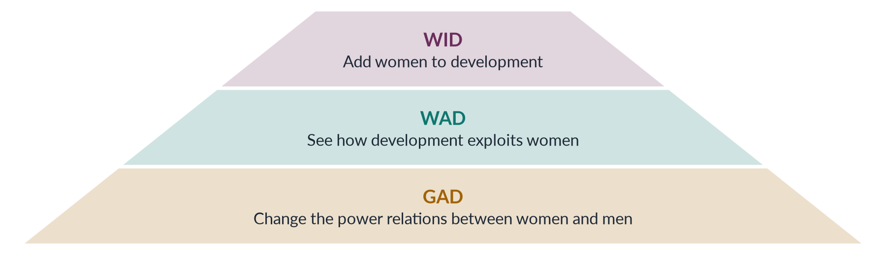
Figure 2 · From WID to GAD: how the approaches deepened.

9. The three compared
Table 2 · WID, WAD and GAD compared.
Point | WID | WAD | GAD
Problem | Women excluded | Women integrated unequally | Unequal gender power
Theory | Liberal; modernisation | Marxism; dependency | Socialist feminism
Goal | Integration | Structural change | Transformation; empowerment
Needs met | Practical | Practical | Practical and strategic
View of women | Recipients | Exploited workers | Agents of change

10. The Pakistan angle

i) WID in Pakistan
The Women's Division (1979), vocational centres and the First Women Bank (1989) followed WID: useful skills and some income, but small scale.

ii) GAD in Pakistan
Gender mainstreaming units, gender budgeting pilots, the Benazir Income Support Programme (2008) paying cash to women, and the Enforcement of Women's Property Rights Act 2020 reflect GAD's strategic aims. Yet female labour-force participation is only 24.4% and Pakistan ranked 143rd of 145 in the Global Gender Gap Report 2026, showing how much remains. Most programmes still meet practical needs; strategic change in land, inheritance and political power is slow.

11. Conclusion
WID made women visible, WAD made development's inequality visible, and GAD made gender power visible. Each was a necessary correction of the one before. The review shows that access alone is not enough and structural critique alone is not enough: development must meet women's practical needs in ways that open the way to strategic change in their position.

Why this answer scores
- Each approach gets origins, principles, contributions and limitations — a true critical review.
- The pyramid and table show the progression and the contrasts at a glance.
- Named scholars and dates (Boserup 1970, Percy 1973, IDS 1978, Molyneux 1985, Moser 1993, Kabeer 1999) prove knowledge.
- A Pakistan angle applies each approach.

Answer 2 · Globalisation and Gender Issues in Developing Countries (CSS 2017)
AT A GLANCE · CSS 2017 · Q6 · 20 MARKS
'Powerful forces of globalization have highlighted various gender issues across cultures and throughout the globe.' Discuss by quoting examples from developing countries.

The answer map
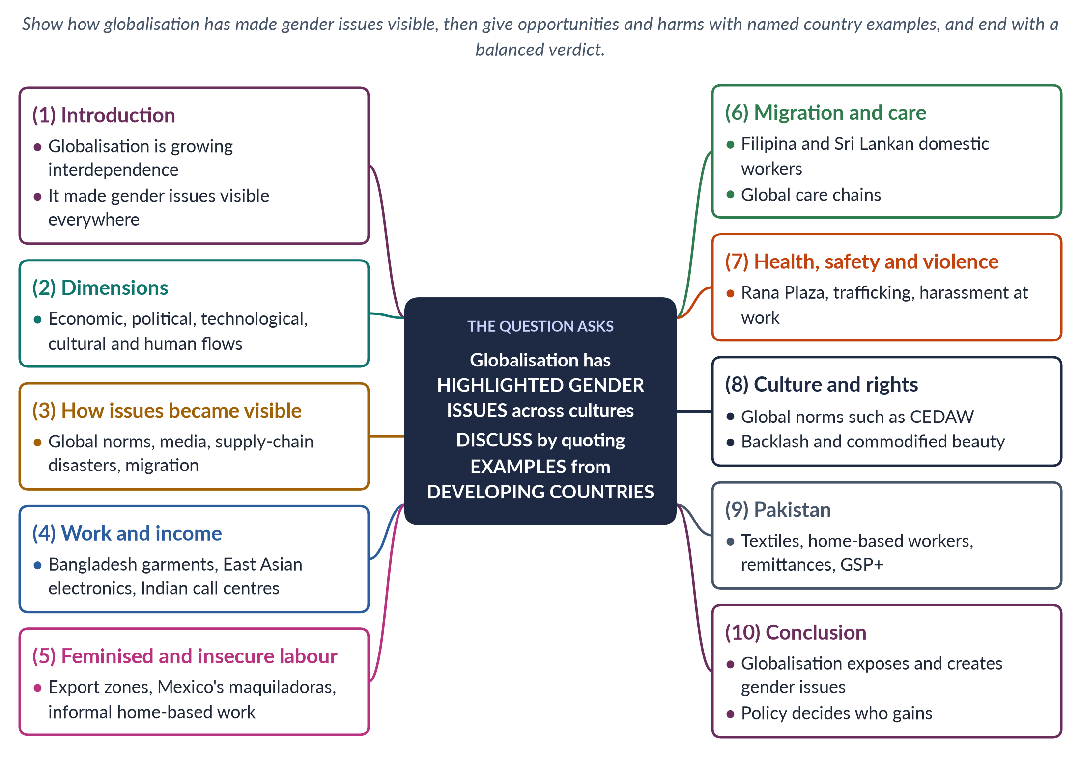
Figure 3 · The answer map: every branch is one numbered heading of the model answer below.

Decoding the question
The quotation claims that globalisation has highlighted gender issues "across cultures and throughout the globe". "Discuss" asks you to explain and weigh this claim, and the instruction to quote examples from developing countries is essential: name countries, industries and events. Organise by issue (work, migration, safety, culture), with examples under each.

The model answer

1. Introduction

i) Definition
Globalisation is the growing interdependence of societies across the world through trade, investment, technology, migration, media and ideas. The sociologist Anthony Giddens called it "the intensification of worldwide social relations which link distant localities".

ii) The argument
Globalisation has highlighted gender issues in two ways: it has made old inequalities visible across borders, and it has created new ones. At the same time it has opened opportunities. Examples from developing countries show both faces.

2. The dimensions of globalisation
Globalisation is economic (free trade, multinational companies, global supply chains), political (the WTO, IMF and UN; global norms), technological (the internet and mobile phones), cultural (global media and consumer culture) and human (migration of workers). It accelerated from the 1980s with trade liberalisation, the founding of the World Trade Organization (1995) and the spread of the internet.

3. How globalisation made gender issues visible

i) Global norms
The Beijing conference (1995), CEDAW and the SDGs put violence, discrimination and women's work on every government's agenda.

ii) Global media
Television and social media spread news of violence and discrimination instantly; #MeToo (2017) crossed from the USA to India, South Korea and Pakistan.

iii) Supply-chain scrutiny
Consumers and campaigners in rich countries now ask who made their clothes — a question that exposes the conditions of women workers. Campaigns such as the Clean Clothes Campaign and, after Rana Plaza, the Bangladesh Accord on Fire and Building Safety (2013) grew out of this scrutiny.

iv) Migration
Millions of women now migrate for work, making their care labour and their vulnerability visible in both sending and receiving countries.

4. Work and income: new opportunities

i) Bangladesh
The garment industry, built for export, employs millions of workers, a large share of them women. For many rural young women it offered a first independent income; research by Naila Kabeer (The Power to Choose, 2000) found that garment work delayed marriage and increased women's bargaining power at home.

ii) East and South Asia
Electronics factories in Malaysia and the Philippines, and call centres and IT services in India, drew educated young women into paid work, often in cities far from their families.

iii) Mobile banking and trade
Mobile money in Kenya and online selling across Asia let women earn and save without travelling far. For women whose mobility is restricted, this is a real gain.

5. Feminised and insecure labour

i) The feminisation of labour
Guy Standing (1989) described how global competition made jobs flexible, informal and low-paid — and increasingly filled by women.

ii) Export processing zones
In Mexico's border factories (maquiladoras) and in zones across Asia, young women are hired because they are seen as cheap and docile; unions are often discouraged, hours are long, and harassment is common.

iii) Informal home-based work
Global brands subcontract to home-based workers — embroiderers in India and Pakistan, garment finishers in Thailand — who have no contracts or social security. They carry the risks of the global market — falling orders, late payment — without any of its protections.

6. Migration and global care chains

i) Domestic workers
Women from the Philippines, Indonesia and Sri Lanka migrate to the Gulf, Hong Kong and Europe as domestic workers and nurses. Their remittances support families, but under sponsorship (kafala) systems many face confiscated passports, unpaid wages and abuse.

ii) Care chains
Arlie Hochschild (2000) described global care chains: poor women care for richer families' children while their own children are cared for by relatives at home.

7. Health, safety and violence

i) Unsafe factories
The Rana Plaza collapse in Bangladesh (24 April 2013) killed more than 1,100 garment workers, most of them women. The Ali Enterprises fire in Karachi (2012) killed about 260.

ii) Trafficking
Open borders and global demand fuel trafficking of women and girls, for example from Nepal to Indian cities and from Eastern Europe and Asia to the Gulf.

iii) Harassment at work
Surveys by labour groups in export factories across Asia report frequent verbal and sexual harassment by supervisors — a workplace patriarchy added to the family's.
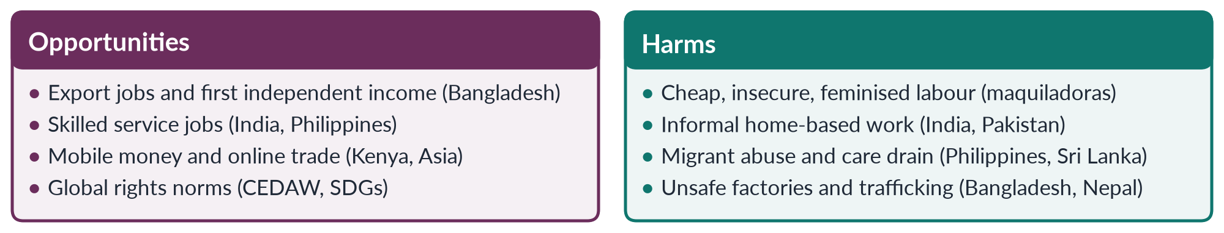
Figure 4 · Globalisation's two faces for women in developing countries.

8. Culture and rights

i) Global rights language
Women's movements in developing countries use CEDAW, the SDGs and trade conditions to press governments — for example, the EU's GSP+ trade preferences are tied to human-rights and labour conventions.

ii) Backlash and commodification
Global media sell beauty standards such as skin-lightening creams across South Asia and Africa. Rapid change can also provoke a conservative reaction that tightens control over women's dress and mobility in the name of protecting local culture. Globalisation thus highlights a clash over who defines women's proper place — global norms, local traditions, or women themselves.

9. The Pakistan angle
In Pakistan, textile and garment exports rely on low-paid workers and home-based stitchers; Sindh passed the first Home-Based Workers Act in 2018. Men's migration to the Gulf brings record remittances — more than 38 billion dollars in 2024–25 — while many women run households alone. The EU's GSP+ (from 2014) ties trade benefits to conventions including CEDAW. Yet female labour-force participation remains 24.4%: globalisation has drawn fewer Pakistani women into export jobs than in Bangladesh, because of unsafe transport, restrictions on mobility and the structure of industry. A gendered side effect of global campaigns appeared in Sialkot: after the Atlanta Agreement (1997) against child labour moved football stitching from homes into centres, many women homeworkers who could not travel lost their work.

10. Conclusion
The statement is right: globalisation has highlighted gender issues across cultures — by exposing violence, exploitation and discrimination to the world, and by creating new forms of work, migration and risk. Examples from Bangladesh, Mexico, the Philippines, India and Pakistan show that globalisation can both empower and exploit. Which face women see depends on labour rights, social protection, safe workplaces and women's own organisation. Governments of developing countries cannot stop globalisation, but they can shape its gender effects — through minimum wages, factory inspection, protection of migrant and home-based workers, safe transport and childcare.

Why this answer scores
- Organised by issue, with named developing countries under each — exactly what the question demands.
- Shows both opportunities and harms, then reaches a verdict.
- A compare figure summarises the evidence by country.
- Scholars (Giddens, Standing, Hochschild, Kabeer) and events (Rana Plaza, Ali Enterprises) add authority.

Answer 3 · Short Note: Gender and Development (CSS 2017)
AT A GLANCE · CSS 2017 · Q8(B) · 10 MARKS
Write short notes on the following: Gender and development

The answer map
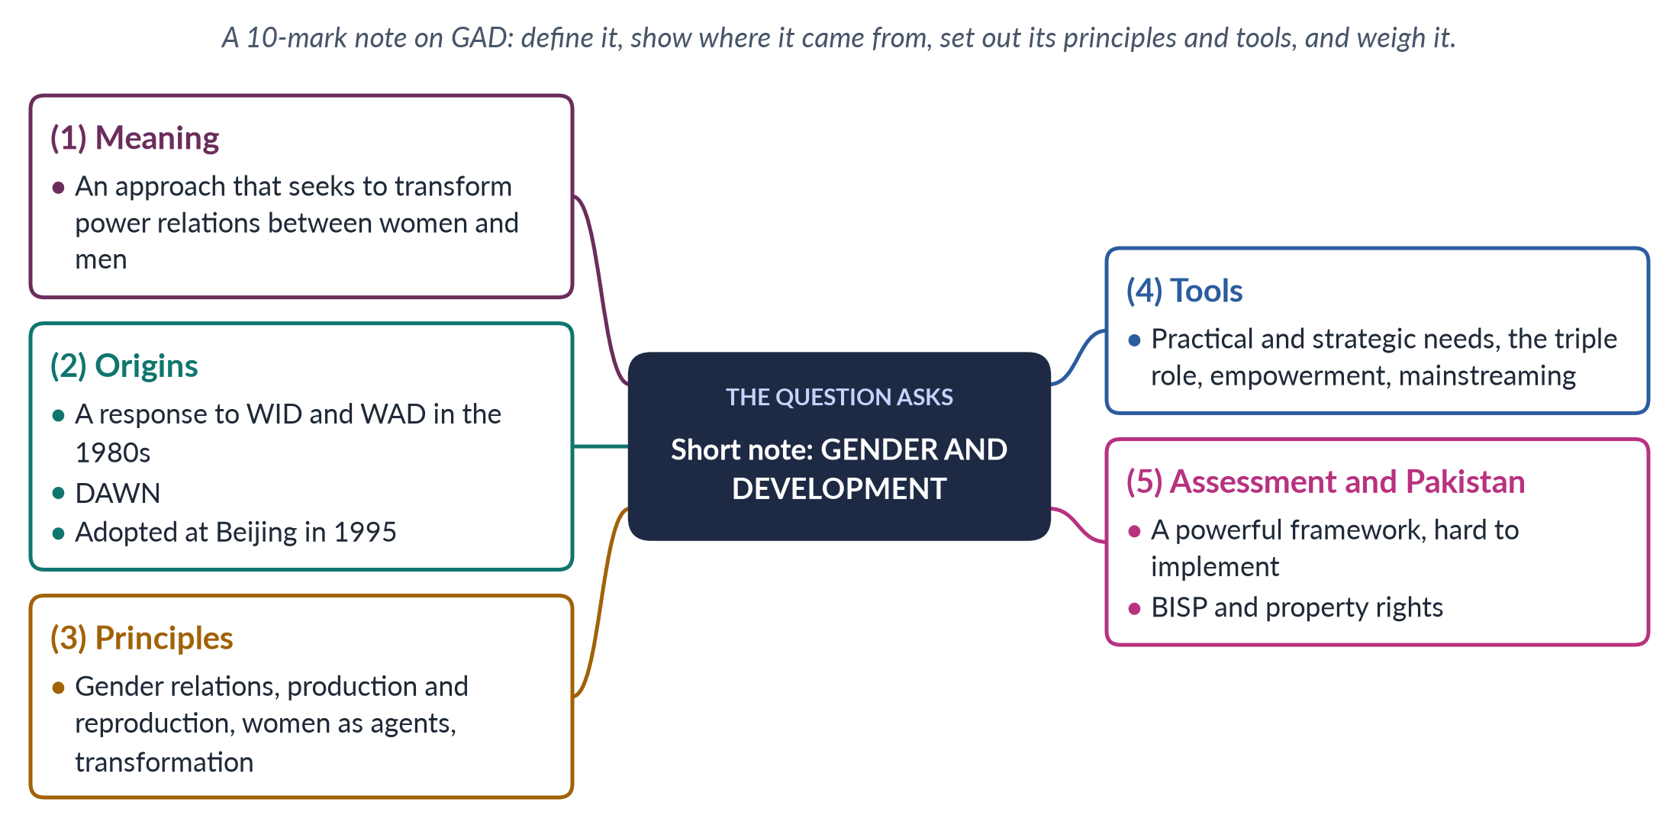
Figure 5 · The answer map for the short note: every branch is one headed point.

Decoding the question
A short note of 10 marks — about 550–650 words. "Gender and development" can mean the whole field or the GAD approach; the best note defines the field in one line and then focuses on GAD, placing it after WID and WAD, with its principles, tools, an assessment and a Pakistani example.

The model answer

1. Meaning

i) The field
Gender and development is the study and practice of how development affects women and men differently, and how development can promote gender equality.

ii) The GAD approach
Gender and Development (GAD) is the approach, dominant since the 1980s, that focuses on gender relations — the socially constructed relations of power between women and men — and seeks to transform them so that women and men share resources, work and decision-making equally, at home and in public life.

2. Origins

i) Beyond WID and WAD
Women in Development (WID, 1970s) tried to integrate women into existing development projects; Women and Development (WAD, late 1970s) argued that women were already integrated, but on unequal terms, because of class and global inequality. Neither examined the power relations between women and men, or what happens inside the household. WID projects often added paid work to women's unpaid work; WAD assumed that fairer world trade would by itself improve women's lives.

ii) The GAD response
GAD grew in the 1980s from socialist-feminist scholars — such as Kate Young at the Institute of Development Studies — and from Southern networks, especially DAWN (1984). The Beijing Platform for Action (1995) adopted its language of gender mainstreaming and empowerment.

3. Principles
1. Gender, not only women — study women and men and the relations between them.
2. Gender is socially constructed, so it can change.
3. Production and reproduction both count; look inside the household.
4. Women are agents, not passive recipients.
5. Transformation of unequal structures — laws, property, institutions.
6. Intersection of gender with class, race and other identities.
7. An active state that provides services such as childcare and protects women's rights.
IN SIMPLE WORDS
WID asked: "Are women getting a share?" GAD asks: "Who decides how the shares are made — and how can that change?"

4. Tools
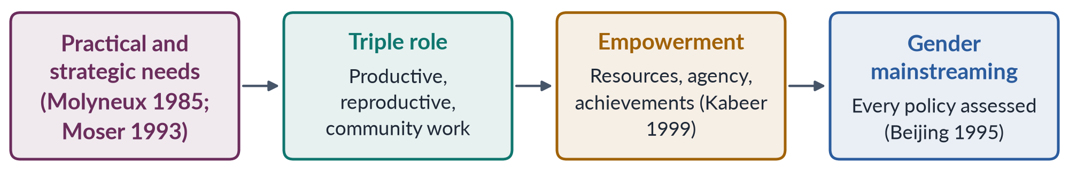
Figure 6 · GAD's main planning tools.
- Practical gender needs meet immediate necessities (water, health, income); strategic gender interests change women's position (land rights, laws against violence, political power).
- Caroline Moser's triple role: women's productive, reproductive and community-managing work.
- Naila Kabeer (1999): empowerment is the ability to make strategic life choices.
- Gender mainstreaming: assessing every policy for its effects on women and men.

5. Assessment and Pakistan

i) Strengths
GAD brought power, men and the household into development thinking and links immediate needs to long-term change. Its tools are used by governments and agencies worldwide, and it treats women as agents of development rather than beneficiaries.

ii) Limitations
Transforming power is political; agencies often reduce GAD to checklists and training; "gender" can shift money away from women; mainstreaming can leave no one responsible. Men and elites resist changes in land and power, so strategic aims are often dropped in practice.

iii) Pakistan
Pakistan's policies moved from WID-style vocational centres towards GAD. GAD-inspired steps include gender budgeting pilots, the 10% quota for women in federal jobs, the Benazir Income Support Programme (2008) paying cash to women, and the Enforcement of Women's Property Rights Act 2020. Yet with women's labour-force participation at 24.4%, strategic change remains limited.

iv) Conclusion
GAD is the most complete approach to gender and development because it asks not only whether women benefit but whether power changes. Its challenge is to move from language to lasting change in women's lives — in who owns land, who earns, who decides and who does the unpaid work at home.

Why this answer scores
- Defines both the field and the approach, and places GAD after WID and WAD.
- Principles, tools, strengths, limits and a Pakistani example in a compact note.
- A small flow figure lists the four tools with their authors.

Answer 4 · The Global Political Economy and Pakistani Women (CSS 2018)
AT A GLANCE · CSS 2018 · Q6 · 20 MARKS
In the last two decades, globalization has had a huge impact on the lives of women in developing nations, including Pakistan. What are the impacts of the global political economy on Pakistani women?

The answer map
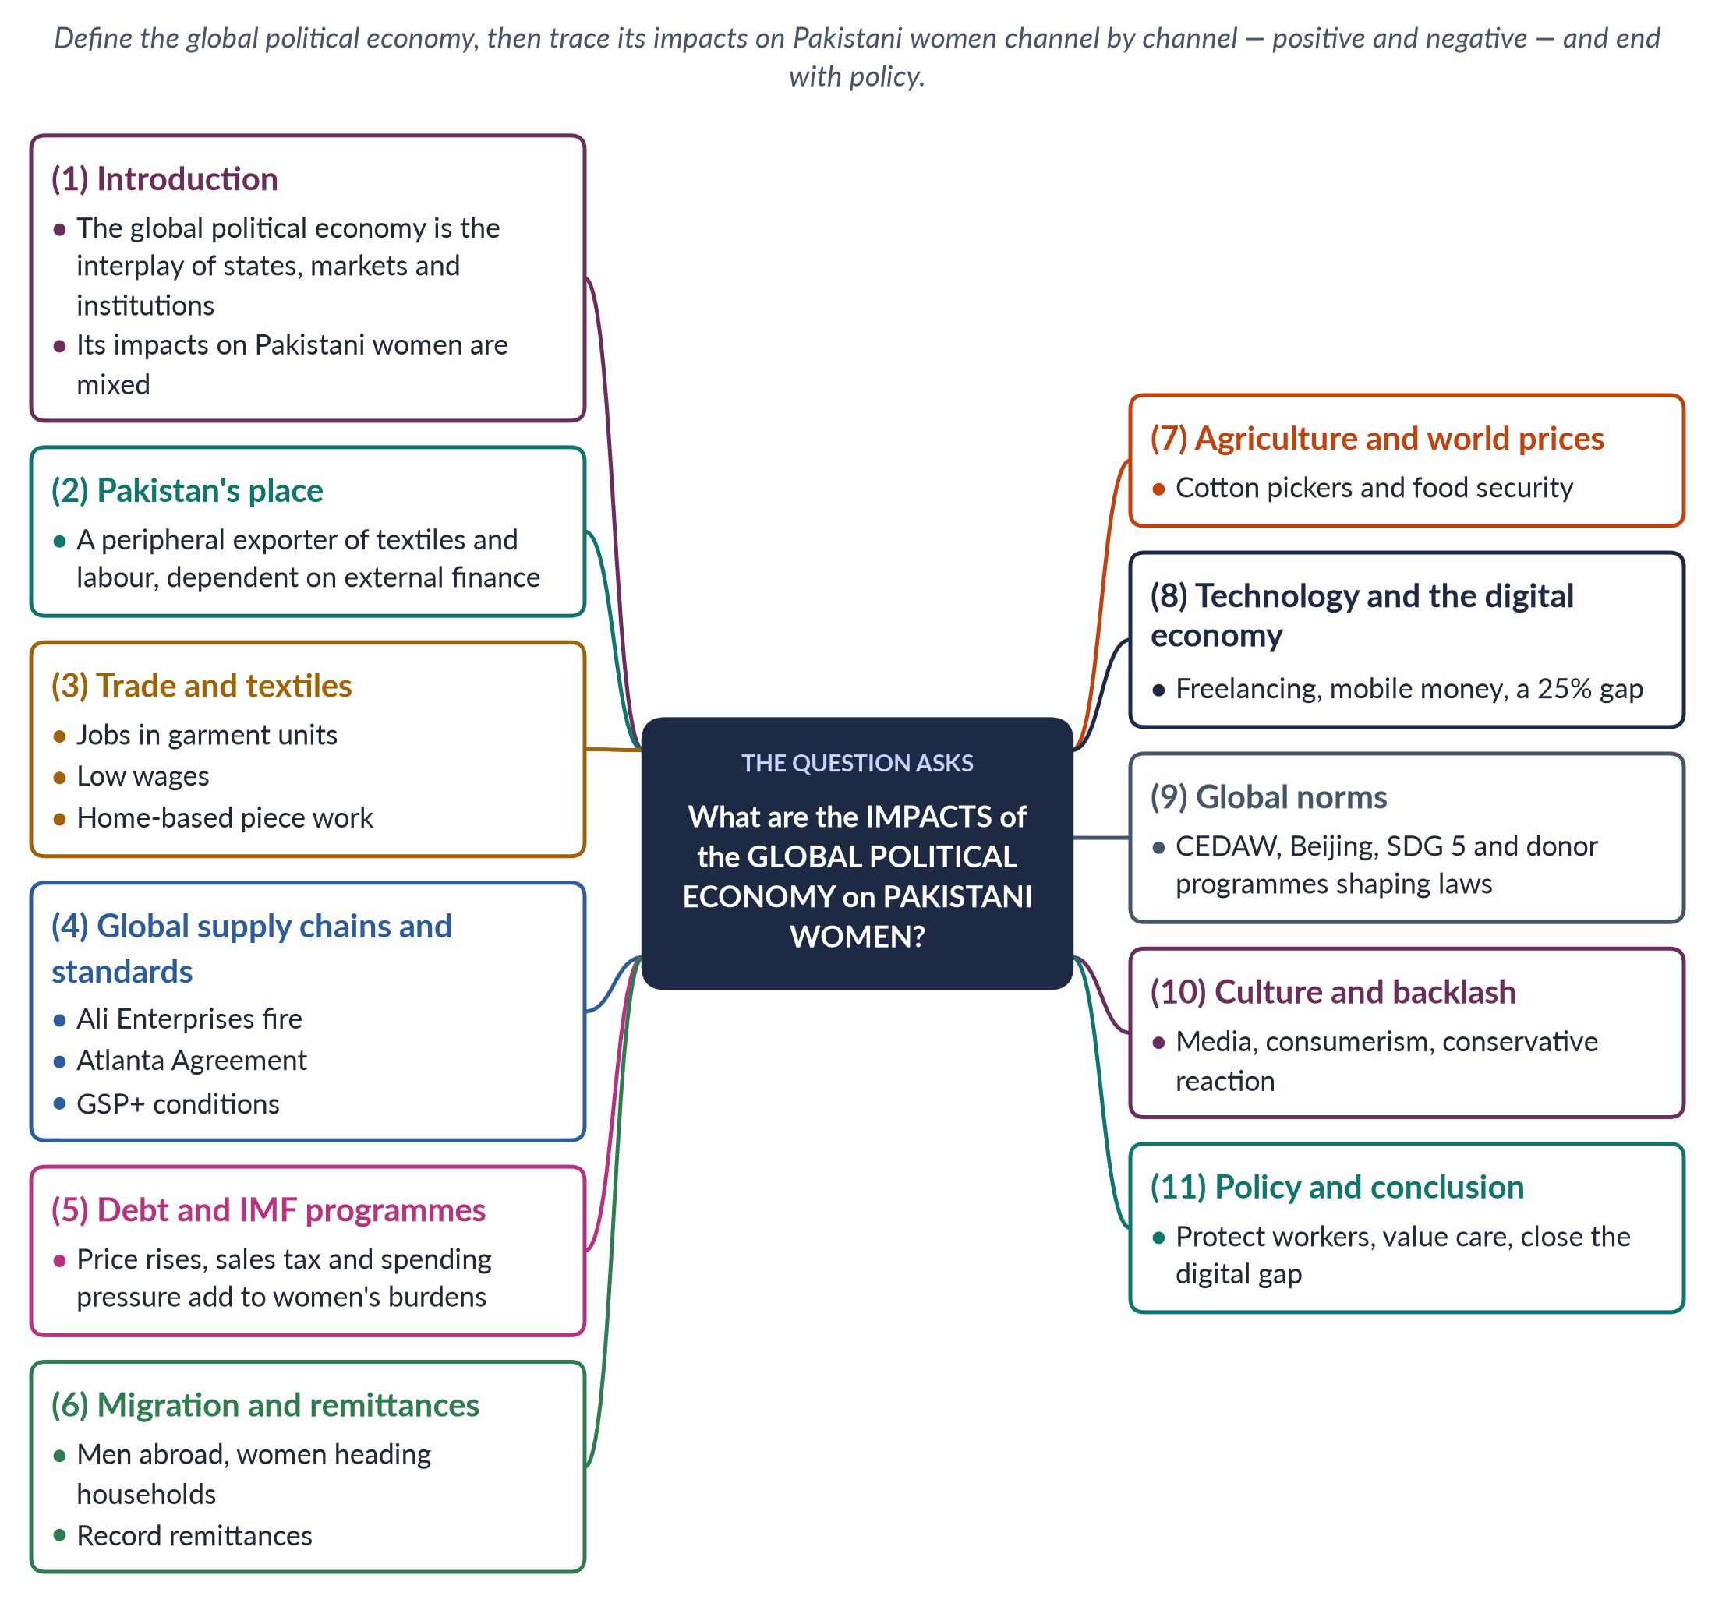
Figure 7 · The answer map: every branch is one numbered heading of the model answer below.

Decoding the question
The "global political economy" means the interplay of states, markets and international institutions — trade, finance, debt, migration, multinational companies, and bodies such as the IMF, WTO and UN. "What are the impacts" asks for a list of effects, organised and evidenced. Organise by channel, give positive and negative impacts under each, with Pakistani data, and end with policy.

The model answer

1. Introduction

i) Definition
The global political economy is the system through which states, markets and international institutions — the IMF, World Bank, WTO, UN and multinational companies — shape how wealth and power are produced and shared across the world.

ii) The argument
Over the last two decades it has affected Pakistani women through trade, supply chains, debt, migration, agriculture, technology, global norms and culture. The impacts are mixed: some new income, rights and information, but also insecure work, heavier unpaid burdens and backlash. Women gain where labour rights and social protection are strong, and lose where they are weak — as they mostly are in Pakistan's informal economy.

2. Pakistan's place in the world economy
In the language of world-system theory, Pakistan sits in the periphery or lower semi-periphery of the world economy (in Wallerstein's terms). It exports textiles, cotton and rice, exports labour to the Gulf, imports fuel and machinery, and depends on external finance from the IMF and other lenders. Women are concentrated at the bottom of these chains — as home-based stitchers, cotton pickers and unpaid family helpers — where earnings are lowest and protection weakest. Pakistan's ranking of 144th of 145 on economic participation in the Global Gender Gap Report 2026 shows how little of the global economy's gains have reached them.

3. Trade and textiles

i) Jobs
Textiles and garments are Pakistan's largest export sector. Garment units in Karachi, Lahore and Faisalabad employ women in stitching, finishing and packing. For some urban women these are the first formal jobs in their families, bringing income and a measure of independence.

ii) Low wages and home-based work
Much of the work is subcontracted to home-based workers who stitch, embroider and pack on piece rates, without contracts or social security. Maria Mies's term "housewifisation" fits: calling them housewives lets employers pay them little. Sindh recognised them in the Home-Based Workers Act 2018.

4. Global supply chains and standards

i) Safety
The fire at Ali Enterprises in Karachi (11 September 2012) killed about 260 workers in a factory producing for a European brand, exposing weak safety in global chains.

ii) Unintended effects
After the Atlanta Agreement (1997) on child labour, Sialkot's football stitching moved from homes into stitching centres; many women homeworkers who could not travel lost income.

iii) Trade conditions
The EU's GSP+ (from 2014) gives Pakistan duty-free access on condition that it implements 27 conventions, including CEDAW and core labour standards — giving activists leverage.

5. Debt and IMF programmes

i) Conditions
Pakistan has had repeated IMF programmes since 1988, most recently a 7-billion-dollar Extended Fund Facility (2024). Conditions include higher electricity and gas prices, wider sales tax and tighter spending.

ii) Gendered effects
Women manage household budgets, so price rises hit them first; pressure on health and education budgets increases their unpaid care. Indirect taxes such as sales tax fall heavily on poor households, and cuts to development spending delay schools, clinics and water schemes that save women's time. Diane Elson warned that such policies treat women's unpaid labour as "infinitely elastic".

iii) Protection
The Benazir Income Support Programme (2008), which pays cash to women, has been expanded as a safety net during IMF programmes.

6. Migration and remittances

i) Men abroad
Millions of Pakistani men work in the Gulf, Europe and elsewhere, drawn by global demand for construction and service labour. Remittances reached a record of more than 38 billion dollars in 2024–25.

ii) Women at home
Many women manage households, finances and children alone. This can increase their autonomy and decision-making, but also their workload and isolation, and they often remain under the control of in-laws. Some women themselves migrate as domestic workers or nurses, facing the risks of global care chains described by Arlie Hochschild (2000).

7. Agriculture and world prices
Most employed women work in agriculture. Cotton-picking women earn very little for hard, seasonal work whose price is linked to world cotton markets. Global food-price shocks (as in 2022) hit women responsible for feeding families. Climate shocks linked to global emissions — the 2022 floods — destroyed women's livestock and home-based work, showing another channel through which the world economy reaches Pakistani women.

8. Technology and the digital economy

i) Opportunities
Online freelancing, e-commerce, mobile money and digital learning offer home-based income to women whose mobility is restricted.

ii) Limits
Platform work is insecure and unprotected. The mobile-internet gender gap is still 25% (GSMA, 2024–25); many women's phone use is controlled by family members, and online harassment deters them.

9. Global norms and institutions
The Beijing conference (1995), CEDAW (acceded 1996) and SDG 5 have shaped Pakistan's laws and institutions: the NCSW (2000), 60 reserved seats (2002), and laws on harassment (2010), honour killing (2016) and child marriage (2025). Donor programmes funded research and NGOs — sometimes criticised as donor-driven. Still, these global commitments give Pakistani women's groups a standard against which to hold their own government to account.

10. Culture and backlash
Global media and consumer culture spread new images of women's lives — and beauty industries selling skin-lightening creams. Rapid change also provokes conservative backlash, with calls to protect "our culture" from foreign influence, often through tighter control of women.
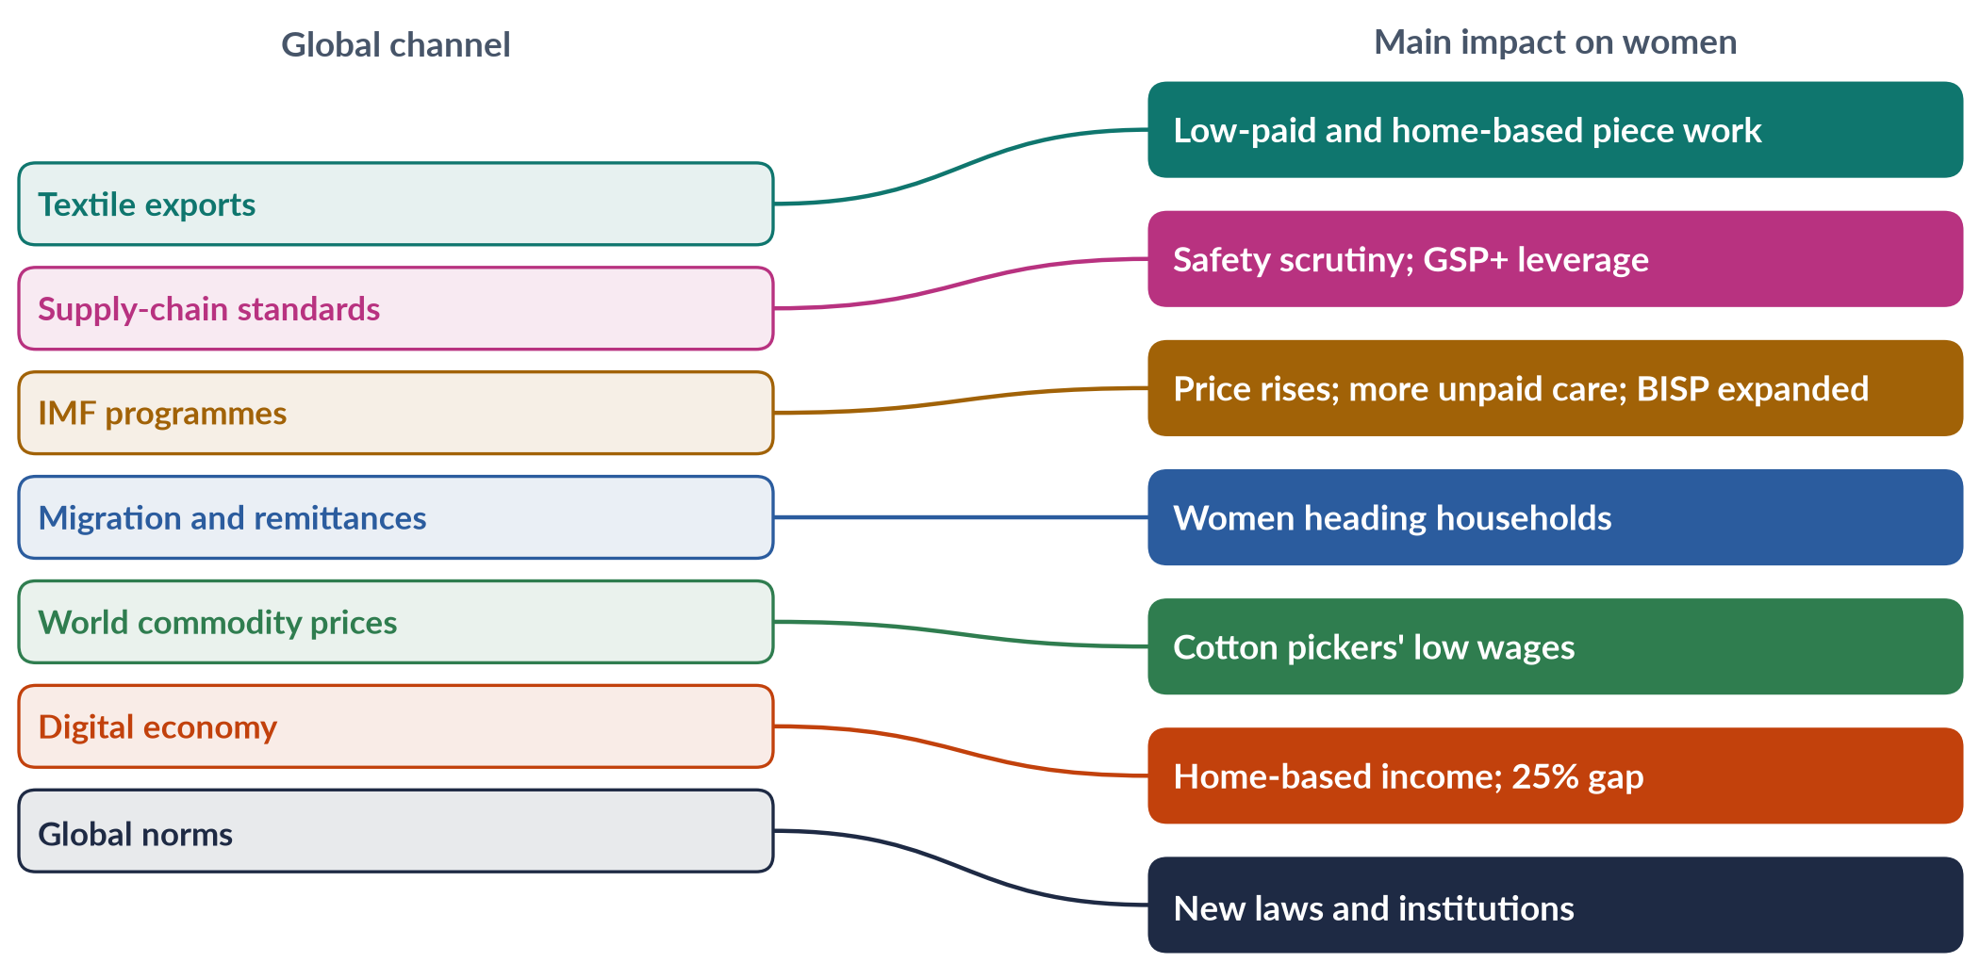
Figure 8 · The global political economy and its impacts on Pakistani women.

11. Policy and conclusion

i) Policy
Extend labour protection and social security to home-based, domestic and garment workers, as Sindh's 2018 Act begins to do; enforce factory safety and building codes; gender-assess IMF programmes and protect BISP, health and education; build safe transport and childcare; close the digital gap; and use GSP+ reviews to push rights and labour standards.

ii) Conclusion
Over the last two decades, the global political economy has given some Pakistani women new work, money and rights language, but it has also placed them at the bottom of global chains and added to their unpaid burdens. With female labour-force participation at 24.4%, Pakistan has captured less of globalisation's benefits for women than its neighbours. The impacts are not fixed: national policy decides whether women gain or lose.

Why this answer scores
- Defines the global political economy and organises impacts by channel.
- Every channel has Pakistani evidence — Ali Enterprises, Atlanta Agreement, GSP+, IMF 2024, remittances, the 25% digital gap.
- Balances positive and negative impacts and ends with policy.
- A mapping figure summarises channels and impacts.

Answer 5 · Short Note: Practical and Strategic Gender Needs (CSS 2018)
AT A GLANCE · CSS 2018 · Q8(A) · 10 MARKS
Write short notes on any TWO: Gender Strategic Needs and Gender Practical Needs

The answer map
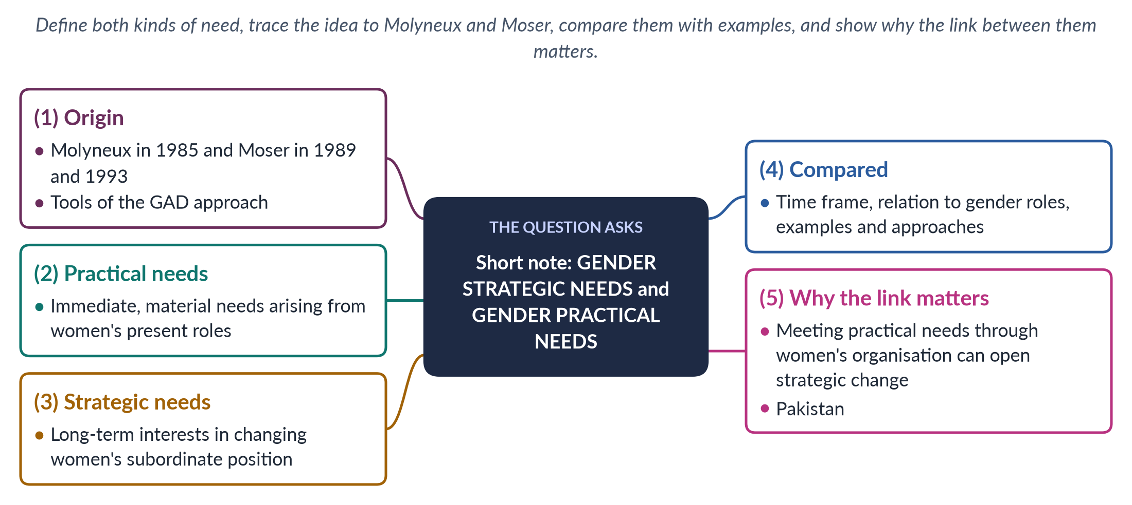
Figure 9 · The answer map for the short note: every branch is one headed point.

Decoding the question
A short note of 10 marks: about 550–650 words. Define both terms, name their authors, compare them — a table is ideal — and give examples, especially from Pakistan. The best notes also explain how the two are connected.

The model answer

1. Origin of the distinction

i) Molyneux
The sociologist Maxine Molyneux, studying women in the Nicaraguan revolution ("Mobilization without Emancipation?", 1985), distinguished practical gender interests from strategic gender interests.

ii) Moser
Caroline Moser ("Gender Planning in the Third World", 1989; Gender Planning and Development, 1993) turned the distinction into planning tools — practical gender needs and strategic gender needs — which became central to the Gender and Development (GAD) approach.

2. Practical gender needs

i) Meaning
Practical gender needs are the immediate, material needs that women identify from their current roles in the gender division of labour — as mothers, carers and workers.

ii) Examples
In a Pakistani village these include clean water near the home, health care, food, fuel, housing, childcare and income.

iii) Character
They are short-term; they help women perform their existing roles more easily but do not challenge the division of labour or women's subordination. A 2026 MCQ: practical needs differ from strategic interests because they address immediate necessities.

3. Strategic gender needs

i) Meaning
Strategic gender needs (or interests) arise from an analysis of women's subordination and aim to change women's position in society.

ii) Examples
Land and inheritance rights, laws against violence, equal wages, freedom of choice in marriage, control over one's own body, and political representation.

iii) Character
They are long-term and challenge existing gender relations, so they often meet resistance from families, communities and sometimes the state.

4. The two compared
Table 3 · Practical and strategic gender needs compared.
Point | Practical gender needs | Strategic gender needs
Nature | Immediate, material | Long-term, structural
Relation to roles | Work within existing roles | Challenge the division of labour and power
Examples | Water, health, food, income, childcare | Land rights, laws, equal pay, political power
Who defines them | Women, from their daily lives | Women and movements, from analysis of subordination
Moser's approaches | Welfare, anti-poverty, efficiency | Equity, empowerment
Pakistani example | A hand pump near the home; a Lady Health Worker's visit | Women's property rights law (2020); reserved seats

IN SIMPLE WORDS
A practical need makes a woman's present life easier: a well near her house. A strategic need changes her position: a law and a village committee that give her a say over who controls the well and the land around it.

5. Why the link matters — and Pakistan

i) The bridge
The two are not opposites. When practical needs are met through women's own organisations, they can build confidence and collective power that lead to strategic demands — a women's water committee may later seek seats on the village council.

ii) The planning lesson
Development programmes that meet only practical needs can entrench women's roles; programmes that push strategic change without meeting daily needs lose women's support. Good planning does both — for example, a water project that also trains women to manage and repair pumps, and gives them seats on the water committee.

iii) Pakistan
The Lady Health Worker Programme (1994) meets practical health needs — and has also created a national workforce of women who earn, travel and organise, winning regularisation through the Supreme Court (2012). BISP cash transfers meet practical needs while giving women money in their own name — a small step towards strategic change, since it strengthens women's bargaining power within the household. Strategic steps include the Enforcement of Women's Property Rights Act 2020 and the Islamabad Child Marriage Restraint Act 2025.

Why this answer scores
- Both terms defined, with their authors and dates.
- A comparison table with Pakistani examples.
- The link between the two, and a planning lesson, show deeper understanding.

Answer 6 · Modernisation, Dependency and the Subordination of Women (CSS 2019)
AT A GLANCE · CSS 2019 · Q4 · 20 MARKS
Explain the relevance of Modernization Theory and Dependency Theory to gender equality. Critically analyze the subordination of women in modern societies in the light of these two theories.

The answer map
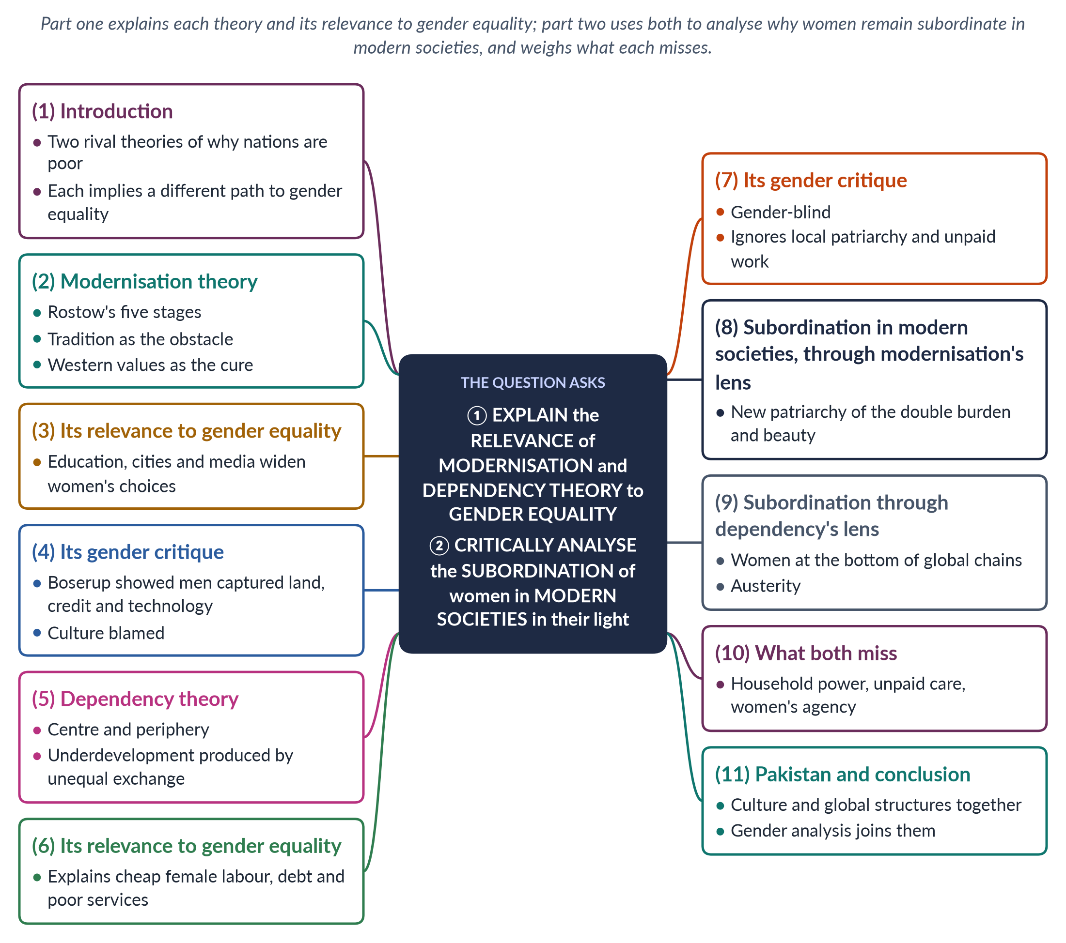
Figure 10 · The answer map: every branch is one numbered heading of the model answer below.

Decoding the question
Two limbs. "Explain the relevance … to gender equality" asks what each theory implies for women's equality — what it helps us see, and what path it suggests. "Critically analyse the subordination of women in modern societies in the light of these two theories" asks you to use both theories to explain why women remain subordinate even where societies have "modernised" — and to judge what each theory explains and misses.

The model answer

1. Introduction

i) Definition
Modernisation theory and dependency theory are the two classic explanations of why some nations are rich and others poor. Modernisation blames internal tradition; dependency blames external exploitation.

ii) The argument
Each theory offers a partial account of women's subordination. Modernisation explains how culture limits women and how education and cities can free them, but misses structures. Dependency explains how global exploitation keeps poor women poor, but misses patriarchy at home. A gender analysis needs both, plus attention to power inside households.

2. Modernisation theory

i) The claims
Modernisation theory, most famously W. W. Rostow's The Stages of Economic Growth (1960), held that every society passes through five stages — traditional society, preconditions for take-off, take-off, drive to maturity and high mass consumption. Poor countries are poor because they are stuck in "traditional" culture; they develop through industry, cities, education and Western values.

ii) What it says about women
Tradition — purdah, early marriage, large families — oppresses women; modernity frees them. The benefits of growth will trickle down to women through their husbands.

3. Relevance of modernisation to gender equality

i) What it gets right
There is truth here. Girls' education, urbanisation, mass media and paid work have widened women's choices in many countries. Education delays marriage, lowers fertility and raises women's earnings. Exposure to media and city life can change ideas about what women may do — for example, acceptance of women working as teachers, doctors or police officers.

ii) Real cultural obstacles
Some cultural practices — child marriage, honour killing, denial of inheritance — are real barriers to equality, and changing attitudes matters.

4. The gender critique of modernisation

i) Boserup's evidence
Ester Boserup (Woman's Role in Economic Development, 1970) showed that modernising agriculture often marginalised women: land titles, machines, training and credit went to men, so women farmers lost income and status.

ii) Blaming culture
By blaming "tradition", the theory ignored colonial history, land ownership, trade and state policy. It also assumed the West was a model of equality — which it was not.

5. Dependency theory

i) The claims
Raúl Prebisch, Andre Gunder Frank ("the development of underdevelopment", 1966) and Walter Rodney argued that poor countries were made poor by colonialism and unequal trade: the rich centre extracts raw materials, cheap labour and profits from the periphery. Underdevelopment is not an early stage but a result.

ii) What it says about women
Very little directly: dependency theory spoke of nations and classes, not women and men. Its cure — national self-reliance and industrialisation — imagined a male industrial worker as the hero of development, while women's farm and household work stayed invisible.

6. Relevance of dependency to gender equality

i) Cheap female labour
Feminists used dependency ideas to explain why women in the periphery do the lowest-paid work in global chains — garment stitching, cotton picking, home-based piece work.

ii) Debt and services
Dependence on foreign lenders brings austerity, which cuts the health, education and social services women depend on most.

iii) Structures, not culture
It moves the explanation of poor women's lives from their "culture" to the global economy.

7. The gender critique of dependency

i) Gender-blind
It ignored the gender division of labour inside the periphery.

ii) Local patriarchy ignored
By blaming the centre, it overlooked local structures — landlords, male household heads, customary law — that subordinate women whatever the world system.

iii) Unpaid work
It missed how women's unpaid subsistence and care work subsidises cheap exports (Maria Mies, 1986).
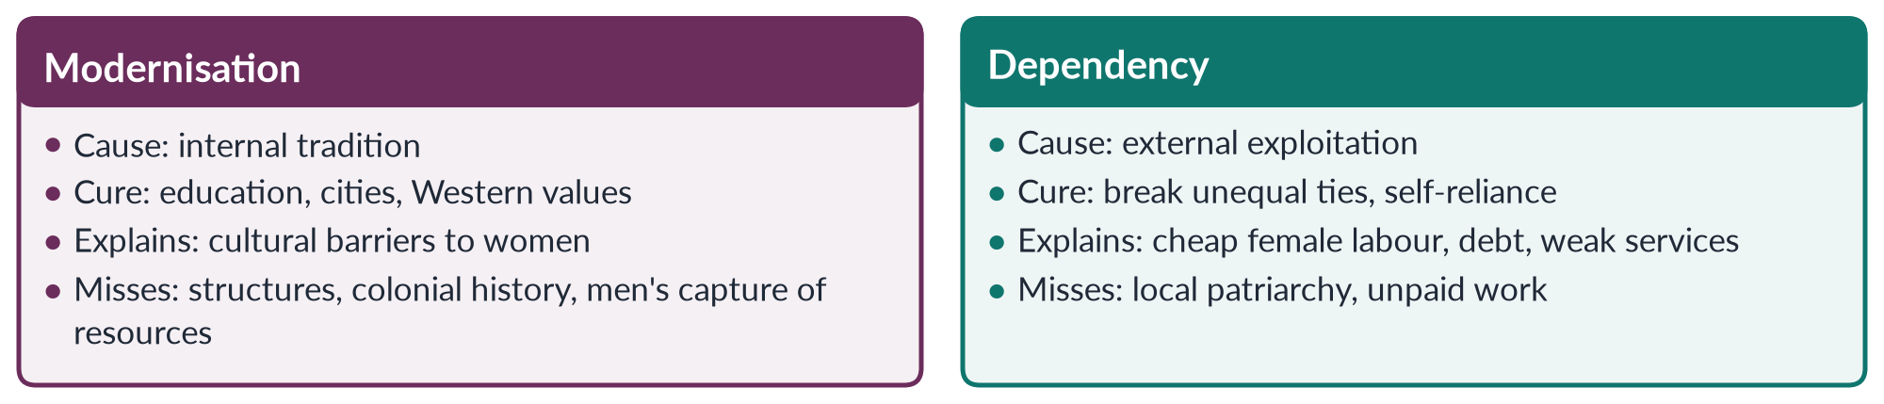
Figure 11 · The two theories and women's subordination.

8. Subordination in modern societies — through modernisation's lens

i) Modernity did not end patriarchy
Modern societies created new forms of subordination: the double burden of paid work plus housework; the glass ceiling; the gender pay gap; and beauty and consumer industries that commodify women's bodies.

ii) What the lens explains
Even in rich countries, where "traditional" attitudes persist inside modern institutions — for example, the belief that men are breadwinners — women are paid less and promoted less. Modernisation theory explains these as cultural lag, but cannot explain why they persist in the richest countries. The persistence suggests that subordination is built into structures — labour markets that penalise carers, and the unequal division of unpaid work — not only into attitudes.

9. Subordination through dependency's lens

i) Women at the bottom of global chains
In modern, globalised economies, women in poorer countries are drawn into export factories and home-based work on insecure terms — the Rana Plaza collapse in Bangladesh (2013) killed more than 1,100 garment workers, most of them women.

ii) Austerity and care
Debt and adjustment shift costs from the state to women's unpaid care.

10. What both theories miss

i) Power inside the household
Both treat the household as a harmonious unit. Feminist economists — Amartya Sen's "cooperative conflict" (1990) and Bina Agarwal's bargaining model — show that women often lose in household bargaining over income, food and decisions.

ii) Unpaid care
Neither counted the unpaid work that keeps economies running.

iii) Women's agency
Both treat women as passive — victims of tradition or of global capital — rather than as actors who organise and resist, as women workers' unions and rural women's movements show.

11. Pakistan and conclusion

i) Pakistan
Modernisation is visible in rising girls' enrolment and falling fertility; dependency in Pakistan's reliance on textile exports and repeated IMF programmes. Yet female labour-force participation remains 24.4%, and Pakistan ranked 143rd of 145 in the Global Gender Gap Report 2026 — showing that neither modernisation nor escape from dependency alone will produce equality.

ii) Conclusion
Modernisation theory is relevant to gender equality because culture and education matter; dependency theory is relevant because global structures matter. But women's subordination in modern societies also rests on household power, unpaid care and male control of resources — which neither theory saw. A gender analysis joins the cultural and the structural, the local and the global — and asks, in every case, who does the work, who owns the resources and who decides.

Why this answer scores
- Both limbs answered: relevance of each theory, then analysis of subordination through each lens.
- Each theory gets its claims, relevance and gender critique with named scholars and dates.
- A compare figure shows what each explains and misses.
- The answer adds what both miss — household bargaining and unpaid care — raising it above description.

Answer 7 · Gendered Inequalities Created by Globalisation (CSS 2019)
AT A GLANCE · CSS 2019 · Q5 · 20 MARKS
The process of globalization has connected nations worldwide and made the world a global village, yet it has also increased inequalities across nations. Discuss the gendered inequalities created and promoted by globalization in contemporary societies worldwide.

The answer map
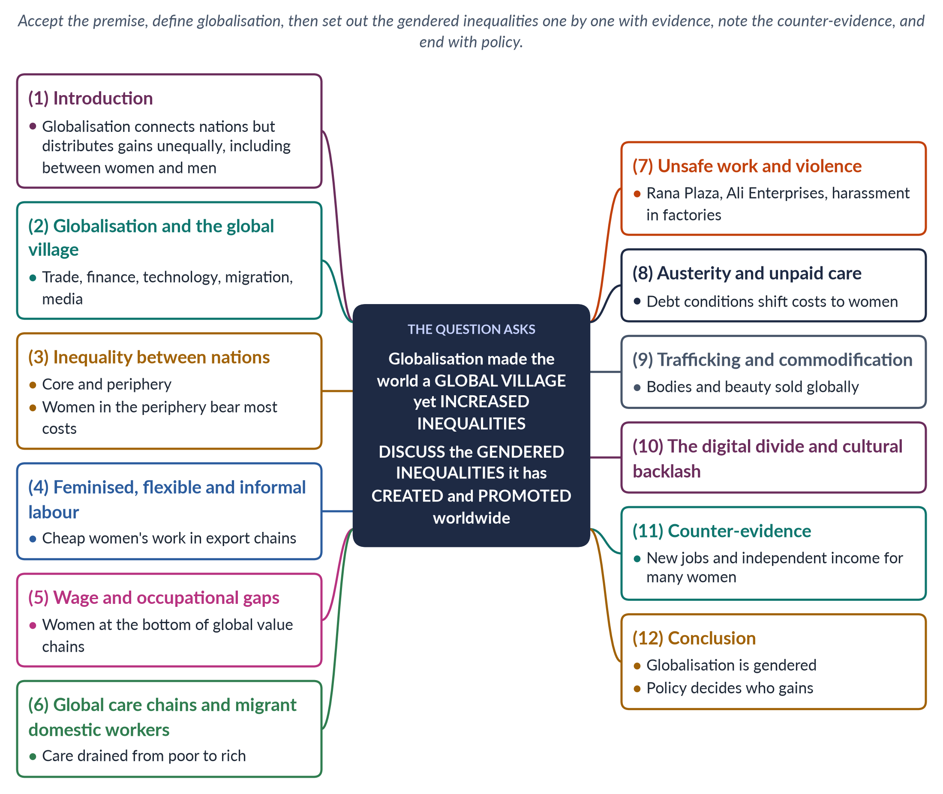
Figure 12 · The answer map: every branch is one numbered heading of the model answer below.

Decoding the question
The question states a premise — globalisation connects the world but increases inequality — and asks you to discuss the gendered inequalities it has created and promoted. List them clearly, one per heading, each with evidence. A top answer also briefly notes the counter-evidence (women's gains) and ends with policy, so that the discussion is balanced.

The model answer

1. Introduction

i) Definition
Globalisation is the growing interdependence of societies worldwide through trade, investment, finance, technology, migration and culture. It has made the world a "global village" in which goods, money, information and people move faster than ever.

ii) The argument
But the village is unequal. Globalisation has created new gendered inequalities — in work, pay, migration and safety — and promoted old ones by drawing on women's cheap and unpaid labour. It has also brought some women new opportunities; the outcome depends on policy and power.

2. How globalisation connected the world
Since the 1980s, trade liberalisation, the founding of the World Trade Organization (1995), global supply chains, the internet and mass migration have linked economies. Multinational companies now design products in one country, make them in another and sell them in a third. Phones, social media and cheap flights connect families across continents. In this sense the "global village" is real — but its benefits and costs are not shared equally between nations, classes, or women and men.

3. Inequality between nations
Immanuel Wallerstein's world-system theory (1974) divides the world into core, semi-periphery and periphery. Gains from globalisation flow mostly to the core. Because women in the periphery are the poorest workers, they bear the heaviest costs. When a brand shifts orders to a cheaper country, the women who stitched its clothes lose their jobs first, with no severance or social security. The World Economic Forum estimated in 2026 that the global gender gap was only 69.2% closed, with parity 120 years away.

4. Feminised, flexible and informal labour

i) The feminisation of labour
Guy Standing (1989) showed that global competition made jobs flexible, insecure and low-paid — and increasingly filled by women.

ii) Export processing zones
From Mexico's maquiladoras to Bangladesh's garment zones, employers prefer young women, seen as cheap and docile; unions are often discouraged and hours are long.

iii) Informal subcontracting
Brands subcontract to home-based workers who stitch or embroider on piece rates without contracts or social security — the "housewifisation" described by Maria Mies (1986).

5. Wage and occupational gaps
Women are concentrated in the lowest-paid segments of global value chains — assembly, sewing, packing, picking — while design, management and profits stay with men and with firms in the core. Pay gaps persist even where women's education has risen. Because women are also expected to do most unpaid care, they are more likely to take part-time, home-based or informal work — which pays less and offers no pension or protection.

6. Global care chains

i) The chain
Arlie Hochschild (2000) described how women from the Philippines, Indonesia, Sri Lanka and elsewhere migrate to care for families in rich countries, leaving their own children with relatives. Care is drained from poor to rich households. The migrant earns more than she could at home, but her own children and elders lose her care, and the burden passes to grandmothers and older daughters.

ii) Abuse
Under sponsorship (kafala) systems in the Gulf, many migrant domestic workers face confiscated passports, unpaid wages and abuse, with little legal protection.

7. Unsafe work and violence

i) Disasters
The Rana Plaza collapse in Bangladesh (24 April 2013) killed more than 1,100 garment workers, most of them women. The Ali Enterprises fire in Karachi (2012) killed about 260.

ii) Harassment
Labour groups report frequent verbal and sexual harassment by supervisors in export factories — a workplace patriarchy added to the family's.

8. Austerity and unpaid care
Global finance and debt brought structural adjustment and austerity. Diane Elson (1991) showed that spending cuts treat women's unpaid labour as "infinitely elastic": when clinics charge fees or subsidies end, women absorb the extra work of caring and stretching food, and girls are often withdrawn from school to help at home. Global finance thus transfers costs from states to women's unpaid time.
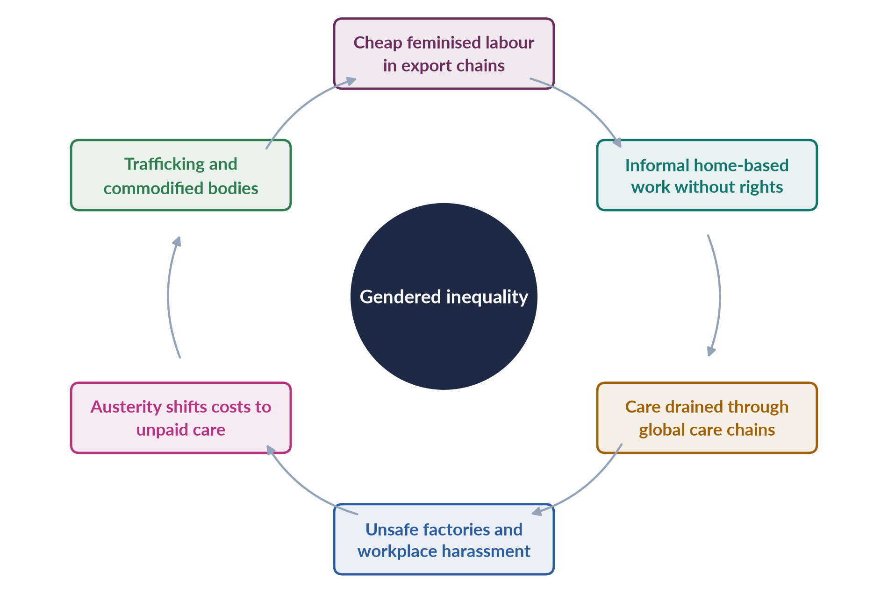
Figure 13 · How globalisation deepens gendered inequality.

9. Trafficking and commodification
Open borders and global demand fuel trafficking of women and girls. Global beauty and consumer industries sell standards such as skin-lightening products across Asia and Africa, turning women's bodies into markets. Commercial surrogacy and the global sex industry also treat poor women's bodies as resources for richer buyers.

10. The digital divide and backlash

i) Digital divide
Women in poor countries have less access to phones and the internet, so the digital economy's gains flow more to men — Pakistan's mobile-internet gender gap is still 25%. Online work and mobile banking, which could help women most, reach them least.

ii) Backlash
Rapid cultural change can provoke conservative reaction that tightens control over women's dress, mobility and work. In this way globalisation can strengthen local patriarchy even while spreading ideas of equality.

11. The counter-evidence
Globalisation also created opportunities. Export jobs gave millions of young women in Bangladesh, Sri Lanka and elsewhere their first independent income; Naila Kabeer (The Power to Choose, 2000) found that garment work delayed marriage and increased women's bargaining power. Global norms such as CEDAW and SDG 5 give activists leverage. The picture is therefore mixed, not simply negative. After Rana Plaza, the Bangladesh Accord on Fire and Building Safety (2013) showed that global pressure can also improve women workers' conditions.

12. Pakistan and conclusion

i) Pakistan
Pakistani women work at the bottom of textile chains as home-based stitchers and cotton pickers; many manage households while men work abroad; IMF-linked price rises increase their burdens; and female labour-force participation is only 24.4%. Sindh's Home-Based Workers Act 2018 is a first step to protecting women at the end of global chains.

ii) Conclusion
The question's premise holds. Globalisation has connected the world, but it has done so on gendered terms: it draws on women's cheap and unpaid labour, drains care from poor to rich, and exposes women to unsafe work and new forms of control. It has also opened doors. Whether women gain depends on labour rights, social protection, safe workplaces, care services and women's own organisation — national and global policy can make the global village fairer.

Why this answer scores
- Accepts the question's premise and sets out ten gendered inequalities, each with evidence.
- A cycle figure shows how the inequalities reinforce each other.
- Counter-evidence (Kabeer) keeps the discussion balanced.
- Current data (GGGR 2026, the 25% digital gap) and a Pakistan section apply the analysis.

Answer 8 · Short Note: Structural Functionalism (CSS 2019)
AT A GLANCE · CSS 2019 · Q8(C) · 10 MARKS
Write short notes on any TWO: Structural Functionalism

The answer map
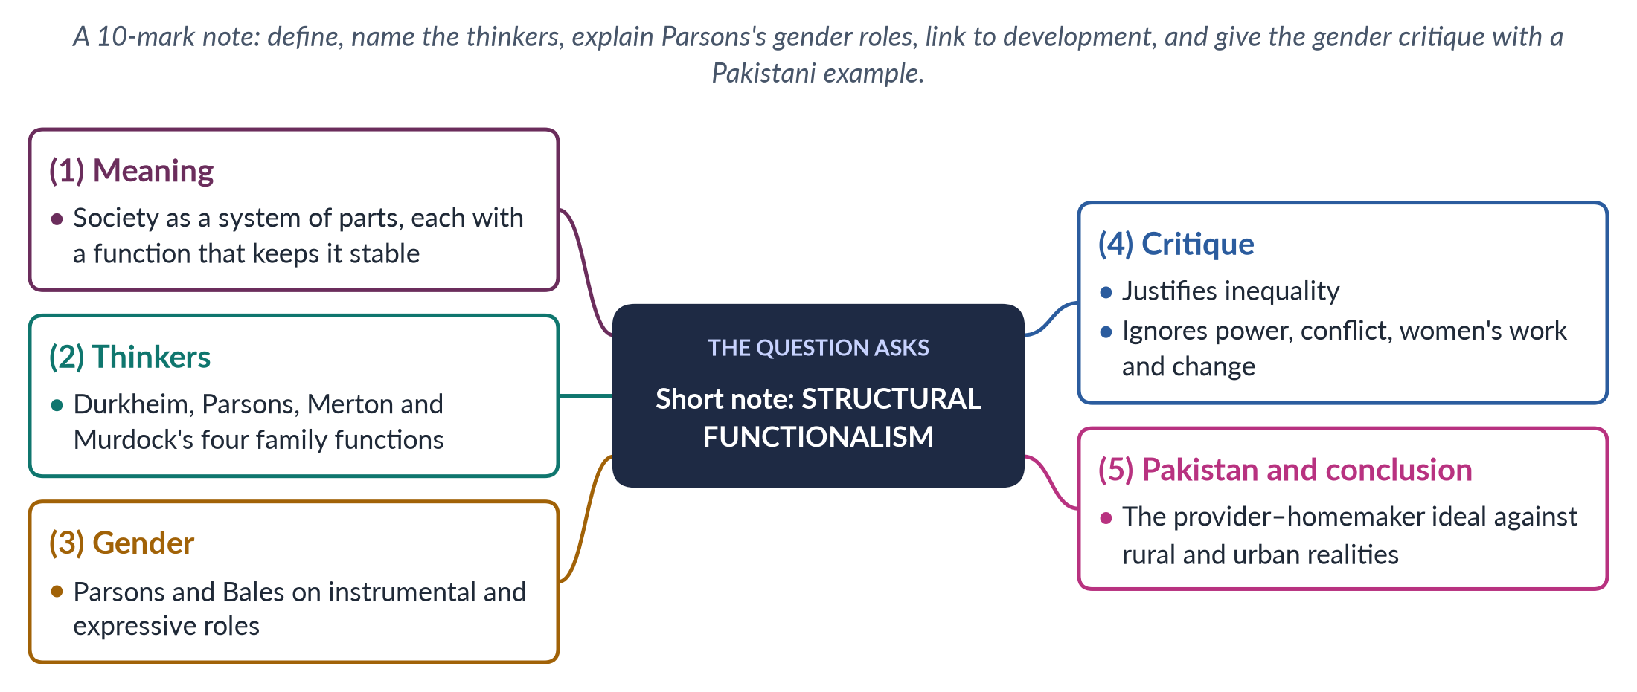
Figure 14 · The answer map for the short note: every branch is one headed point.

Decoding the question
A short note of 10 marks: about 550–650 words. Define the theory (its key word is stability), name the thinkers, explain what it says about gender, show its link to development thinking, and give the gender critique with an example.

The model answer

1. Meaning

i) Definition
Structural functionalism is a sociological theory that sees society as a system of interrelated parts — family, education, religion, economy and government — each performing a function that keeps the whole stable and in balance. A 2019 MCQ captured its key idea: it is related to the stability of society.

ii) The core question
For any custom or institution, the functionalist asks: "What does this do for society?" If something exists, it is assumed to be useful. Society is compared to a living body, in which each organ has a job; when one part changes, the others adjust to restore equilibrium.

2. Thinkers
- Émile Durkheim argued that society is held together by shared values and a division of labour.
- Talcott Parsons, the leading American sociologist of the 1950s, built the full theory, including the "pattern variables" that contrasted traditional and modern societies.
- Robert Merton added manifest (intended) and latent (unintended) functions and dysfunctions.
- George Murdock (Social Structure, 1949) claimed the nuclear family is universal and performs four functions: sexual, reproductive, economic and educational.

3. Gender roles: instrumental and expressive
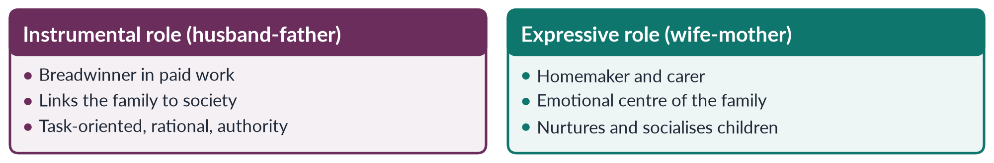
Figure 15 · Parsons and Bales's roles in the family (1955).
Talcott Parsons and Robert Bales (Family, Socialization and Interaction Process, 1955) argued that this division of roles is functional: it avoids competition between spouses, gives children stable models, and lets the family perform its two key functions — socialising children and stabilising adult personalities.

4. Link to development
Functionalism shaped modernisation theory. Planners of the 1950s–60s treated men as producers and household heads and women as homemakers — for example, agricultural extension services trained men as farmers and offered women only cooking and sewing classes. Where women did most of the farming, this wasted their knowledge.

5. The gender critique
1. It justifies inequality. Calling the gender division of labour "functional" makes women's subordination look natural. Functional for whom?
2. It ignores power and conflict — domestic violence, men's control of money, conflicts of interest between spouses.
3. It is historically narrow — based on middle-class, white America of the 1950s, not on societies where women have always worked in fields and markets. Even in America, working-class and Black women had always worked for wages.
4. It hides women's economic work in farming, crafts and the informal sector.
5. It cannot explain change in gender roles, such as the entry of married women into paid work since the 1960s.
Critics include Betty Friedan (The Feminine Mystique, 1963), who showed how unhappy the "expressive" housewife often was, and Ann Oakley (The Sociology of Housework, 1974), who showed housework to be real, often monotonous labour.

6. Pakistan and conclusion

i) Pakistan
The ideal of the man as provider and the woman as homemaker is strong in Pakistani textbooks, sermons and dramas. Yet most rural women already do heavy productive work in fields and with livestock; rising prices push urban families to need two incomes; and men's migration leaves many women heading households. The functionalist picture no longer fits much of Pakistani reality.

ii) Conclusion
Structural functionalism usefully shows how gender roles are tied to institutions and learnt through socialisation. But by treating inequality as functional, it cannot explain — or support — the change that gender equality requires. Used critically, its own idea of dysfunction helps: rigid gender roles waste women's talent and keep families poor.

Why this answer scores
- The MCQ key word stability anchors the definition.
- Thinkers with dates, and Parsons and Bales's roles in a small compare figure.
- A clear five-point critique with named critics and a Pakistani example.

Answer 9 · How the Colonial Era Influenced the Status of Women in the Subcontinent (CSS 2020)
AT A GLANCE · CSS 2020 · Q3 · 20 MARKS
How did the colonial era influence the status of women in the subcontinent?

The answer map
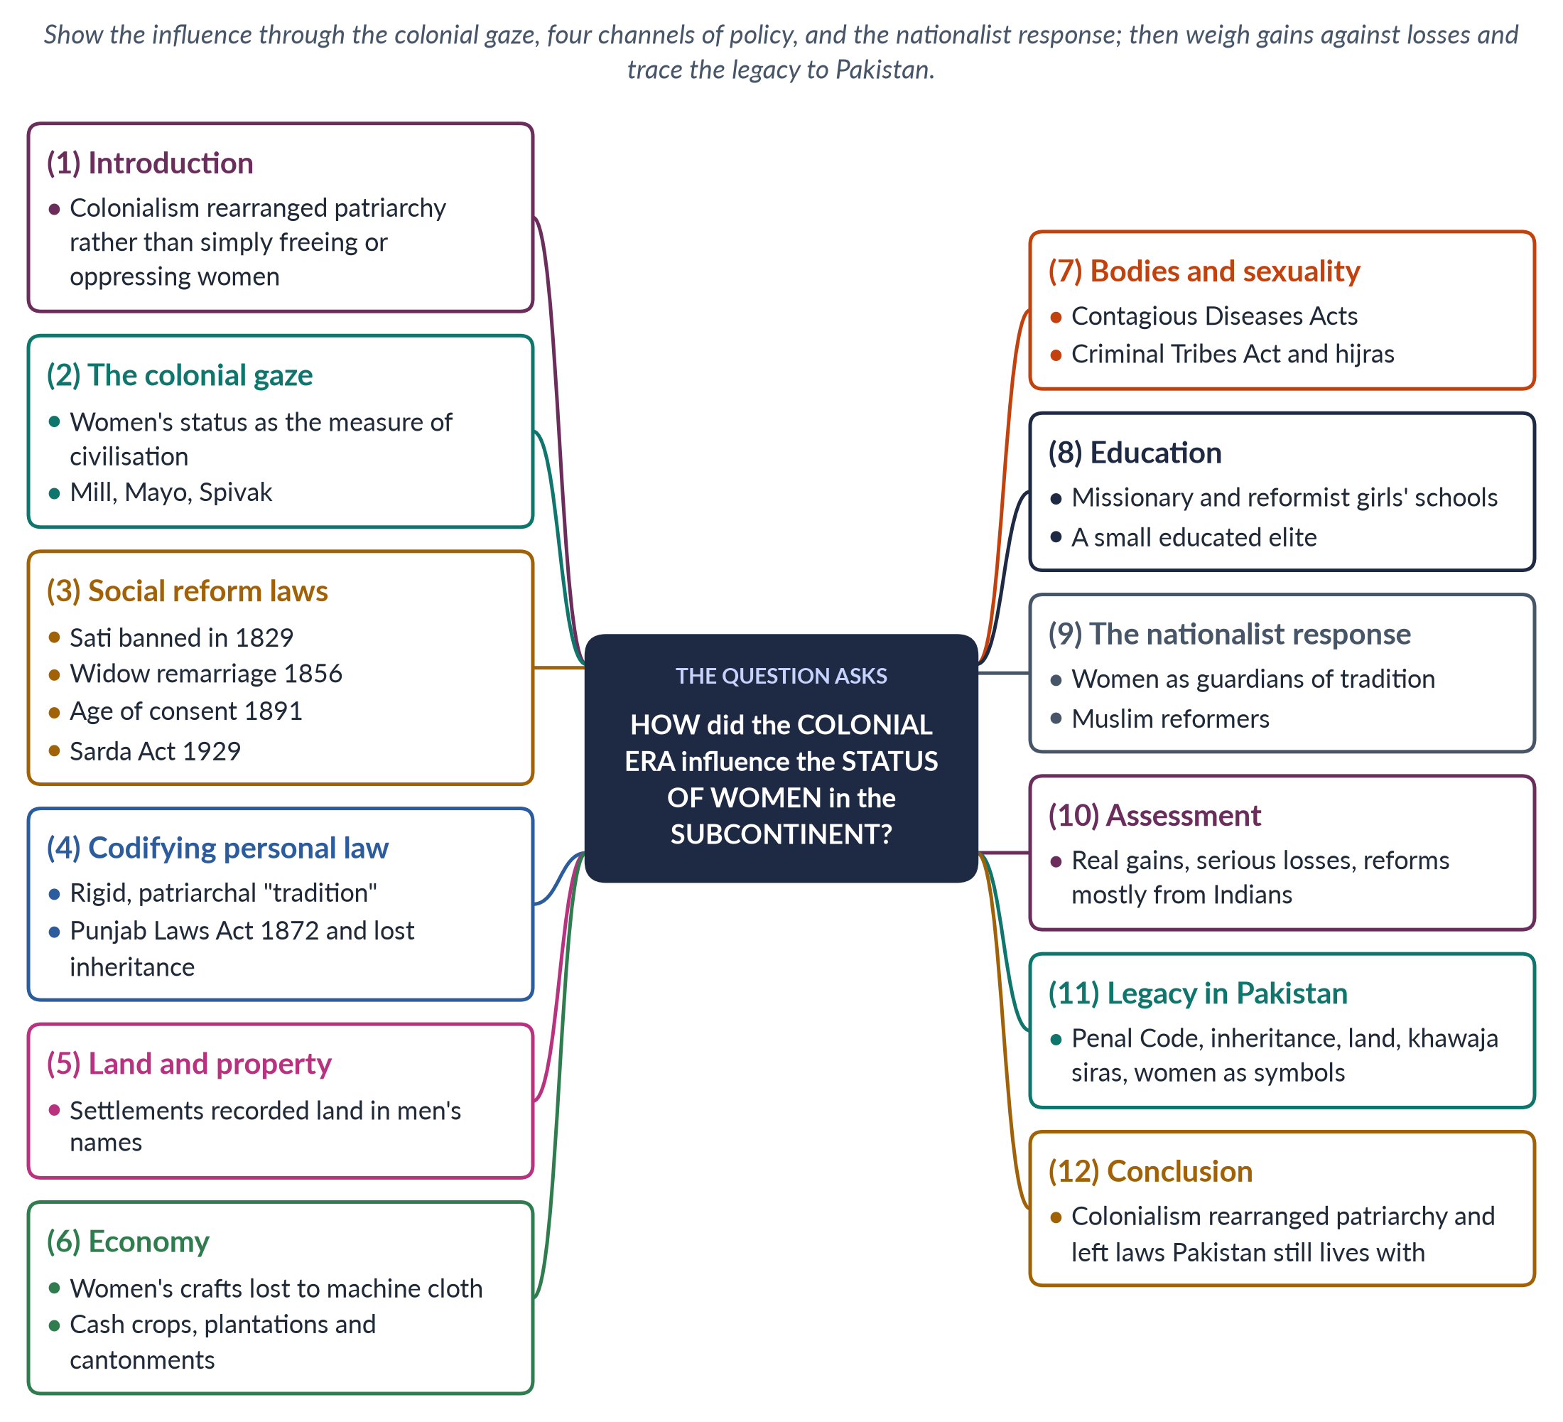
Figure 16 · The answer map: every branch is one numbered heading of the model answer below.

Decoding the question
"How did … influence" asks for the channels through which colonial rule changed women's status, with evidence — laws, policies, economic changes — and an assessment of whether women gained or lost. Organising by channel (gaze, law, land, economy, body, education) and ending with the legacy in Pakistan gives a complete answer.

The model answer

1. Introduction

i) Definition
The colonial era in the subcontinent means British rule — by the East India Company from the mid-eighteenth century and by the Crown from 1858 to 1947. The status of women means their legal rights, economic position, education, bodily freedom and social standing.

ii) The argument
Colonial rule did not simply liberate or oppress women. It rearranged patriarchy: it abolished some harmful practices, but it also codified the most patriarchal readings of custom, took away women's property rights, controlled their bodies, and used them to justify foreign rule. Indian reformers and nationalists, in turn, made women symbols of national identity. The laws and patterns it left behind still shape women's lives in Pakistan.

2. The colonial gaze

i) Women as the measure of civilisation
The British historian James Mill (The History of British India, 1817) argued that the condition of women measures a society's civilisation, and judged Indian society low. This justified British rule as a "civilising mission".

ii) Mother India
The American writer Katherine Mayo's Mother India (1927) portrayed Indian women as helpless victims of child marriage and Indian men as unfit to rule themselves. Gandhi called it "a drain inspector's report".

iii) Voiceless women
Gayatri Spivak (1988) summed up the colonial attitude as "White men are saving brown women from brown men". The historian Lata Mani showed that in the debate on sati, women were the "ground" of an argument between British and Indian men, not speakers in it.

3. Social reform laws
Table 4 · Colonial-era reform laws affecting women.
Year | Law | Effect
1829 | Bengal Sati Regulation | Banned widow burning (Raja Ram Mohan Roy's campaign)
1856 | Hindu Widows' Remarriage Act | Allowed widows to remarry — but they lost their late husband's property
1870 | Female Infanticide Prevention Act | Targeted killing of baby girls in north India
1891 | Age of Consent Act | Raised the age of consent for girls from 10 to 12
1929 | Child Marriage Restraint Act (Sarda Act) | Set minimum marriage ages
1939 | Dissolution of Muslim Marriages Act | Gave Muslim women grounds for divorce through the courts

These laws gave women some protection, but most came after long campaigns by Indian reformers, and many were weakly enforced.

4. Codifying personal law

i) Rigid "tradition"
The British ruled marriage, divorce and inheritance by religious and customary law, which they collected and codified with the help of male scholars and landowners. Flexible, local practices became rigid written rules, often in their most patriarchal form — "Anglo-Muhammadan law" for Muslims.

ii) Custom over Islam
The Punjab Laws Act (1872) made custom the first rule in matters such as inheritance. Because Punjabi custom usually excluded daughters, many Muslim women lost the inheritance shares Islamic law gave them.

5. Land and property
Colonial land settlements recorded land in the names of male heads of household. Women's customary rights to use land — to graze animals, gather fuel and cultivate family plots — were not recorded and were easily lost. This laid the foundation for today's very low levels of women's land ownership.

6. The economy
Cheap British machine-made cloth destroyed much of the hand-spinning and weaving in which women earned income. The colonial economy drew men into cash crops, plantations, railways and the army, and treated women's household and subsistence work as secondary. Women's economic independence declined in many regions, and their unpaid work became less visible to the colonial state, which counted only cash crops and wages.

7. Bodies and sexuality

i) Contagious Diseases Acts
Under the Cantonment and Contagious Diseases Acts (1864–68), women suspected of prostitution near army bases were registered and forced into medical examination — control of women's bodies for the army's convenience.

ii) Criminal Tribes Act
The Criminal Tribes Act (1871) labelled whole communities, including hijras, as criminal — a stigma that khawaja siras still carry.

iii) The Penal Code
The Indian Penal Code (1860) treated adultery as an offence by a man against another man's property — the wife was not punished but was treated as her husband's possession.

8. Education
Missionaries and the colonial state opened some girls' schools; Indian reformers opened many more, such as the girls' school at Aligarh (1906). Education created a small class of educated women who later led women's organisations and joined the freedom movements.
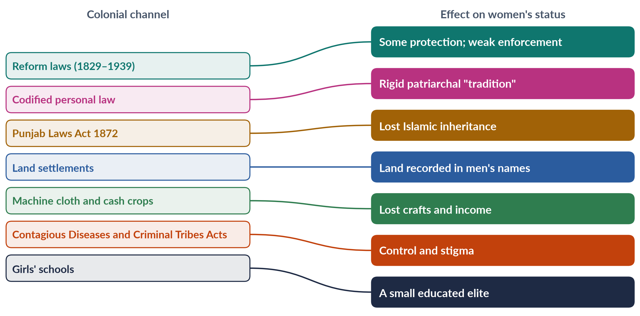
Figure 17 · Channels of colonial influence and their effects on women.

9. The nationalist response
Partha Chatterjee (1989) argued that nationalists divided life into an outer material world, where the West could be copied, and an inner spiritual world of home and family, which women were to guard. The "new woman" was educated but modest. Muslim reformers — Nazir Ahmad (Mirat-ul-Uroos, 1869) and Mumtaz Ali (Huquq-un-Niswan, 1898) — promoted girls' education within Islamic family values. Women thus became symbols of honour and identity for both religion and nation.

10. Assessment
The gains were real: laws against sati and infanticide, widow remarriage, a higher age of consent, girls' schools and Muslim women's right to seek divorce. The losses were also real: patriarchal codification, lost inheritance and land, bodily control, criminalised hijras, and the use of women to justify foreign rule. Most reforms came from Indian reformers, not British initiative, and colonial officials were often reluctant to interfere in "native custom" when it risked unrest.

11. The legacy in Pakistan
The Penal Code of 1860 remains the base of Pakistan's criminal law. The Sarda Act of 1929 remained the national child-marriage law until provinces and Islamabad raised the age (Sindh 2013; Islamabad 2025, age 18). Women's low land ownership and the customary denial of inheritance echo colonial land records and the Punjab Laws Act. Khawaja siras still carry the stigma of 1871. Debates over women as symbols of national and religious identity continue.

12. Conclusion
The colonial era changed women's status in the subcontinent through law, land, the economy, control of bodies and education. It removed some cruel practices but hardened others, took away property rights and turned women into symbols in a contest between colonial and nationalist men. Its most lasting influence was to rearrange patriarchy — and to leave laws and property patterns that Pakistan is still reforming.

Why this answer scores
- Influence is shown through clear channels, each with dated laws and effects.
- The colonial gaze and the nationalist response add depth beyond a list of laws.
- A table and a mapping figure make the evidence easy to mark.
- A balanced assessment and the legacy in Pakistan complete the answer.

Answer 10 · Modernisation Theory and the "Internal Cultural" Explanation of Women's Subordination (CSS 2021)
AT A GLANCE · CSS 2021 · Q6 · 20 MARKS
Modernization Theory blames internal cultural factors for women's subordination in the developing world. Discuss and elaborate the statement in respect of Modernization perspectives.

The answer map
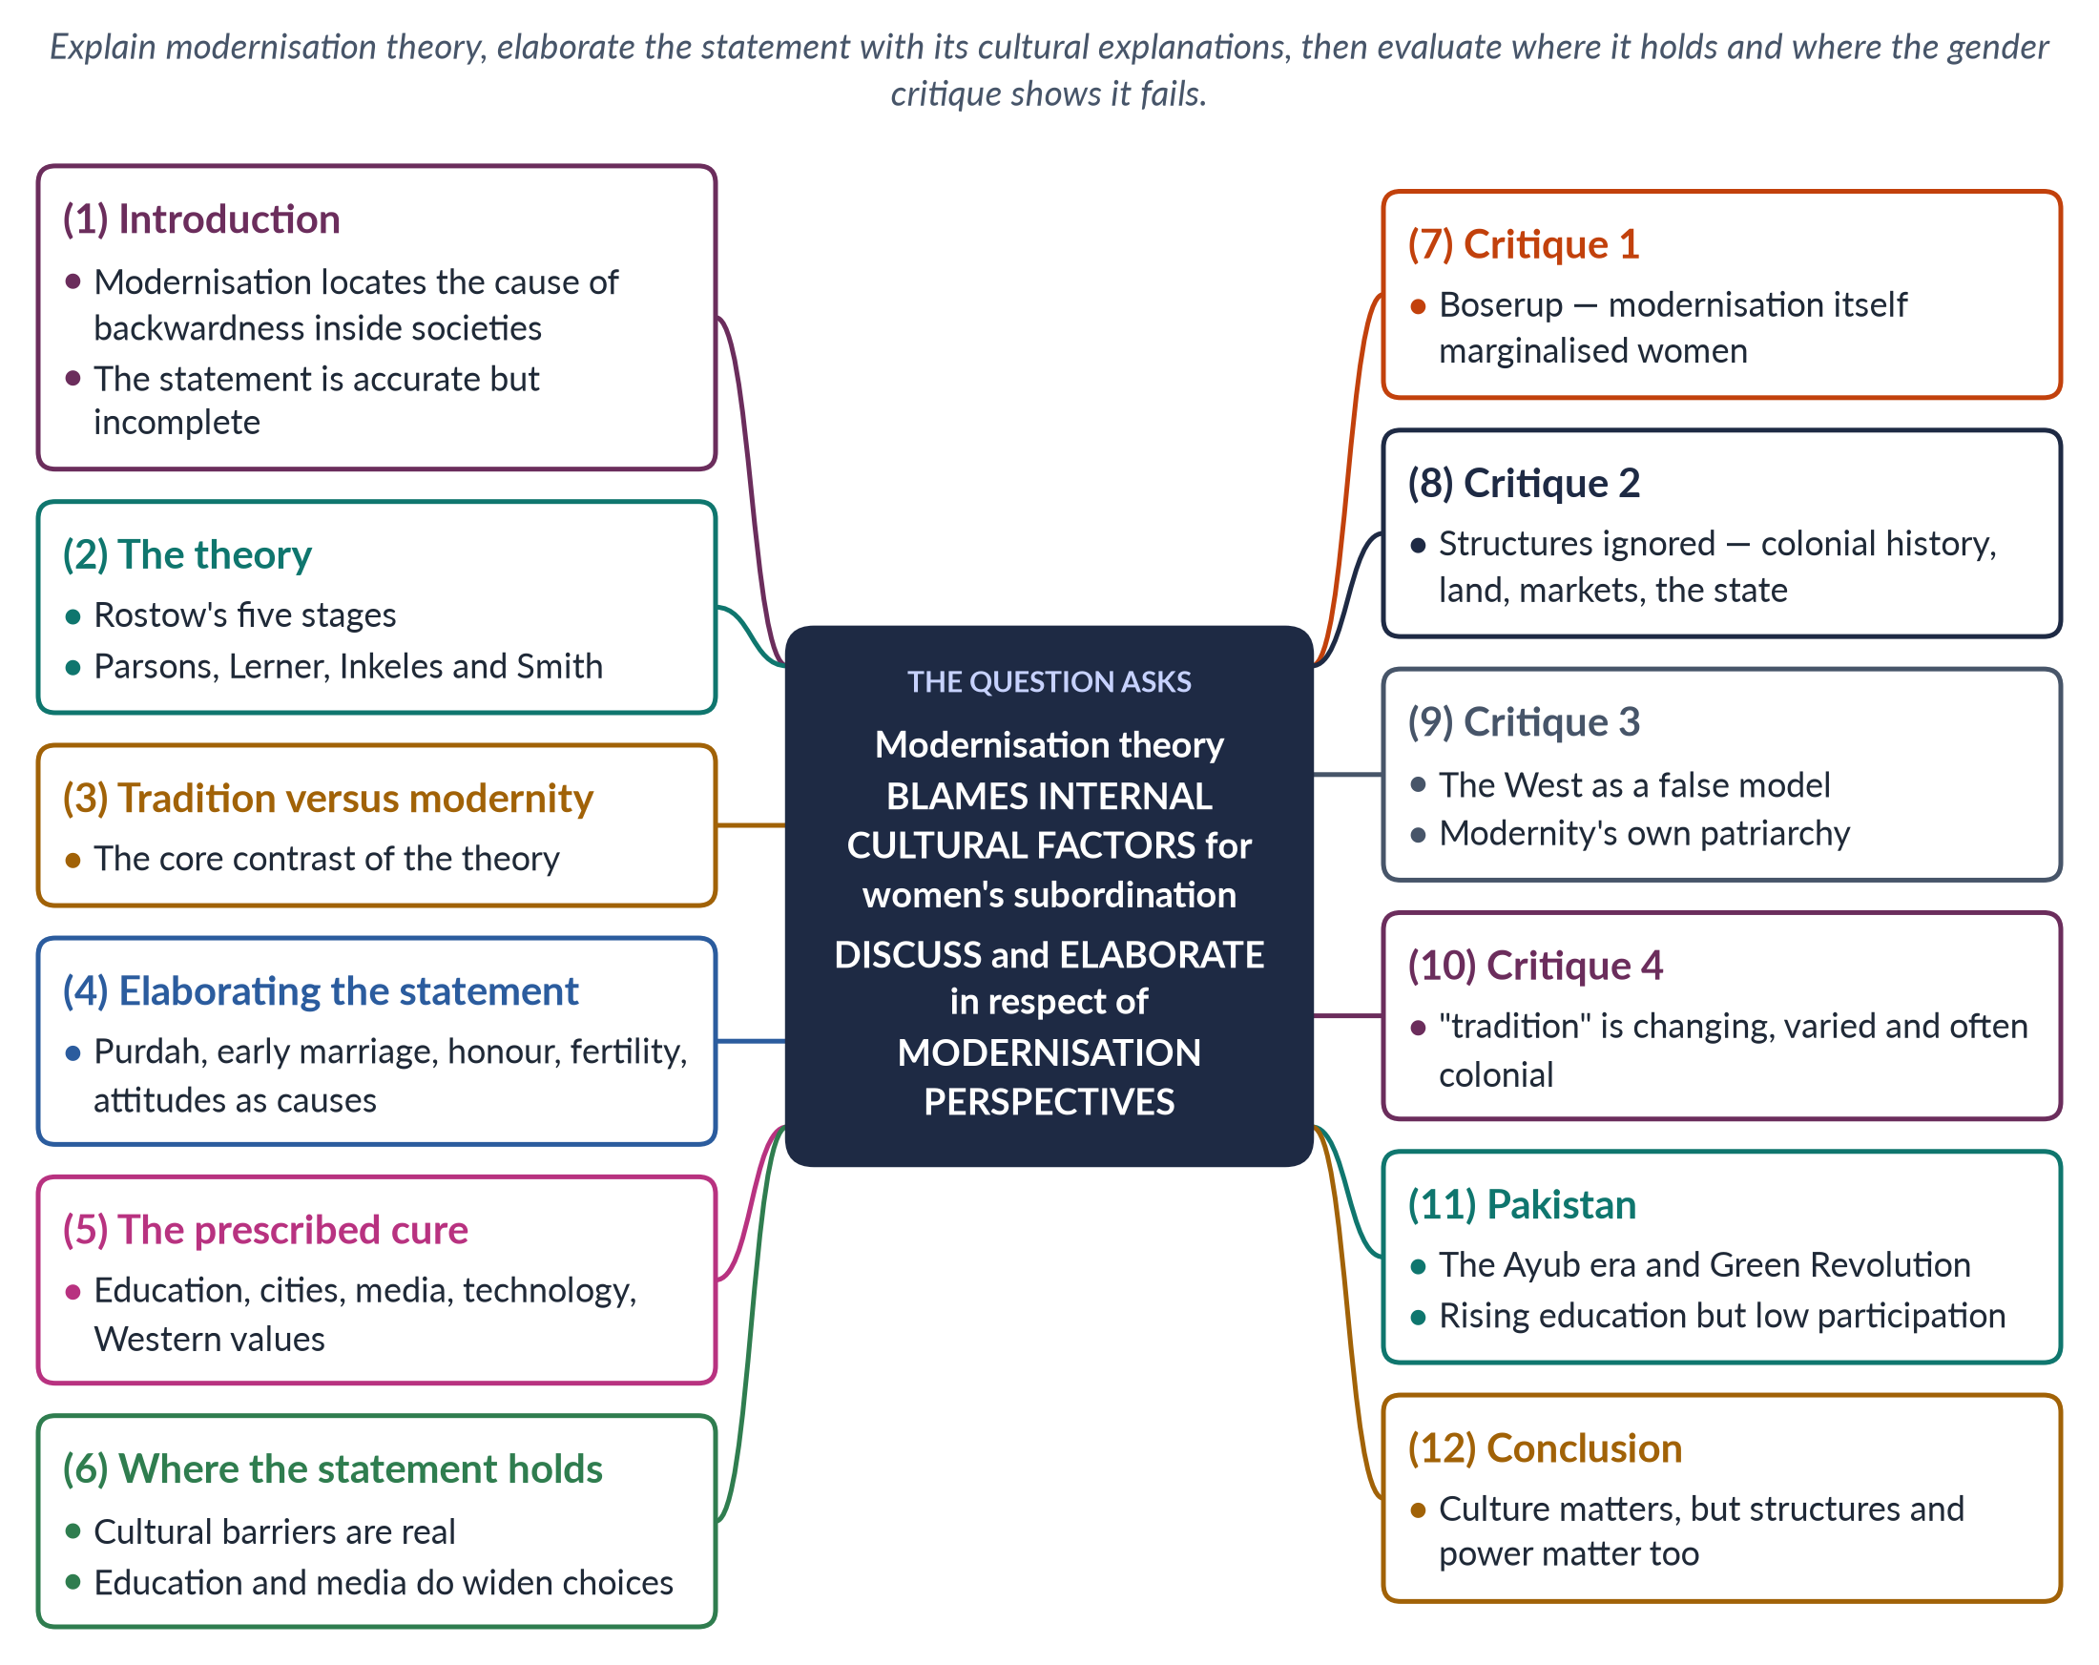
Figure 18 · The answer map: every branch is one numbered heading of the model answer below.

Decoding the question
The statement is a summary of modernisation theory: it blames "internal cultural factors" for women's subordination. "Discuss and elaborate" asks you to explain the theory, show how it uses cultural explanations with examples, and then discuss — that is, weigh — whether this explanation is adequate, using the gender critique. Both the elaboration and the evaluation need space.

The model answer

1. Introduction

i) Definition
Modernisation theory, dominant in the 1950s and 1960s, holds that poor countries are poor because they are "traditional", and that they develop by becoming like the West — industrial, urban, educated and "modern" in values.

ii) The argument
The statement accurately describes the theory: it explains women's subordination in the developing world by internal cultural factors — tradition, religion, family customs and attitudes. This explanation contains truth, but it is incomplete: it ignores colonial history, global economics, land and power, and the ways modernisation itself harmed women.

2. The theory

i) Rostow
W. W. Rostow's The Stages of Economic Growth: A Non-Communist Manifesto (1960) set out five stages: traditional society, preconditions for take-off, take-off, drive to maturity and high mass consumption. Aid, investment and technology from the West could help poor countries "take off". The subtitle shows that the theory was also a Cold War argument for capitalist development.

ii) Other voices
Talcott Parsons contrasted traditional societies based on family and status with modern ones based on achievement and universal rules. Daniel Lerner (The Passing of Traditional Society, 1958) argued that cities and mass media create "modern" personalities. Alex Inkeles and David Smith (Becoming Modern, 1974) measured modern attitudes.

3. Tradition versus modernity
At the heart of the theory is a contrast. Tradition is seen as rigid, religious, family-centred and resistant to change; modernity as rational, secular, individual and progressive. Development means moving from the first to the second — and the obstacles lie inside traditional societies.

4. Elaborating the statement: culture as the cause

i) Seclusion and honour
Women's absence from schools, jobs and public life is explained by purdah, family honour and restrictions on mobility.

ii) Early marriage and large families
Child marriage and high fertility are explained by traditional values that see women mainly as wives and mothers.

iii) Attitudes
Parents' preference for sons and their reluctance to educate daughters are explained as traditional attitudes that must change.

iv) Religion
Religious interpretations are treated as a cause of women's lower status, without distinguishing between religious texts and patriarchal customs that claim religious authority.

v) Rural life
Rural "backwardness" is blamed for women's heavy workloads and poor health, rather than lack of water supply, clinics and roads.
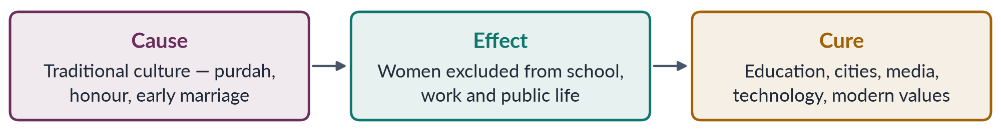
Figure 19 · Modernisation theory's explanation of women's subordination.

5. The prescribed cure
If culture is the cause, the cure is to change culture: educate girls, spread mass media, encourage urbanisation, promote family planning, and bring in Western technology and values. Development projects of the 1950s–60s followed this logic, treating women mainly as mothers in need of education in nutrition, hygiene and family planning. Benefits for women's work and income were expected to trickle down automatically through the male breadwinner.

6. Where the statement holds
The cultural explanation is not simply wrong. Child marriage, honour killing, the denial of inheritance and restrictions on mobility are real barriers to women's equality. And the cure has worked in part: girls' education delays marriage, lowers fertility and raises earnings; media and city life widen ideas of what women can do.

7. Critique 1: modernisation itself marginalised women
Ester Boserup (Woman's Role in Economic Development, 1970) showed that modernising agriculture gave land titles, machines, training and credit to men, so women farmers lost income and status. Women's subordination was often produced by modernisation, not only by tradition. Boserup also contrasted female farming systems (hoe cultivation, common in Africa) with male farming systems (plough cultivation, common in Asia) — showing that women's status depends on material production, not culture alone.

8. Critique 2: structures are ignored
By blaming culture, the theory overlooked external and structural causes: colonial laws and land settlements, unequal world trade (dependency theory), land concentration, labour markets that pay women less, and state policies. It "blamed the victim's culture" for problems partly caused elsewhere. Dependency and world-system theorists argued that poverty in the South was produced by its unequal place in the world economy — a structural cause that affects women most, because they do the lowest-paid work.

9. Critique 3: the West as a false model
Western societies also subordinated women — unequal pay, domestic violence, the "feminine mystique" that confined educated women to the home (Friedan, 1963). Modernity brought new forms of patriarchy: the double burden, the beauty industry, the glass ceiling. Holding up the West as the model of equality was misleading, and it made gender reform look like a foreign import — which critics in developing countries could then reject.

10. Critique 4: "tradition" is not fixed
Many practices called "traditional" were reshaped by colonial rule — for example, the codification of personal law and the Punjab Laws Act (1872), which put custom before Islamic inheritance. Traditions also vary and change, and some gave women rights that "modern" laws removed. Women were treated as passive objects of culture, not as actors.
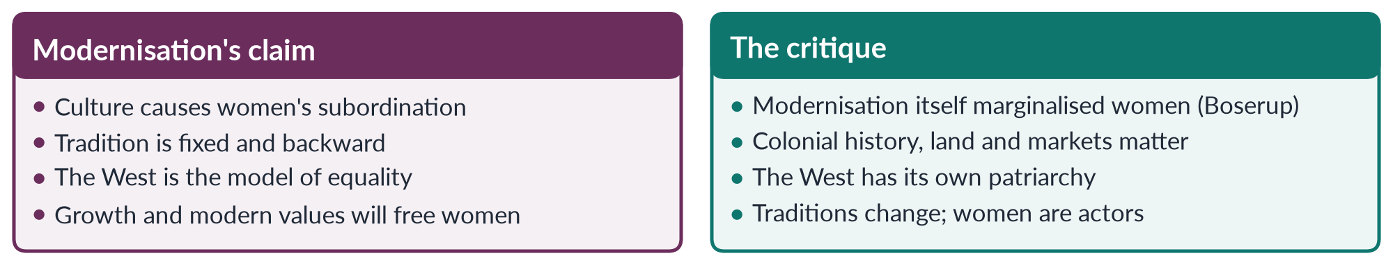
Figure 20 · The cultural explanation and its critics.

11. The Pakistan angle

i) The Ayub era
Pakistan's Decade of Development under Ayub Khan (1958–69) followed modernisation thinking. The Green Revolution raised output, but machines, credit and new seeds went mainly to male landowners, and many poor women lost farm work. The Muslim Family Laws Ordinance 1961 was a "modernising" reform of family law.

ii) Today
Girls' education and mobile phones have spread, yet female labour-force participation remains only 24.4% (LFS 2024–25). Culture plays a role — norms on mobility — but so do structures: unsafe transport, lack of childcare, harassment, low wages and women's lack of land.

12. Conclusion
The statement correctly summarises modernisation theory: it located women's subordination in internal cultural factors. That explanation captures real obstacles and led to real gains through education and media. But it is incomplete and one-sided. Women's subordination is also produced by colonial history, global economics, property systems, labour markets and development itself. Development policy should therefore change laws, property and markets as well as attitudes. A sound analysis treats culture as one cause among many — and treats women as agents who can change both culture and structures.

Why this answer scores
- The statement is elaborated with concrete cultural explanations and the theory's cure.
- It then discusses — showing where the statement holds and four critiques.
- A flow figure and a compare figure make the argument clear.
- Pakistan's Ayub era and today's data apply the theory.

Answer 11 · Approaches to Women's Development: WID, WAD and GAD (CSS 2021)
AT A GLANCE · CSS 2021 · Q7 · 20 MARKS
Critically analyze the various approaches to women's development, focusing on Women in Development (WID), Women and Development (WAD), and Gender and Development (GAD).

The answer map
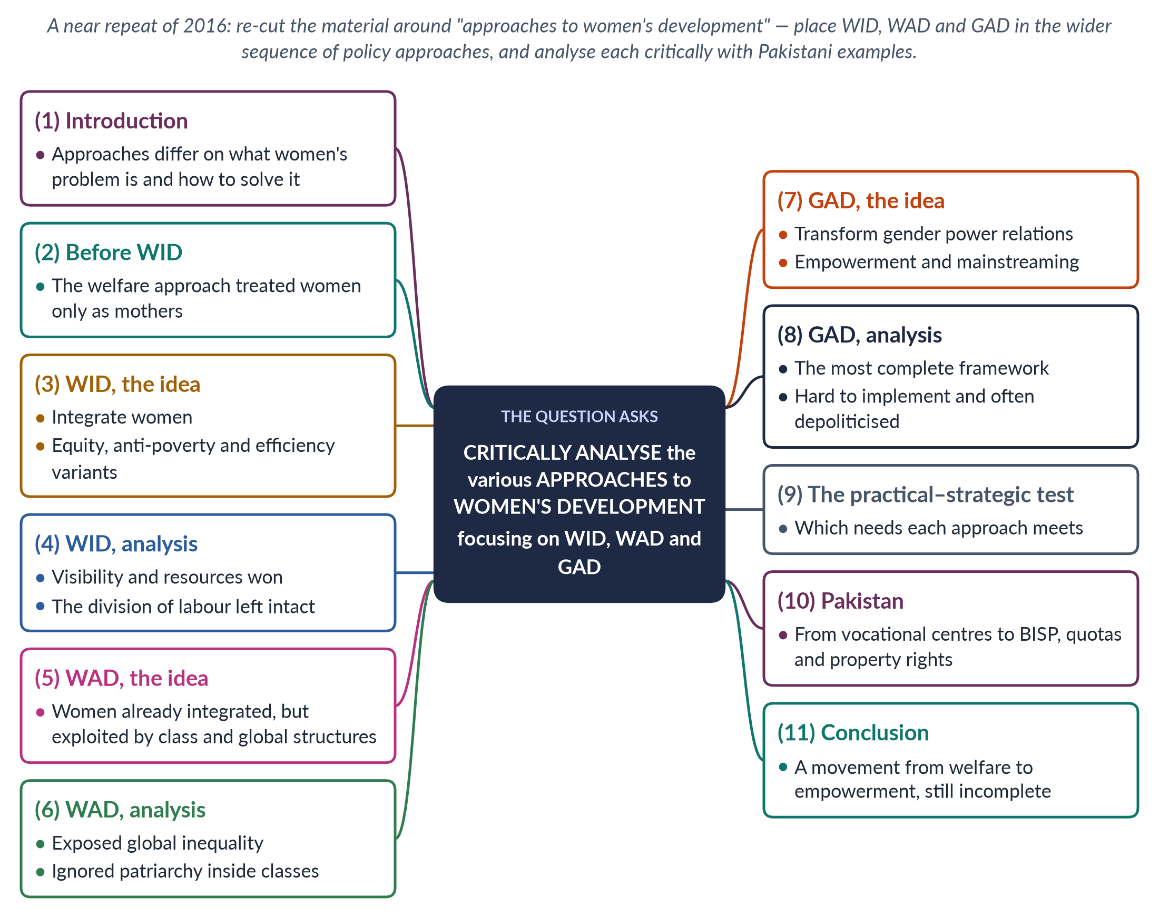
Figure 21 · The answer map: every branch is one numbered heading of the model answer below.

Decoding the question
This is a near repeat of 2016 Q8, but the wording differs: "approaches to women's development". Use this to widen the frame — show that WID, WAD and GAD belong to a sequence of policy approaches (welfare, equity, anti-poverty, efficiency, empowerment). "Critically analyse" needs strengths and weaknesses of each, a test for comparing them, and Pakistani examples.

The model answer

1. Introduction

i) Definition
An approach to women's development is a set of assumptions about what women's problem is in development and how policy should solve it. Since 1950, approaches have moved from seeing women as mothers to seeing them as producers, then as exploited workers, and finally as agents whose power relations with men must change.

ii) The argument
WID, WAD and GAD mark three stages in this movement. Each corrected the blind spot of the last: WID brought women in, WAD exposed the unequal system, and GAD focused on gender power. Critical analysis shows that each has strengths, and that the most ambitious — GAD — is also the hardest to put into practice.

2. Before WID: the welfare approach
From the 1950s, development agencies treated women as mothers and homemakers. Programmes offered food aid, nutrition education, maternal and child health and family planning. Women were passive recipients; their work as farmers and traders was ignored. Caroline Moser (1993) called this the welfare approach. It met some practical needs but reinforced women's domestic role. Women's work as farmers, traders and craftworkers was invisible, and assistance often reached them only through their husbands.

3. WID — the idea

i) Origins
Ester Boserup (Woman's Role in Economic Development, 1970) showed that modernisation had marginalised women producers. Women professionals in Washington coined "Women in Development", and the Percy Amendment (1973) required US aid to integrate women.

ii) Three variants
Moser identified three WID approaches. Equity — the original WID — sought equal rights and status through law and access; governments found it threatening. Anti-poverty focused on raising poor women's income through small projects. Efficiency, from the 1980s, involved women because it made development more efficient — often by using their unpaid time during structural adjustment.

4. WID — critical analysis

i) Strengths
WID made women visible in development statistics, created women's ministries and UN bodies, and won education, credit and training for women. It recognised women as producers.

ii) Weaknesses
WID accepted the existing model of development — "add women and stir". It took the sexual division of labour for granted, so women's paid work was added to their unpaid work. It focused on women alone, not on men's power, and ignored class and global inequality. Its projects — sewing, handicrafts, poultry — were small and marginal, and its efficiency variant often used women's unpaid time to deliver services cheaply during structural adjustment.

5. WAD — the idea

i) Origins
In the late 1970s, scholars influenced by Marxism and dependency theory criticised WID. The IDS workshop on "The Continuing Subordination of Women" (1978) was a landmark.

ii) Principles
WAD argued that women had always been part of development — as farmers, workers and carers — but on unequal and exploitative terms. The problem was the nature of development: an unequal international and class system that exploits both poor men and poor women.

6. WAD — critical analysis

i) Strengths
WAD asked "development for whom?", gave Southern scholars a voice, linked women's position to class, debt and global trade, and valued women's existing work.

ii) Weaknesses
WAD emphasised class and neglected patriarchy within classes — why poor men also dominate poor women. It paid little attention to the household and, in practice, often funded separate women's projects again. Its call for changing the international economic order was hard for governments and donors to adopt.

7. GAD — the idea

i) Origins
GAD emerged in the 1980s from socialist feminists — such as Kate Young — and Southern networks such as DAWN (1984). Beijing (1995) adopted its language.

ii) Principles
GAD focuses on gender relations — power between women and men — in households, markets and states. It values both productive and reproductive work, treats women as agents, and seeks to transform unequal structures through empowerment and gender mainstreaming.

iii) Tools
Practical and strategic needs (Molyneux, 1985; Moser, 1993); Moser's triple role; Naila Kabeer's definition of empowerment (1999) as the ability to make strategic life choices.

8. GAD — critical analysis

i) Strengths
GAD brought men, power and the household into analysis, and links everyday needs to long-term change. It treats women as actors rather than beneficiaries, and supports their collective organisation — women's groups, unions and movements — as the engine of change.

ii) Weaknesses
Transforming power is political, so agencies often reduce GAD to checklists and workshops; "gender" can divert resources from women; mainstreaming can leave no one responsible; and men and elites resist.
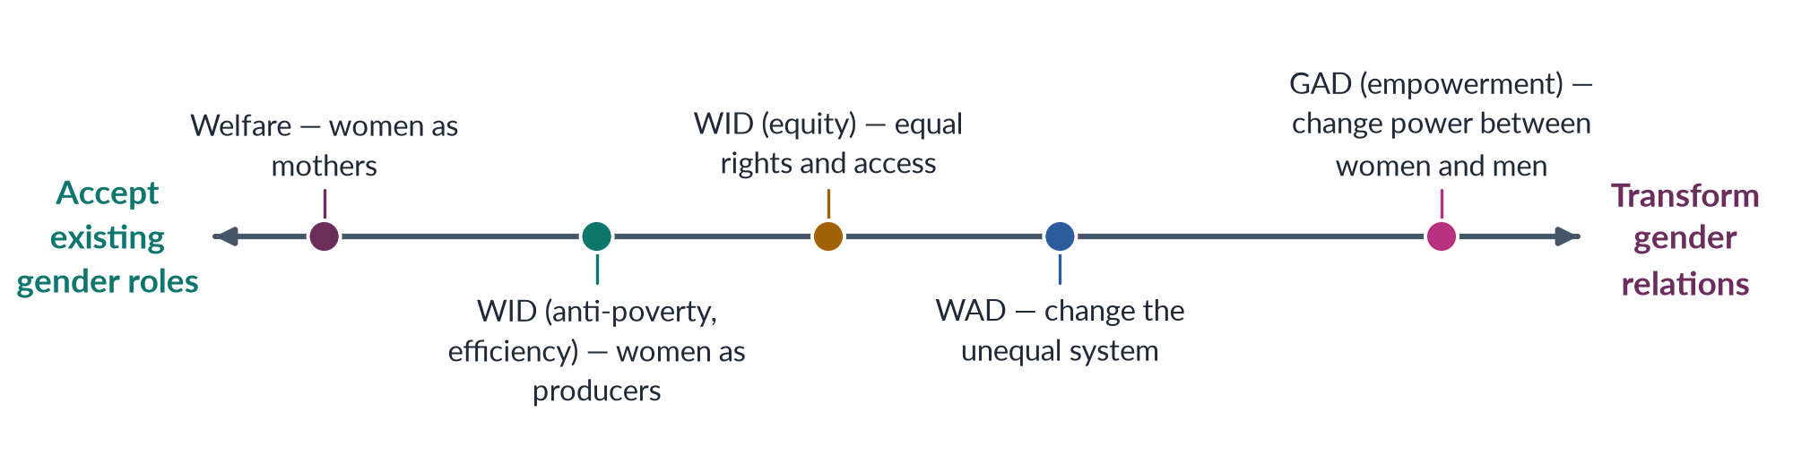
Figure 22 · Approaches to women's development, from meeting roles to changing power.

9. The practical–strategic test
A useful test is which needs each approach meets. Welfare and most WID projects meet practical needs — food, health, income — without changing women's position. WAD addresses structural inequality but mainly between classes and nations. GAD aims to meet practical needs in ways that serve strategic interests — land, laws, power. By this test, GAD is the most complete approach, but the one least often fully delivered.

10. The Pakistan angle

i) Welfare and WID
Pakistan's early programmes were welfare-oriented — maternal and child health, family planning. The Women's Division (1979), vocational centres, sewing and handicraft training and the First Women Bank (1989) followed WID.

ii) GAD
Later steps reflect GAD: gender mainstreaming and budgeting pilots; the 10% quota for women in federal jobs; 60 reserved seats (2002); BISP (2008) paying cash to women; and the Enforcement of Women's Property Rights Act 2020. Yet women's labour-force participation remains 24.4% and Pakistan ranked 143rd of 145 in the Global Gender Gap Report 2026, showing that strategic change is incomplete.

11. Conclusion
The approaches to women's development moved from welfare (women as mothers), to WID (women as producers to be integrated), to WAD (women as exploited workers in an unequal system), to GAD (gender relations to be transformed). Each advance corrected a blind spot. Critical analysis shows that the problem today is less one of ideas than of implementation and political will: meeting women's practical needs in ways that genuinely shift power.

Why this answer scores
- Re-cuts a repeated topic around the question's own words — "approaches" — by adding welfare and Moser's variants.
- Each approach gets its idea and a critical analysis (strengths and weaknesses).
- A spectrum figure and a practical–strategic test show analytical depth.
- Pakistan's programmes are mapped onto the approaches.

Answer 12 · The Capitalistic Perspectives of Gender (CSS 2022)
AT A GLANCE · CSS 2022 · Q7 · 20 MARKS
What are the capitalistic perspectives of gender? Explain.

The answer map
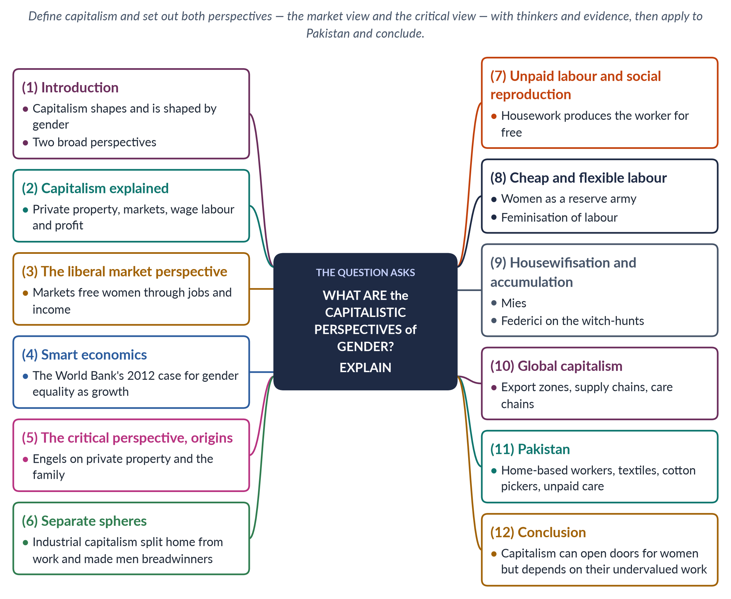
Figure 23 · The answer map: every branch is one numbered heading of the model answer below.

Decoding the question
"What are the capitalistic perspectives of gender? Explain." asks you to identify the different ways of understanding the relation between capitalism and gender, and to explain each with thinkers and evidence. There are at least two perspectives — the liberal/market view and the critical/Marxist-feminist view — and a strong answer presents both, then applies them.

The model answer

1. Introduction

i) Definition
Capitalism is an economic system based on private ownership, markets, wage labour and profit. Capitalistic perspectives of gender are the ways scholars explain how capitalism shapes gender relations — and how it depends on them.

ii) The argument
There are two main perspectives. The liberal (market) perspective sees capitalism as a force that can free women through jobs and income. The critical (Marxist and socialist-feminist) perspective sees capitalism as depending on and deepening women's subordination, by profiting from their unpaid work at home and cheap work outside. The evidence supports parts of both.

2. Capitalism explained
Under capitalism, a few people own the means of production — land, factories, machines — and most people earn a living by selling their labour for wages. Firms compete to make profit. The system spread from Europe with industrialisation and colonialism, and today operates as a global economy. Its logic of profit and competition reaches into households, farms and informal work everywhere — including in Pakistan.

3. The liberal market perspective

i) The claim
Markets reward skills and effort, not sex. When women gain education and enter paid work, they earn independent income, gain bargaining power at home and escape family control.

ii) The barriers
Women's disadvantage comes from barriers — discriminatory laws, prejudice, lack of education and credit. Remove them and the market will treat women fairly.

iii) The evidence
Export jobs in Bangladesh and East Asia gave millions of young women their first independent income; research by Naila Kabeer (2000) found garment work delayed marriage and increased women's voice.

4. Smart economics
The World Bank's World Development Report 2012: Gender Equality and Development argued that gender equality is "smart economics": educating and employing women raises productivity and growth. Critics such as Sylvia Chant and Caroline Sweetman (2012) replied that this values women mainly as instruments of growth, not as rights-holders, and ignores unpaid care and power.

5. The critical perspective — origins
Friedrich Engels (The Origin of the Family, Private Property and the State, 1884) argued that women's subordination began with private property: men who owned herds and land wanted to pass them to their own sons, and so controlled women's sexuality through monogamy — "the world historical defeat of the female sex". Capitalism, as a system of private property, inherited and used this subordination.

6. Separate spheres
Before industrial capitalism, most production took place in the household, where men and women both worked. Industrial capitalism moved production into factories, creating a public world of paid work, seen as men's, and a private world of unpaid domestic work, seen as women's. The ideology of separate spheres and the male breadwinner followed. Trade unions sometimes fought for a "family wage" for men that pushed women out of paid work (Heidi Hartmann, 1979).

7. Unpaid labour and social reproduction
Marxist feminists showed that housework is real production. Margaret Benston (1969) and Mariarosa Dalla Costa and Selma James (1972) argued that housework produces the most important commodity of all — the worker — every day, for free. This social reproduction lets employers pay wages that do not cover the full cost of keeping workers alive. Because it is unpaid, it is left out of GDP (Marilyn Waring, If Women Counted, 1988), and women who do it are seen as economically "inactive". Silvia Federici (1975) wrote: "They say it is love. We say it is unwaged work."

8. Cheap and flexible labour

i) Reserve army
Women are treated as a reserve army of labour — hired when needed, as in wartime factories, and dropped when not — and as "secondary earners", which justifies lower wages.

ii) Feminisation of labour
Guy Standing (1989) showed that global competition turned many jobs into flexible, informal, low-paid work increasingly filled by women.

9. Housewifisation and accumulation
✦ THINKER
Maria Mies · *Patriarchy and Accumulation on a World Scale* (1986)
Studying the lace makers of Narsapur, India, Mies found that women making lace at home for world markets were counted as "housewives" doing leisure work, so they were paid very little. She called this "housewifisation": defining women as housewives so that their productive work can be cheapened. Capitalism, colonialism and patriarchy form one system of accumulation.

The same logic applies wherever global firms subcontract to women working at home. Silvia Federici (Caliban and the Witch, 2004) argued that the rise of capitalism in Europe involved the witch-hunts, which destroyed women's control over reproduction and pushed them into unpaid domestic roles.
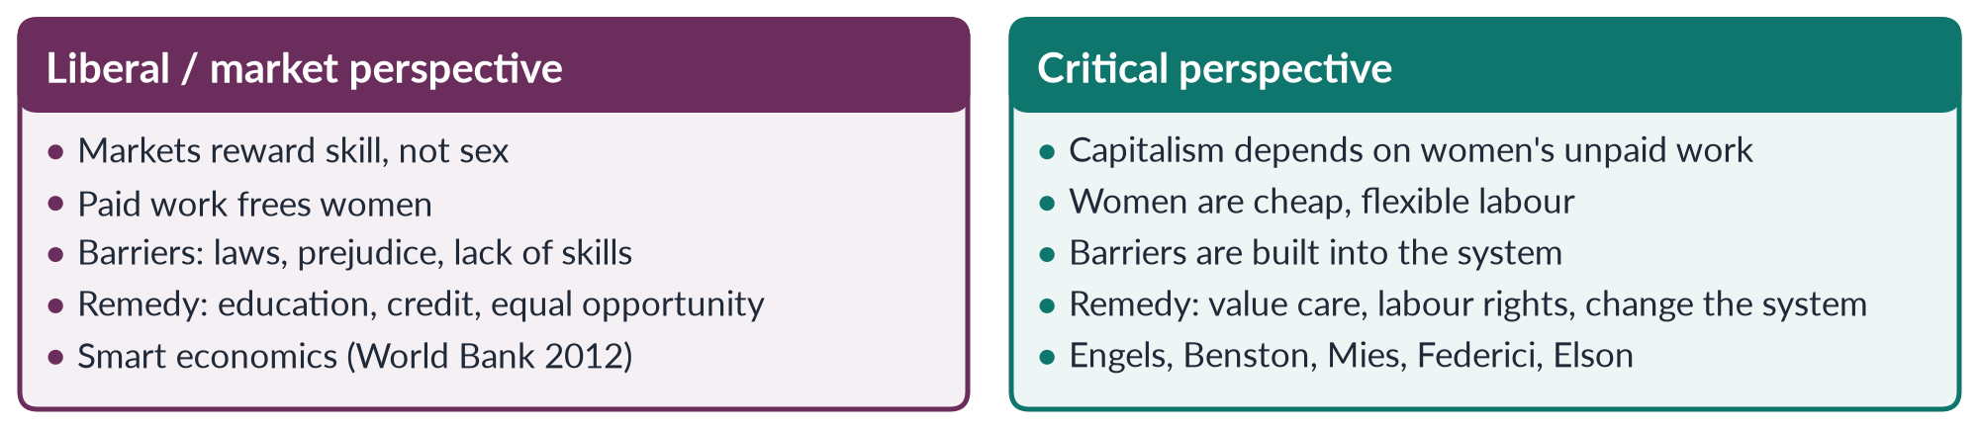
Figure 24 · Two capitalistic perspectives of gender.

10. Global capitalism and gender
Global capitalism draws on women's labour in export processing zones, global supply chains (garments, electronics) and global care chains (migrant domestic workers). It creates jobs — and for many women, a first wage — but often insecure, unsafe and low-paid ones — as the Rana Plaza collapse (Bangladesh, 2013) and the Ali Enterprises fire (Karachi, 2012) showed.

11. The Pakistan angle

i) Home-based and textile work
Millions of Pakistani women stitch, embroider and pack at home for piece rates — housewifisation in action. Sindh's Home-Based Workers Act 2018 was the first to recognise them. Textile exports depend on low-paid labour.

ii) Agriculture and care
Women pick cotton for low seasonal wages and do most unpaid care — none of it counted in GDP.

iii) Limited entry
Female labour-force participation is only 24.4% (LFS 2024–25): capitalism in Pakistan has drawn fewer women into paid work than in Bangladesh — because of mobility limits, unsafe transport, harassment and lack of childcare. Where women do work, they are concentrated in the least protected parts of the economy.

12. Conclusion
The liberal perspective is right that paid work and markets can give women income and independence. The critical perspective is right that capitalism depends on women's unpaid and underpaid labour and does not value care. The two views meet in policy: women need access to paid work and recognition, reduction and redistribution of unpaid care, with labour rights that make capitalism work for them rather than on them.

Why this answer scores
- Identifies two perspectives and explains each with thinkers and dates.
- The critical view is built step by step — Engels, separate spheres, social reproduction, reserve army, housewifisation.
- A compare figure sets the perspectives side by side.
- Pakistani evidence and a policy-oriented conclusion reconcile the two views.

Answer 13 · The Gender Critique of Structural Adjustment Policies (CSS 2022)
AT A GLANCE · CSS 2022 · Q8 · 20 MARKS
Discuss in detail the gender critique of Structural Adjustment Policies (SAPs).

The answer map
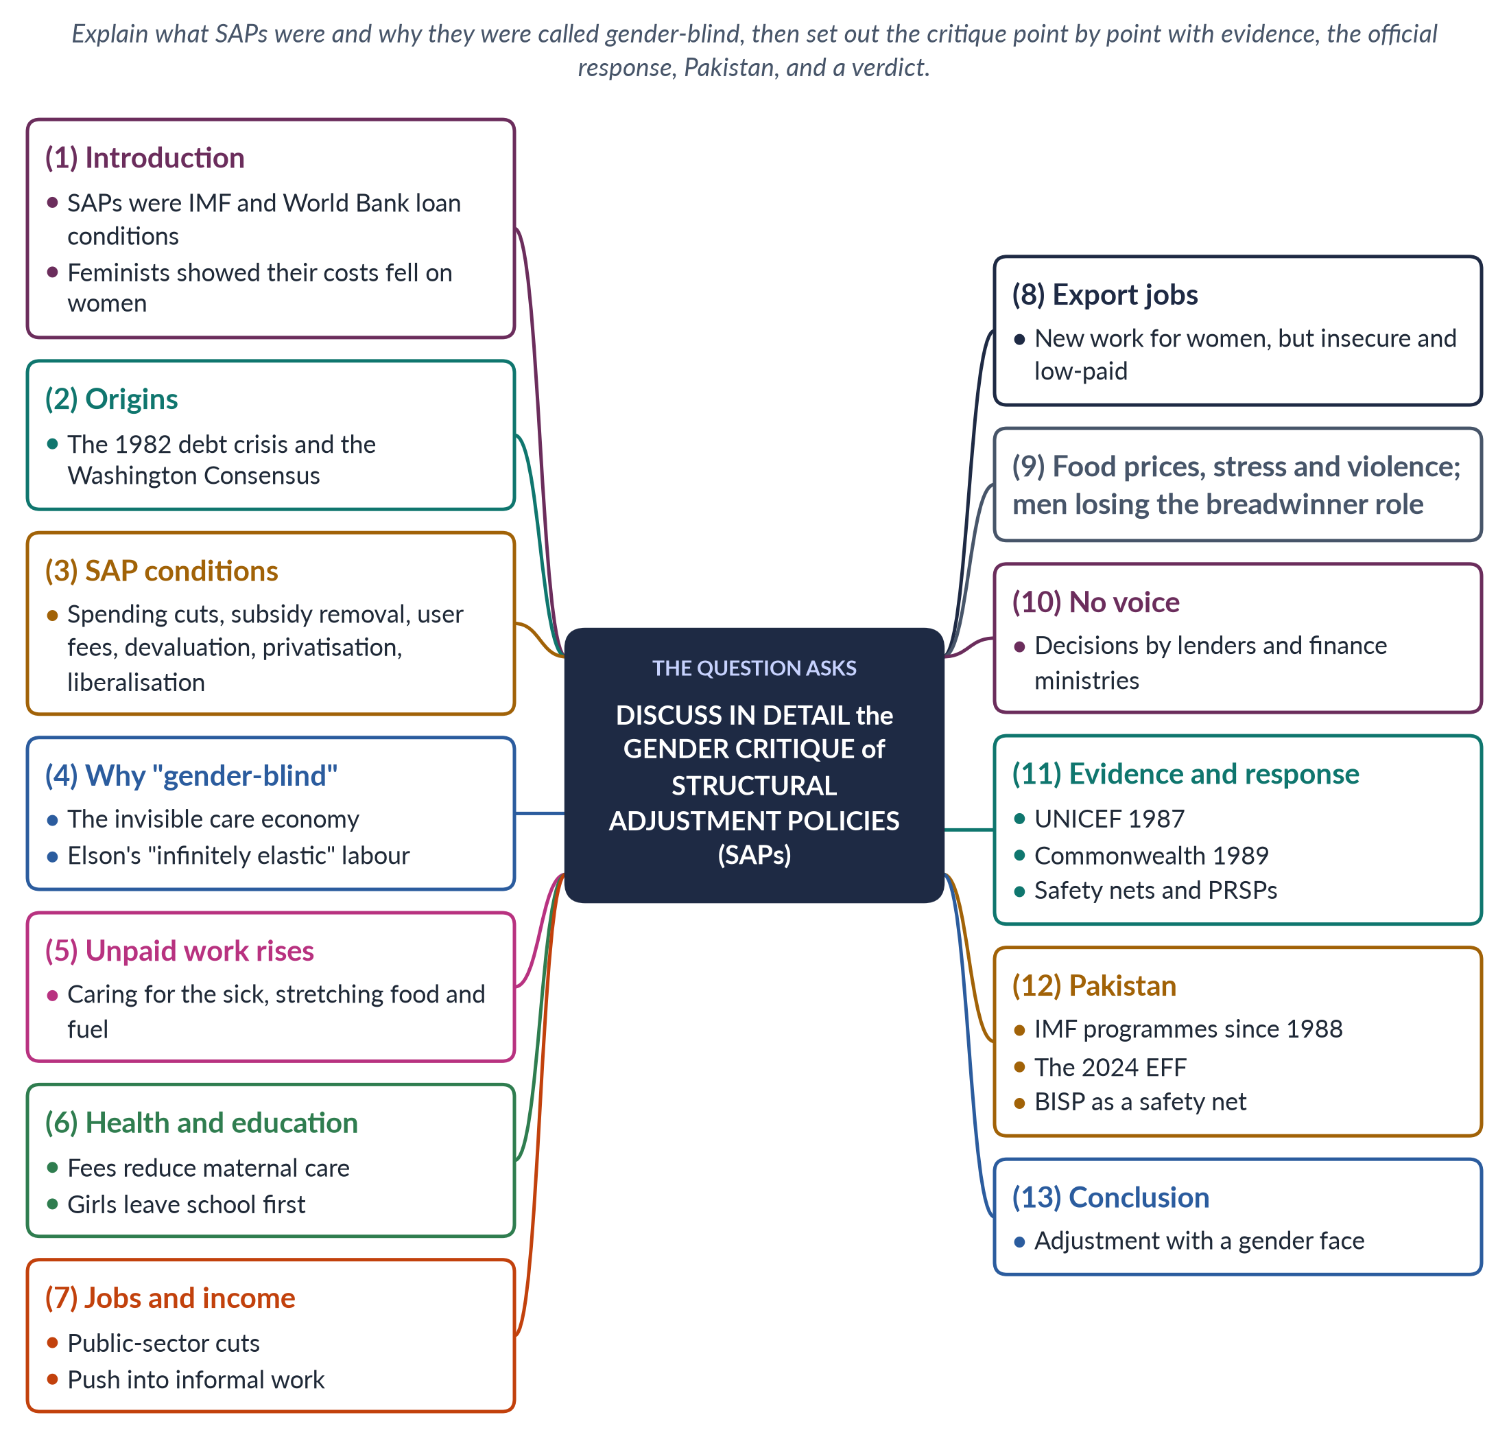
Figure 25 · The answer map: every branch is one numbered heading of the model answer below.

Decoding the question
"Discuss in detail the gender critique" asks you to set out, with evidence, what feminists and others said was wrong with SAPs from a gender point of view. Explain first what SAPs were, then give the critique point by point (each a sub-heading), then note the evidence, the official response, Pakistan's experience and a balanced verdict.

The model answer

1. Introduction

i) Definition
Structural Adjustment Programmes (SAPs) were packages of economic reforms that the IMF and World Bank required from developing countries in return for loans, especially in the 1980s and 1990s.

ii) The argument
SAPs were designed as if they were gender-neutral, but feminist economists showed that they shifted the costs of adjustment onto women — above all onto their unpaid work — while giving women no voice. The critique changed how development institutions talk about social protection, though the core policies changed less.

2. Origins
In 1982 Mexico announced that it could not pay its debts, starting a debt crisis across Latin America, Africa and Asia. Lenders required reforms that the economist John Williamson later (1989) called the "Washington Consensus": fiscal discipline, market liberalisation and privatisation. The aim was to cut deficits, control inflation and earn foreign exchange to repay debt — goals set in Washington, not in the borrowing countries.

3. SAP conditions
Table 5 · The main SAP conditions.
Condition | What it meant
Cut government spending | Less for health, education, food subsidies and public jobs
Remove subsidies | Food, fuel and electricity prices rise
User fees | Charges for clinics and schools
Devaluation | Imported food and medicine become dearer
Privatisation | State firms sold; public jobs cut
Trade and financial liberalisation | Tariffs removed; exports promoted
Labour deregulation | Weaker job protection; "flexible" labour

4. Why SAPs were called "gender-blind"

i) The invisible economy
SAPs treated the economy as markets plus the state. They ignored the household, where unpaid care keeps people alive. When the state withdrew, households had to fill the gap — and inside households the extra work fell on women.

ii) Elson's critique
Diane Elson (Male Bias in the Development Process, 1991) argued that adjustment policies contain male bias: they assume women's unpaid labour can expand without limit — as if it were "infinitely elastic" — to absorb the costs of cuts.

5. Unpaid work rises
When hospitals charged fees or discharged patients early, women cared for the sick at home. When subsidies ended, women spent more time stretching food and fuel, walking farther for cheaper goods, and queuing. The saving to the state was paid for with women's time. Because that time is unpaid and uncounted, official statistics showed the savings but not the cost — a gap that feminist economists set out to measure through time-use surveys.

6. Health and education

i) Women's health
Health spending cuts and user fees reduced women's use of maternal health services; in some countries maternal deaths rose. Women also delayed treatment for themselves so that children or husbands could be treated first.

ii) Girls' schooling
School fees and household poverty led families to withdraw girls first — to save money and to help with extra housework.

7. Jobs and income

i) Public-sector cuts
Cuts removed jobs in teaching, nursing and administration, where many women were employed.

ii) Informal work
To make up lost income, women moved into informal work — petty trade, home-based production, domestic service — with low pay and no protection. Their earnings kept households afloat but were invisible in official accounts.

8. Export jobs
Export promotion created jobs for women in garments, electronics and flowers. But they were often low-paid, insecure and without labour rights, in export zones where unions were discouraged. Adjustment used women's cheap labour to earn foreign exchange. Women gained income, but on terms that left them without security when orders fell.
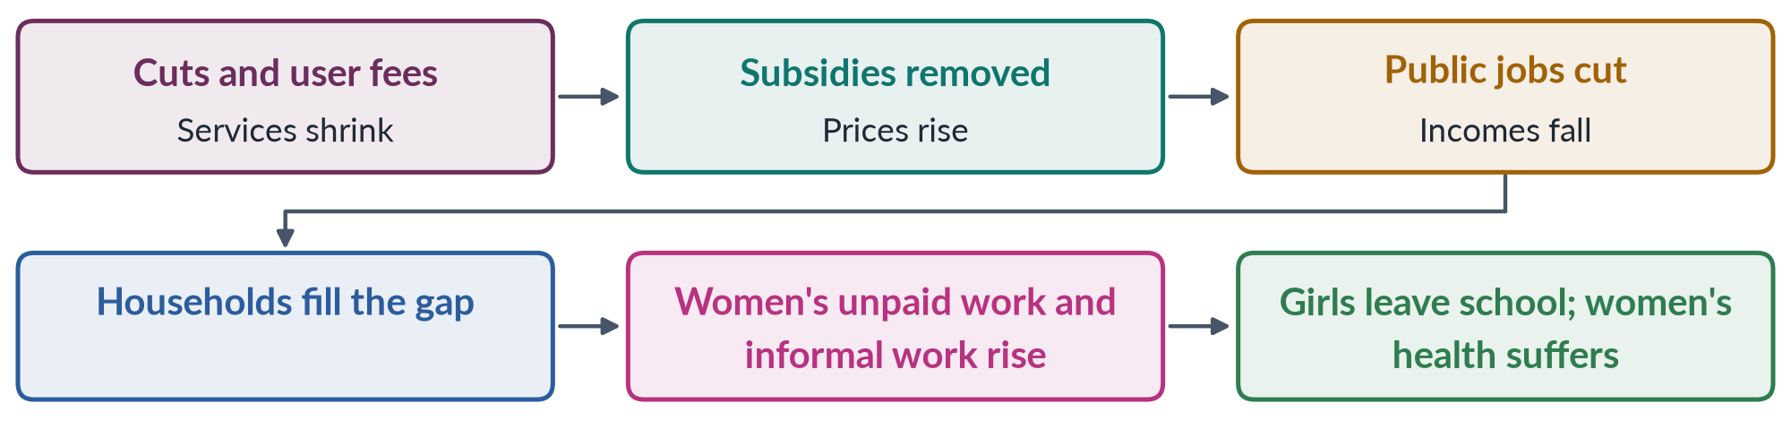
Figure 26 · How structural adjustment shifted costs onto women.

9. Food prices, stress and violence
Removal of food subsidies hit poor women responsible for feeding families. Economic stress was linked with rising domestic tension and violence. Where men lost jobs and the breadwinner role, more of the burden of survival fell on women, who often combined several informal jobs with all the housework.

10. No voice
SAPs were negotiated by finance ministries and lenders. Women — and the social ministries that served them — had no say in decisions that reshaped their lives. Budgets were judged by deficits and growth, never by their effect on women's time, health or income.

11. The evidence and the response

i) Evidence
UNICEF's Adjustment with a Human Face (Cornia, Jolly and Stewart, 1987) documented harm to children and women. The Commonwealth Secretariat's Engendering Adjustment for the 1990s (1989) showed the burden on women. DAWN (1985) put the debt crisis at the centre of its critique.

ii) Response
The IMF and World Bank added social safety nets, then Poverty Reduction Strategy Papers (1999) and gender language. Critics argue that the core conditions — austerity, liberalisation — changed little, and that safety nets treat women as vulnerable recipients rather than as citizens with rights to public services.

12. The Pakistan angle

i) Adjustment in Pakistan
Pakistan's first IMF structural adjustment programme began in 1988; many followed, including a Stand-By Arrangement (2023) and a 7-billion-dollar Extended Fund Facility (2024). Typical conditions include higher electricity and gas prices, wider sales tax and restrained development spending.

ii) Gendered effects
Women who manage household budgets feel price rises first; pressure on health and education increases their unpaid care; and informal work grows. Sales tax on essentials falls heavily on poor households, while cuts to development spending delay water schemes and clinics that save women's time.

iii) Protection
The Benazir Income Support Programme (2008), which pays cash to women, has been expanded during IMF programmes — a partial answer to the gender critique, though cash cannot replace public services.

13. Conclusion
The gender critique showed that SAPs were not neutral: they transferred the costs of adjustment from the state to women's unpaid labour, harmed women's health and girls' schooling, pushed women into insecure work, and excluded them from decisions. The critique does not deny that economies sometimes need stabilisation; it insists that stabilisation must be gender-assessed — protecting health, education and social protection, using progressive taxes and counting unpaid care. In UNICEF's phrase, adjustment needs a human face — and that face is very often a woman's.

Why this answer scores
- Explains SAPs and the idea of gender blindness before the critique.
- The critique is set out point by point, each with a sub-heading.
- Evidence (Elson, UNICEF, Commonwealth, DAWN) and the official response make it detailed and balanced.
- A table, a flow figure and a Pakistan section (1988 to 2024; BISP) complete it.

Answer 14 · The Colonial and Capitalistic Perspectives of Gender (CSS 2023)
AT A GLANCE · CSS 2023 · Q6 · 20 MARKS
Write a detailed note on the colonial and capitalistic perspectives of gender.

The answer map
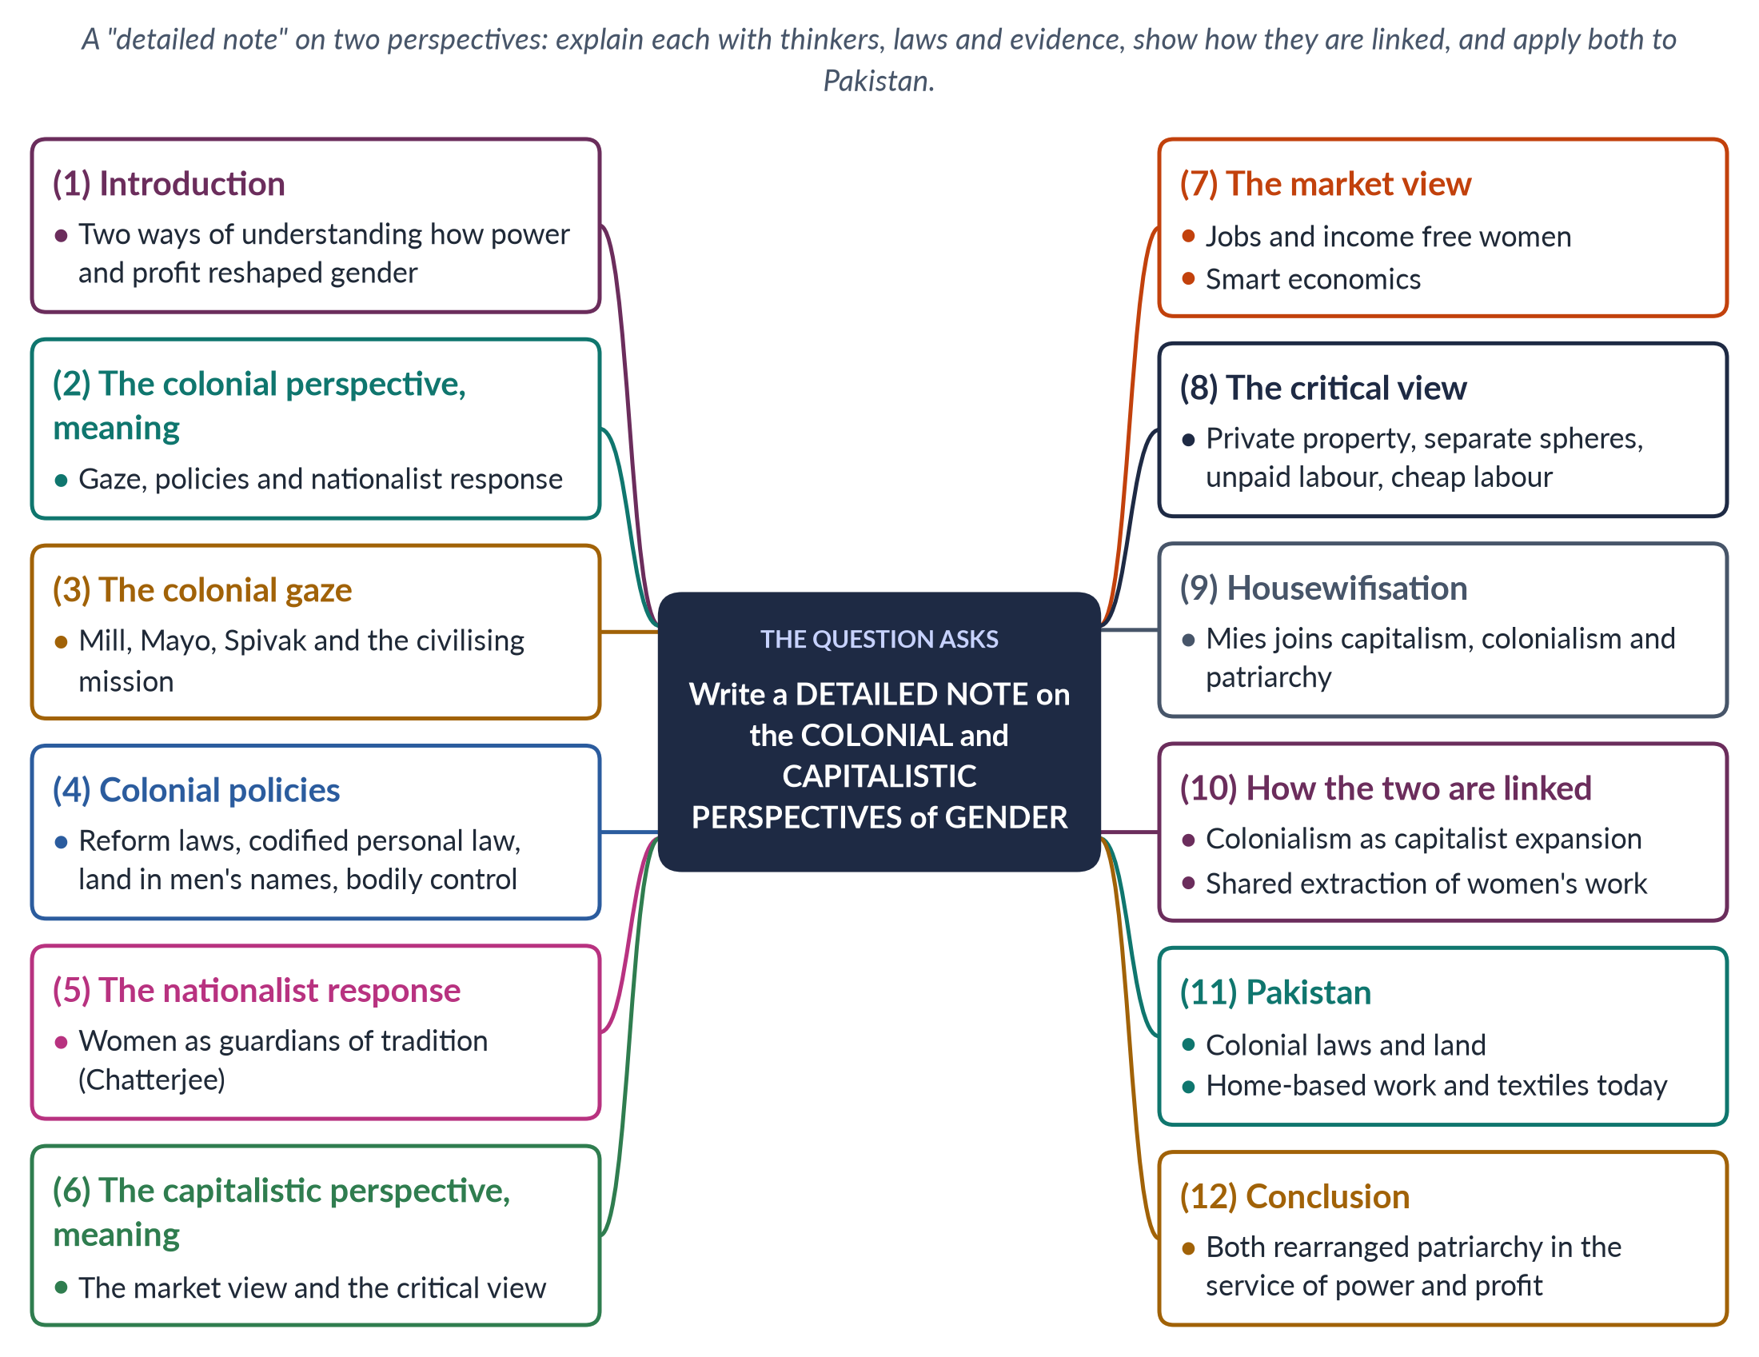
Figure 27 · The answer map: every branch is one numbered heading of the model answer below.

Decoding the question
"Write a detailed note" asks for a full, organised explanation — not a list. There are two perspectives: give each its meaning, thinkers, evidence and critique, then show how they are linked (the examiner put them together for a reason), and apply them to Pakistan. (In 2024 the same pair returned with an added thesis on coloniality — Answer 15.)

The model answer

1. Introduction

i) Definition
The colonial perspective of gender examines how colonial rulers saw, judged and changed gender relations in the societies they ruled. The capitalistic perspective examines how capitalism — private property, markets, wage labour and profit — shapes and depends on gender relations.

ii) The argument
Both perspectives show that gender arrangements are not simply "traditional" or "natural" but have been reshaped by power and profit. Colonialism rearranged patriarchy to serve imperial rule; capitalism rearranged it to serve accumulation. The two were closely linked, and both left legacies that shape women's lives in Pakistan today.

2. The colonial perspective — meaning
The colonial perspective has three parts: the colonial gaze (how colonisers described colonised women and men); colonial policies (laws, land, economy, education); and the nationalist response (how colonised societies reacted, often by making women symbols of identity).

3. The colonial gaze
The British historian James Mill (The History of British India, 1817) made women's status the measure of civilisation and judged India low. Katherine Mayo's Mother India (1927) portrayed Indian women as helpless victims — Gandhi called it "a drain inspector's report". Gayatri Spivak (1988) summed up the attitude as "White men are saving brown women from brown men". This gaze justified colonial rule as a "civilising mission". The historian Lata Mani showed that in the sati debate, women were the "ground" on which British and Indian men argued, not speakers in their own right.

4. Colonial policies

i) Reform laws
The ban on sati (1829), the Hindu Widows' Remarriage Act (1856), the Age of Consent Act (1891) and the Sarda Act (1929) gave some protection — mostly after campaigns by Indian reformers.

ii) Codified personal law
Codifying religious and customary law with male scholars and landlords created rigid, patriarchal "tradition". The Punjab Laws Act (1872) put custom before Islamic law, so many Muslim women lost their inheritance.

iii) Land and economy
Land settlements recorded land in men's names, so women's customary rights of use were lost. Cheap machine cloth from Britain destroyed much of the spinning and weaving that gave women income.

iv) Bodies
The Contagious Diseases Acts (1864–68) forced medical examination on women near army bases; the Criminal Tribes Act (1871) criminalised hijras.

5. The nationalist response
Partha Chatterjee (1989) showed that nationalists divided life into an outer material world, where the West could be copied, and an inner spiritual world of home, which women were to guard. Muslim reformers such as Nazir Ahmad (1869) and Mumtaz Ali (1898) promoted girls' education within family values. Women became symbols of honour and identity — a legacy still visible in debates about dress and the Aurat March. Reform was accepted when framed as protecting the nation's or community's women, not as women's own freedom.

6. The capitalistic perspective — meaning
There are two broad capitalistic perspectives. The liberal/market view sees capitalism as potentially freeing women through jobs and income. The critical (Marxist and socialist-feminist) view sees capitalism as depending on women's unpaid and cheap labour.

7. The market view
Markets reward skills, not sex; paid work gives women independent income and bargaining power, and can loosen family control over their choices of marriage and movement. The World Bank's World Development Report 2012 called gender equality "smart economics". Export jobs in Bangladesh gave many young women their first income (Naila Kabeer, 2000). Critics reply that smart economics values women as instruments of growth (Chant and Sweetman, 2012), and adds paid work to women's day without reducing their unpaid care.

8. The critical view

i) Private property
Engels (1884) traced women's subordination to private property and men's control of inheritance — "the world historical defeat of the female sex".

ii) Separate spheres
Industrial capitalism separated paid work (public, male) from unpaid domestic work (private, female), creating the male breadwinner ideal.

iii) Unpaid labour
Housework cooks, cleans and cares so that it produces the worker for free (Benston, 1969; Dalla Costa and James, 1972) — social reproduction that capitalism needs but does not pay for.

iv) Cheap labour
Women are a reserve army and "secondary earners"; global firms seek young women as cheap labour in export zones (Standing, 1989).

9. Housewifisation
Maria Mies (Patriarchy and Accumulation on a World Scale, 1986) studied the lace makers of Narsapur, India, whose export work was counted as a housewife's leisure activity and paid very little. She called this "housewifisation" and argued that capitalism, colonialism and patriarchy form one system of accumulation — joining the two perspectives in one theory.
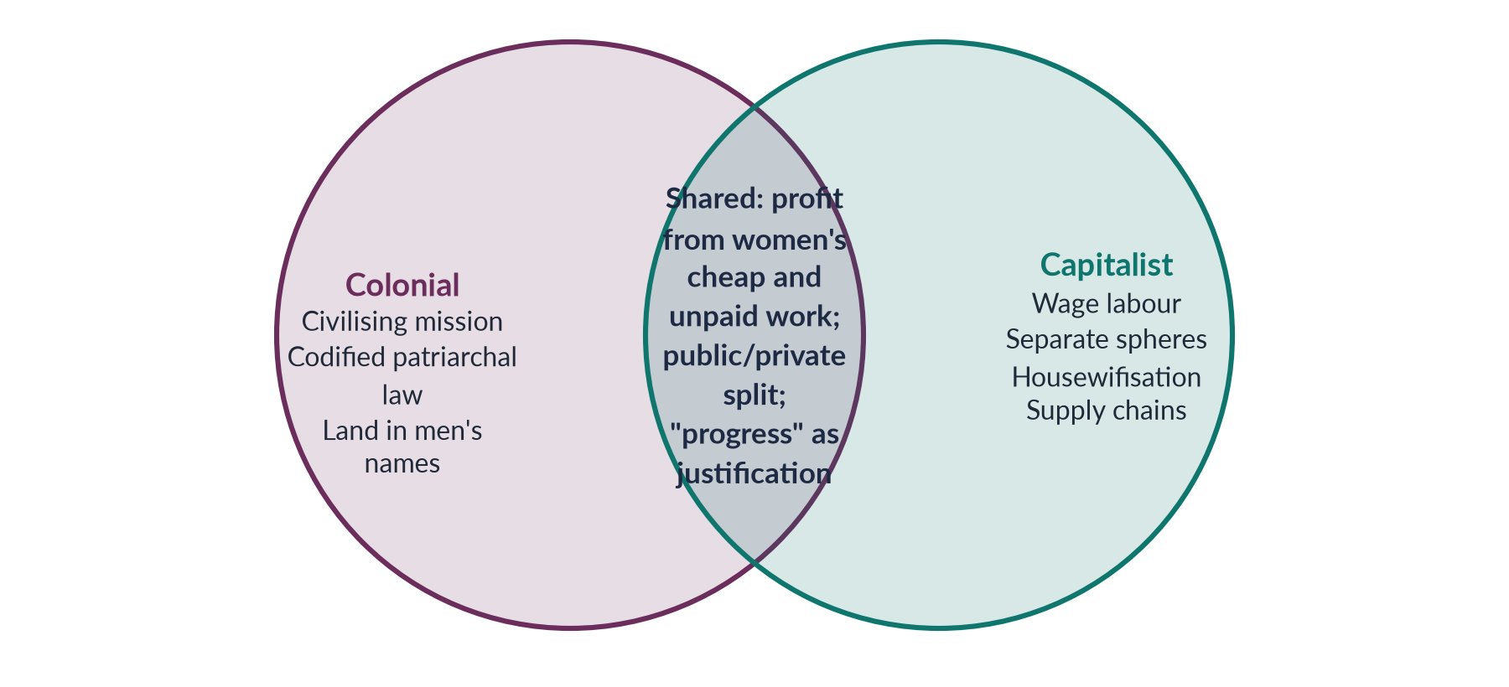
Figure 28 · How the colonial and capitalistic perspectives overlap.

10. How the two are linked
1. Colonialism was capitalist expansion — the East India Company was a profit-seeking firm.
2. Both created a public/private split and a male breadwinner ideal.
3. Both extracted value from women's cheap or unpaid work — in crafts, plantations and homes.
4. Both used ideas of "civilisation" and "progress" to justify their power — the civilising mission then, "development" and "modernisation" later.

11. The Pakistan angle

i) Colonial legacy
The Penal Code of 1860 remains the base of criminal law; customary denial of inheritance and very low land ownership by women echo colonial land records and the Punjab Laws Act.

ii) Capitalist present
Millions of women do home-based piece work for export chains — housewifisation today; Sindh's Home-Based Workers Act 2018 began to recognise them. The Ali Enterprises fire in Karachi (2012) exposed unsafe supply chains. Female labour-force participation is only 24.4%, and most working women are in agriculture or informal work, where both colonial property patterns and capitalist cheap-labour patterns meet.

12. Conclusion
The colonial perspective shows how empire rearranged patriarchy — through the gaze, codified law, land and bodily control — and how nationalism made women symbols of identity. The capitalistic perspective shows how capitalism both offers women paid work and depends on their unpaid and cheap labour. Together, as Mies argued, they reveal gender as shaped by power and profit — and point to reforms in law, property, labour rights and the valuing of care.

Why this answer scores
- A truly detailed note: each perspective has meaning, thinkers, laws and evidence.
- Both market and critical capitalistic views are covered.
- The links between the perspectives are made explicit, with a Venn figure.
- Pakistani legacy and present-day evidence apply both.

Answer 15 · Colonial and Capitalistic Perspectives, and Development as the New Coloniality (CSS 2024)
AT A GLANCE · CSS 2024 · Q3 · 20 MARKS
Write a note on the colonial and capitalistic perspectives of gender. Throw light on the thesis that development is the new name of coloniality in the context of emerging perspectives of gender.

The answer map
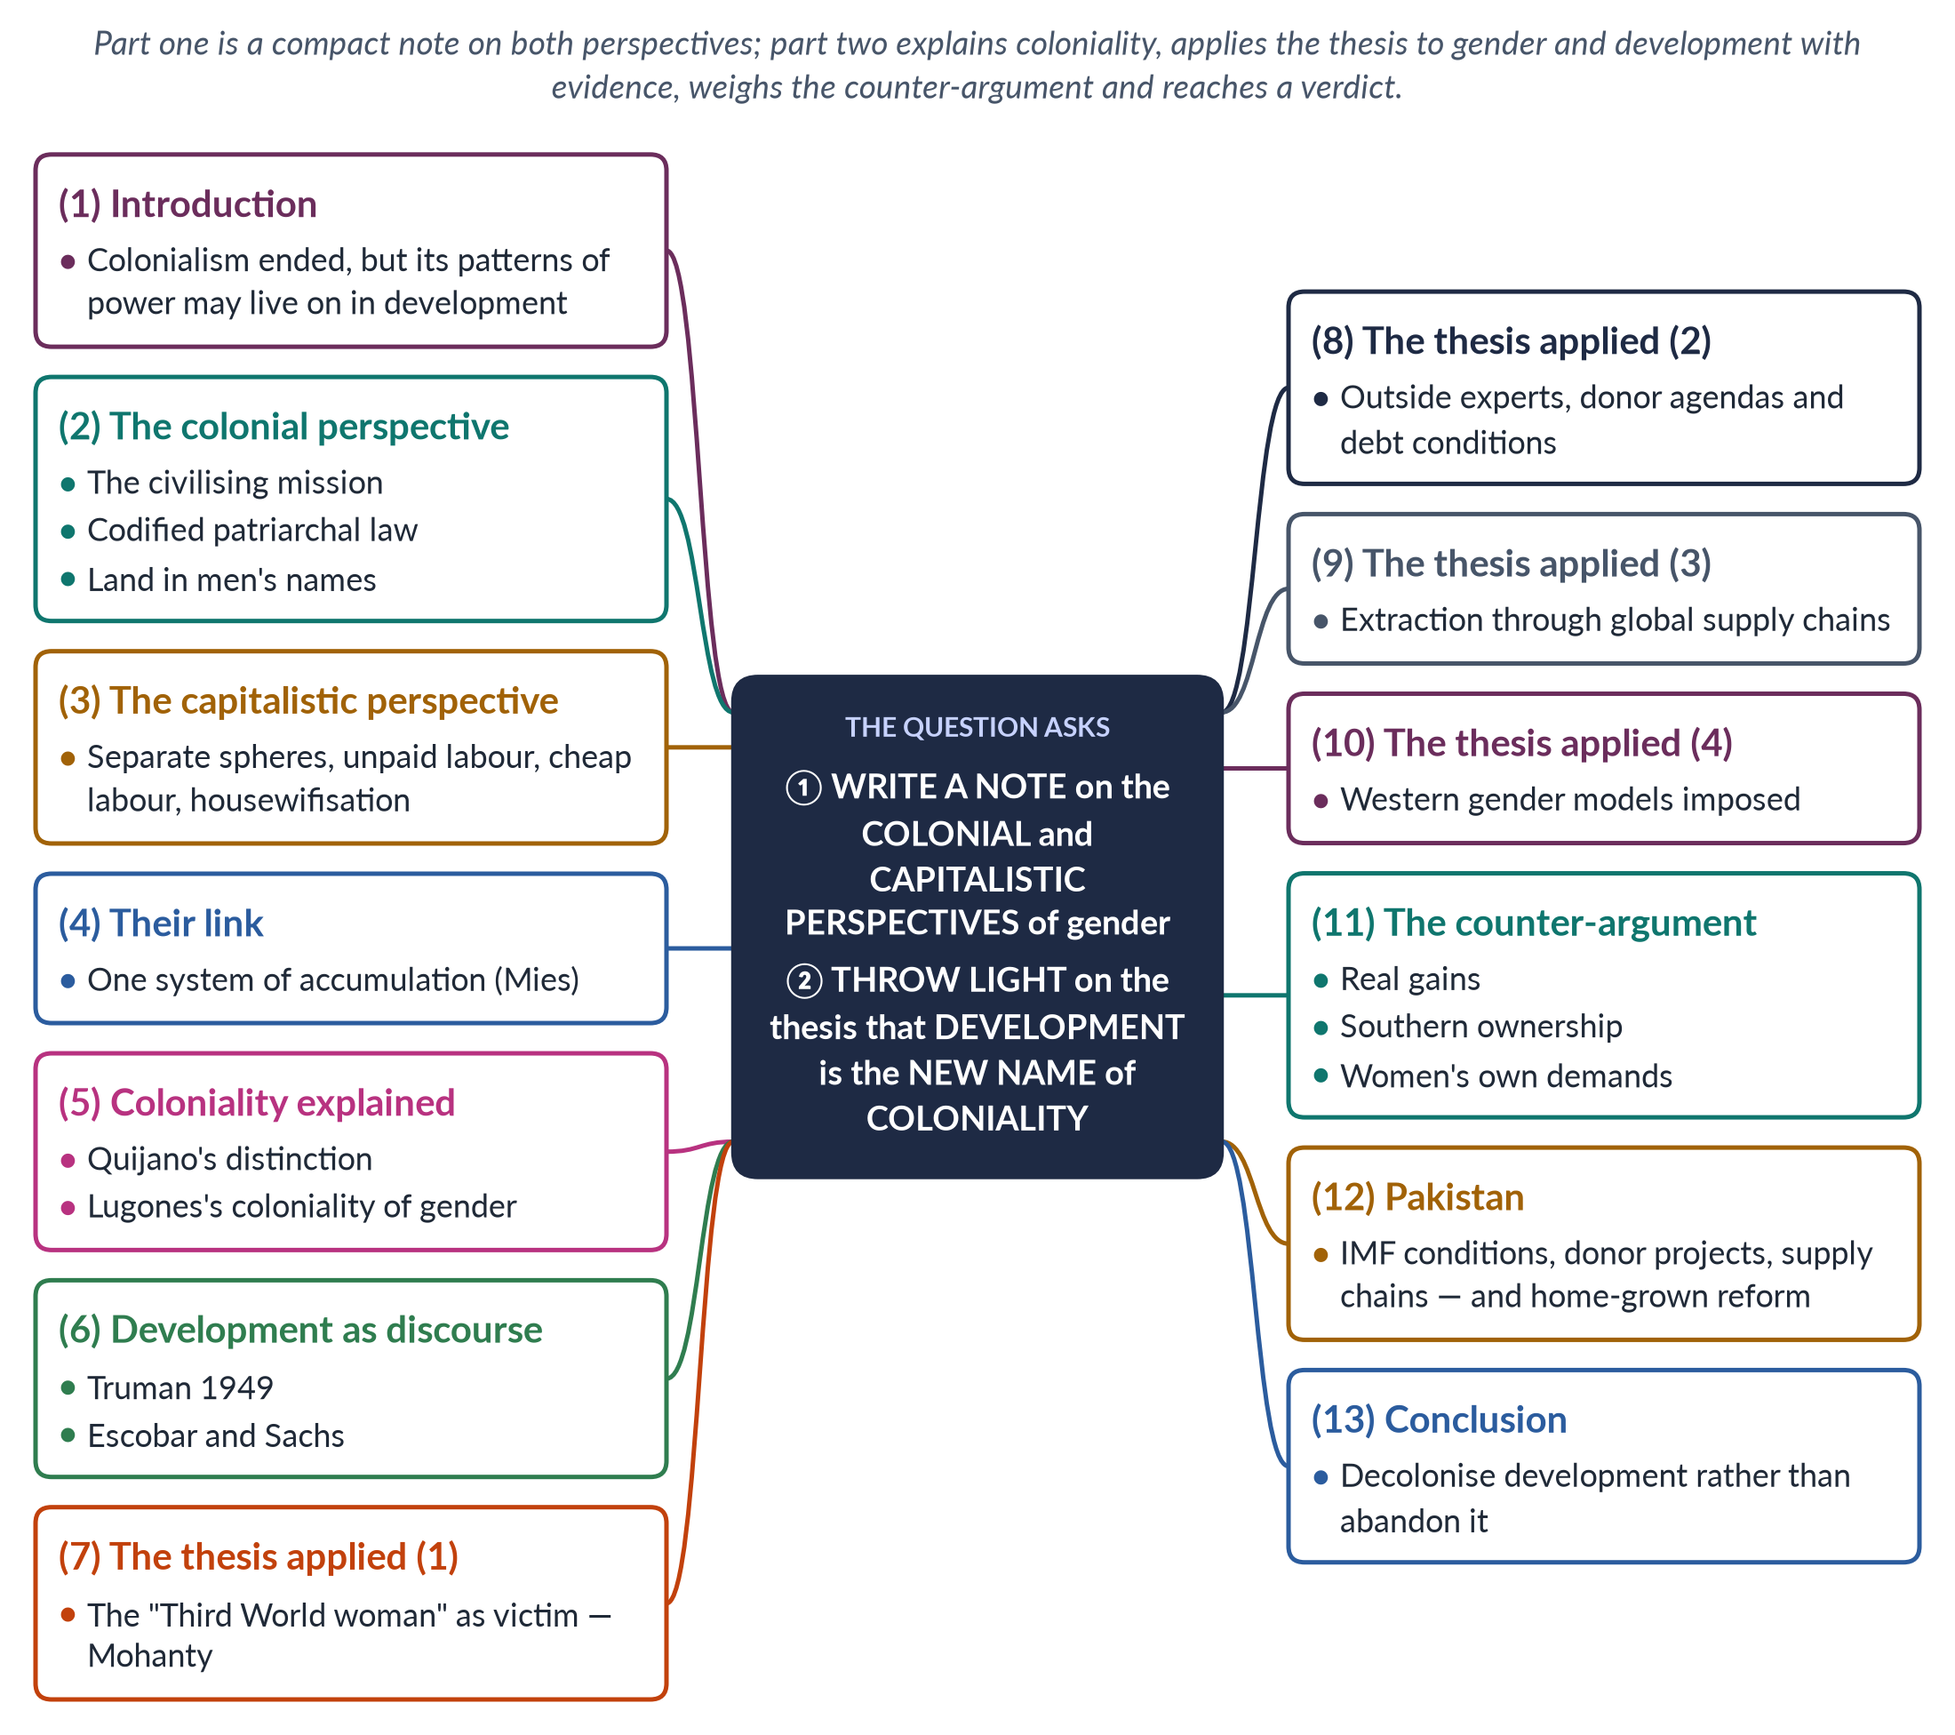
Figure 29 · The answer map: every branch is one numbered heading of the model answer below.

Decoding the question
Two limbs. "Write a note on the colonial and capitalistic perspectives" asks for a compact explanation of both (see Answer 14 for a fuller version). "Throw light on the thesis that development is the new name of coloniality in the context of emerging perspectives of gender" asks you to explain the thesis, apply it to gender, and weigh it. The "emerging perspectives" are decolonial and post-development feminism — name Quijano, Lugones, Escobar and Mohanty.

The model answer

1. Introduction

i) Definition
Colonialism was the formal rule of one country over another. Coloniality, a term of the Peruvian sociologist Aníbal Quijano (2000), refers to the patterns of power that colonialism created and that continue after independence — in the world economy, in racial and gender hierarchies, and in who controls knowledge.

ii) The argument
The colonial and capitalistic perspectives show how empire and markets reshaped gender for power and profit. The thesis that "development is the new name of coloniality" claims that development continues these patterns by other means. The thesis is partly true — development often reproduces colonial hierarchies — but development can also be owned and reshaped by the people it serves, especially women.

2. The colonial perspective
Colonial rulers justified empire as a "civilising mission", portraying colonised women as victims of backward cultures (James Mill, 1817; Katherine Mayo, 1927). They codified personal law in its most patriarchal forms — the Punjab Laws Act (1872) put custom before Islamic inheritance — recorded land in men's names, controlled women's bodies (the Contagious Diseases Acts) and criminalised hijras (1871). Nationalists, in turn, made women guardians of the inner world of tradition (Partha Chatterjee, 1989).

3. The capitalistic perspective
Industrial capitalism separated paid work (male, public) from unpaid domestic work (female, private). Capitalism depends on this unpaid social reproduction and on women as cheap, flexible labour. Maria Mies (1986) called the process "housewifisation": defining women as housewives so that even their productive work — like the lace makers of Narsapur — is paid little.

4. The link
Mies argued that colonialism, capitalism and patriarchy form one system of accumulation: colonies, nature and women are all treated as free or cheap resources. Colonialism was itself capitalist expansion, led by trading companies.

5. Coloniality explained

i) Quijano
Aníbal Quijano distinguished colonialism, which ended with independence, from the coloniality of power, which continues in a world economy centred on the West, in racial hierarchies, and in the belief that Western knowledge is universal and superior.

ii) Lugones
María Lugones ("Heterosexualism and the Colonial/Modern Gender System", 2007) argued that colonialism imposed a European gender system — rigid binaries, the male-headed household, heterosexual norms — on peoples with different arrangements. She called this the coloniality of gender.

6. Development as a discourse
Scholars date the "development era" from US President Truman's speech of 20 January 1949, which named much of the world "underdeveloped". Arturo Escobar (Encountering Development, 1995) and Wolfgang Sachs (The Development Dictionary, 1992) argued that development is a discourse: it defines the South as lacking, makes Western experts the authorities, and turns local ways of life into problems to be fixed. This is the core of the thesis.

7. The thesis applied (1): the "Third World woman"
Chandra Talpade Mohanty ("Under Western Eyes", 1984) showed that development and feminist writing often portray the "Third World woman" as poor, ignorant, veiled and victimised — the same image the colonial gaze used to justify rule. The rescuer changes from the colonial officer to the aid worker. Lila Abu-Lughod ("Do Muslim Women Really Need Saving?", 2002) made the same point about the use of Afghan women's rights to justify intervention.

8. The thesis applied (2): experts, donors and debt

i) Outside expertise
Development priorities are often set by donors, consultants and international agencies — as policy was once set by colonial administrators. Local women appear as "beneficiaries" and "target groups", not as decision-makers.

ii) Debt conditions
Structural adjustment and IMF conditions give foreign lenders power over national budgets, cutting services women rely on (Diane Elson, 1991).

9. The thesis applied (3): extraction through supply chains
Global supply chains draw on cheap female labour in the South — garment workers, home-based stitchers, cotton pickers — while profits flow to firms in the North. The Rana Plaza collapse (Bangladesh, 2013) and the Ali Enterprises fire (Karachi, 2012) show the human cost. This mirrors the colonial extraction of raw materials and crafts.

10. The thesis applied (4): imposed gender models
Programmes may assume Western models of the family, of "empowerment" or of gender identity without asking local women — Lugones's coloniality of gender in a new form. Indicators designed abroad may count what donors value and miss what local women value, such as security within extended families or rights under religious law.
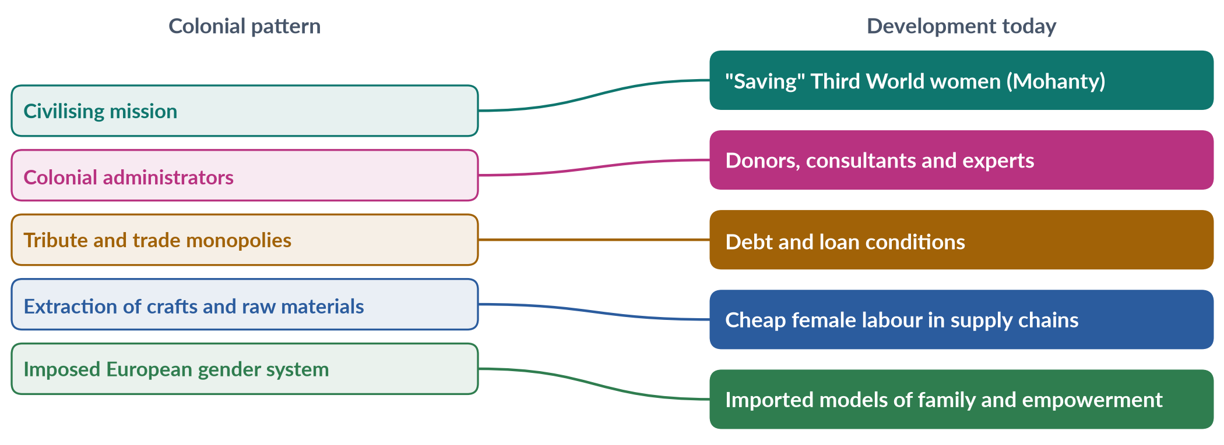
Figure 30 · How development can repeat colonial patterns — the thesis applied to gender.

11. The counter-argument

i) Real gains
Development has brought vaccines, schools, clean water, lower maternal and child mortality and rising incomes — gains women value.

ii) Southern ownership
Southern thinkers shaped development: the Pakistani economist Mahbub ul Haq created the Human Development Report (1990); DAWN (1984), a Southern women's network, shaped GAD and Beijing.

iii) Women's own demands
Women in the South demand education, health, safety and rights. Calling these "colonial" risks silencing them and defending local patriarchy. Conservative opponents of women's rights often use the language of anti-colonialism to reject reforms that women themselves have demanded.

12. The Pakistan angle

i) Evidence for the thesis
Repeated IMF programmes (most recently a 7-billion-dollar facility in 2024) shape budgets and prices; many gender projects have been donor-driven; women work at the bottom of global textile chains.

ii) Evidence against
Pakistan's key gender reforms — the MFLO (1961), the Protection of Women Act (2006), the honour-killing law (2016) and the child-marriage law (2025) — were won by Pakistani women's movements and legislators, often argued in Islamic and constitutional terms.

13. Conclusion
The colonial and capitalistic perspectives show that gender has long been reshaped by power and profit. The thesis that development is the new coloniality captures a real danger: development can repeat the colonial gaze, outside control, extraction and imposed models. But it is not the whole truth. Development becomes emancipatory when it is owned by local people — especially women — and when it addresses power, not only projects. The task is to decolonise development, not abandon it.

Why this answer scores
- Both limbs answered: a compact note on the two perspectives, then the thesis.
- The "emerging perspectives" are named and explained — Quijano, Lugones, Escobar, Sachs, Mohanty.
- The thesis is applied to gender in four ways and weighed against a counter-argument.
- A mapping figure and Pakistani evidence on both sides lead to a reasoned verdict.

Answer 16 · A Critical Gender Analysis of Development Theories (CSS 2024)
AT A GLANCE · CSS 2024 · Q5 · 20 MARKS
Give a critical gender analysis of development theories.

The answer map
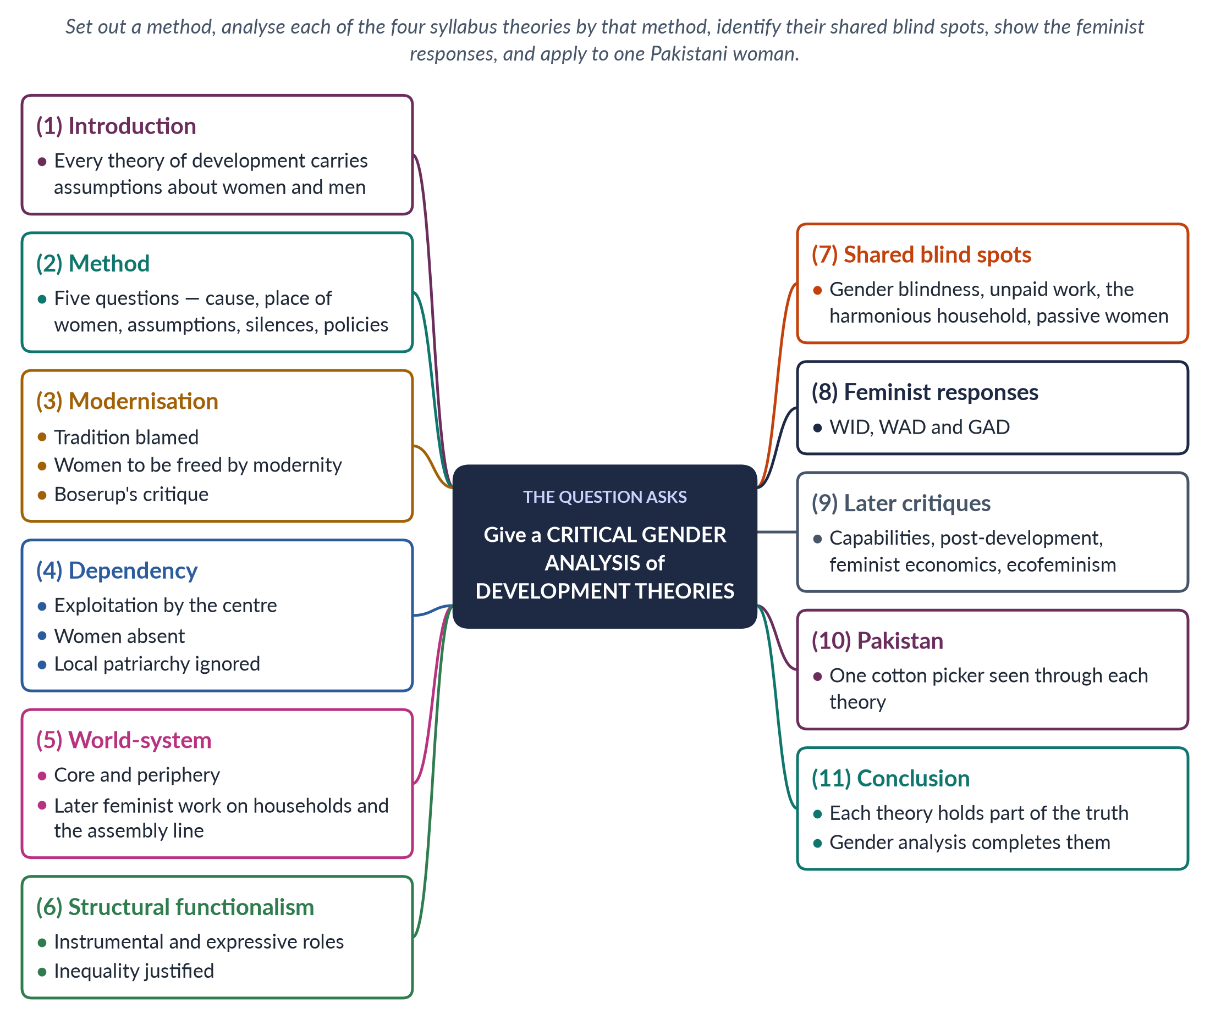
Figure 31 · The answer map: every branch is one numbered heading of the model answer below.

Decoding the question
"Give a critical gender analysis of development theories" asks you to examine the main theories — the syllabus names modernisation, dependency, world-system and structural functionalism — asking what each says and assumes about women and men, what it leaves out, and what its policies do to gender relations. "Critical" means judging strengths and weaknesses. A consistent method applied to each theory, a comparison, and an example make the answer analytical rather than descriptive.

The model answer

1. Introduction

i) Definition
A development theory explains why some societies are rich and others poor, and how the poor can develop. A critical gender analysis asks what each theory assumes about women and men, what it hides, and whose interests it serves.

ii) The argument
All four classic theories began gender-blind. Each captures part of the truth — culture, global structures, institutions — but none saw women's unpaid work, power inside households or women's agency. Feminist scholarship exposed these blind spots and produced new approaches.

2. The method
Each theory is analysed by five questions: (1) what causes poverty; (2) where women appear; (3) what it assumes about family and work; (4) what it is silent about; and (5) what its policies do to gender relations.

3. Modernisation theory

i) The theory
W. W. Rostow (The Stages of Economic Growth, 1960) argued that societies pass from traditional to high mass consumption through five stages. Poverty is caused by internal tradition; the cure is industry, cities, education and Western values.

ii) Gender analysis
Women appear as mothers and victims of tradition, to be freed by modernity; benefits "trickle down" through the male breadwinner. Ester Boserup (1970) showed the opposite often happened: modernisation gave land, machines and credit to men, and marginalised women farmers. The theory blames culture and ignores structures, and holds up the West — which had its own patriarchy — as the model of equality.

4. Dependency theory

i) The theory
Prebisch, Frank ("the development of underdevelopment", 1966) and Rodney argued that poverty is produced by colonialism and unequal trade between centre and periphery.

ii) Gender analysis
It moves attention from culture to global structures, and helps explain why poor women do the cheapest work and why debt leads to cuts in the services women rely on. But it is gender-blind — it speaks of nations and classes — and it ignores local patriarchy and the unpaid subsistence work of women that subsidises cheap exports (Maria Mies, 1986).

5. World-system theory

i) The theory
Immanuel Wallerstein (1974) described one capitalist world-economy divided into core, semi-periphery and periphery.

ii) Gender analysis
At first it too ignored gender. Feminist extensions showed that households combine wages with unpaid work, allowing employers to pay below a living wage (Smith and Wallerstein, 1992), and that global firms rely on a global assembly line of young women (Fuentes and Ehrenreich, 1983). Its strength is to show that women's cheap and unpaid labour is not marginal but central to global capitalism. Its weakness is to portray women as victims of a global machine, overlooking their organising and the ways paid work can increase their bargaining power (Naila Kabeer, 2000).

6. Structural functionalism

i) The theory
Talcott Parsons and Robert Bales (1955) argued that the family is stable when the husband plays the instrumental role (breadwinner) and the wife the expressive role (carer).

ii) Gender analysis
It presents the gender division of labour as functional and natural, and so justifies inequality. It ignores power, conflict and women's economic work, and reflects 1950s middle-class America. It shaped development planning that treated men as producers and women as homemakers — for example, extension services that trained men as farmers and offered women only cooking classes. Its concept of socialisation remains useful for explaining how gender roles are learnt.
Table 6 · The four theories — a critical gender analysis.
Theory | Cause of poverty | View of women | Main gender critique | What it still offers
Modernisation (1960) | Internal tradition | Freed by modernity; mothers | Blames culture; men captured benefits | Education and media widen choices
Dependency (1966) | External exploitation | Absent | Gender-blind; ignores local patriarchy | Explains cheap female labour
World-system (1974) | Unequal world economy | Absent, then assembly line | Women as victims | Gendered globalisation
Functionalism (1955) | Incomplete modernisation | Expressive homemakers | Justifies inequality | Institutions, socialisation

7. Shared blind spots
1. Gender blindness — "society", "the economy" and "the nation" treated as gender-neutral.
2. Unpaid work invisible — none counted care and subsistence work (Marilyn Waring, 1988).
3. The harmonious household — all assumed income is shared fairly; Amartya Sen's "cooperative conflict" (1990) and Bina Agarwal's bargaining model show households are sites of bargaining.
4. Women as passive — victims or homemakers, rarely actors.
5. Male-centred progress — measured by industry, cash crops and formal jobs.

8. The feminist responses
The critique of these theories produced three approaches. WID (1970s) answered modernisation by integrating women into development; WAD (late 1970s), drawing on dependency and Marxism, argued women were integrated on exploitative terms; GAD (1980s) focused on transforming gender relations of power, with tools such as practical and strategic needs and empowerment (Kabeer, 1999).

9. Later critiques
Capabilities thinking (Sen; Martha Nussbaum, 2000) judges development by people's real freedoms; post-development and decolonial writers (Escobar, 1995; Mohanty, 1984) question development itself; feminist economics counts care; ecofeminism and feminist environmentalism (Agarwal, 1992) link gender and nature.

10. Pakistan: one cotton picker
A woman picking cotton in southern Punjab illustrates the theories. Modernisation would blame her lack of education and traditional norms. Functionalism would call her a homemaker who "helps" in the fields. Dependency would point to low world cotton prices. World-system analysis would place her at the bottom of a global textile chain. A gender analysis adds what all of them miss: she does most unpaid care, owns no land, may not control her wages, and has no labour protection — and that she may be organising with other women. With female labour-force participation at 24.4%, her case is typical, not exceptional.

11. Conclusion
Each development theory captures part of the truth: culture matters (modernisation), institutions shape roles (functionalism), and global structures exploit poor countries (dependency and world-system). But all began blind to gender relations, unpaid work and women's agency. A critical gender analysis does not discard these theories; it completes them — joining the local and the global, the cultural and the structural, and asking always who works, who owns and who decides.

Why this answer scores
- A clear five-question method applied consistently to all four theories.
- A comparison table and a list of shared blind spots make the analysis critical.
- The feminist responses and later critiques show the field's development.
- A single Pakistani case seen through each theory makes the analysis concrete.

Answer 17 · Gendered Globalisation, World-System Theory and New Patriarchal Power (CSS 2025)
AT A GLANCE · CSS 2025 · Q3 · 20 MARKS
Critically evaluate the concept of 'gendered globalisation', focusing on World-System Theory and how the globalisation of capitalism has created new forms of patriarchal power that increase gender inequalities.

The answer map
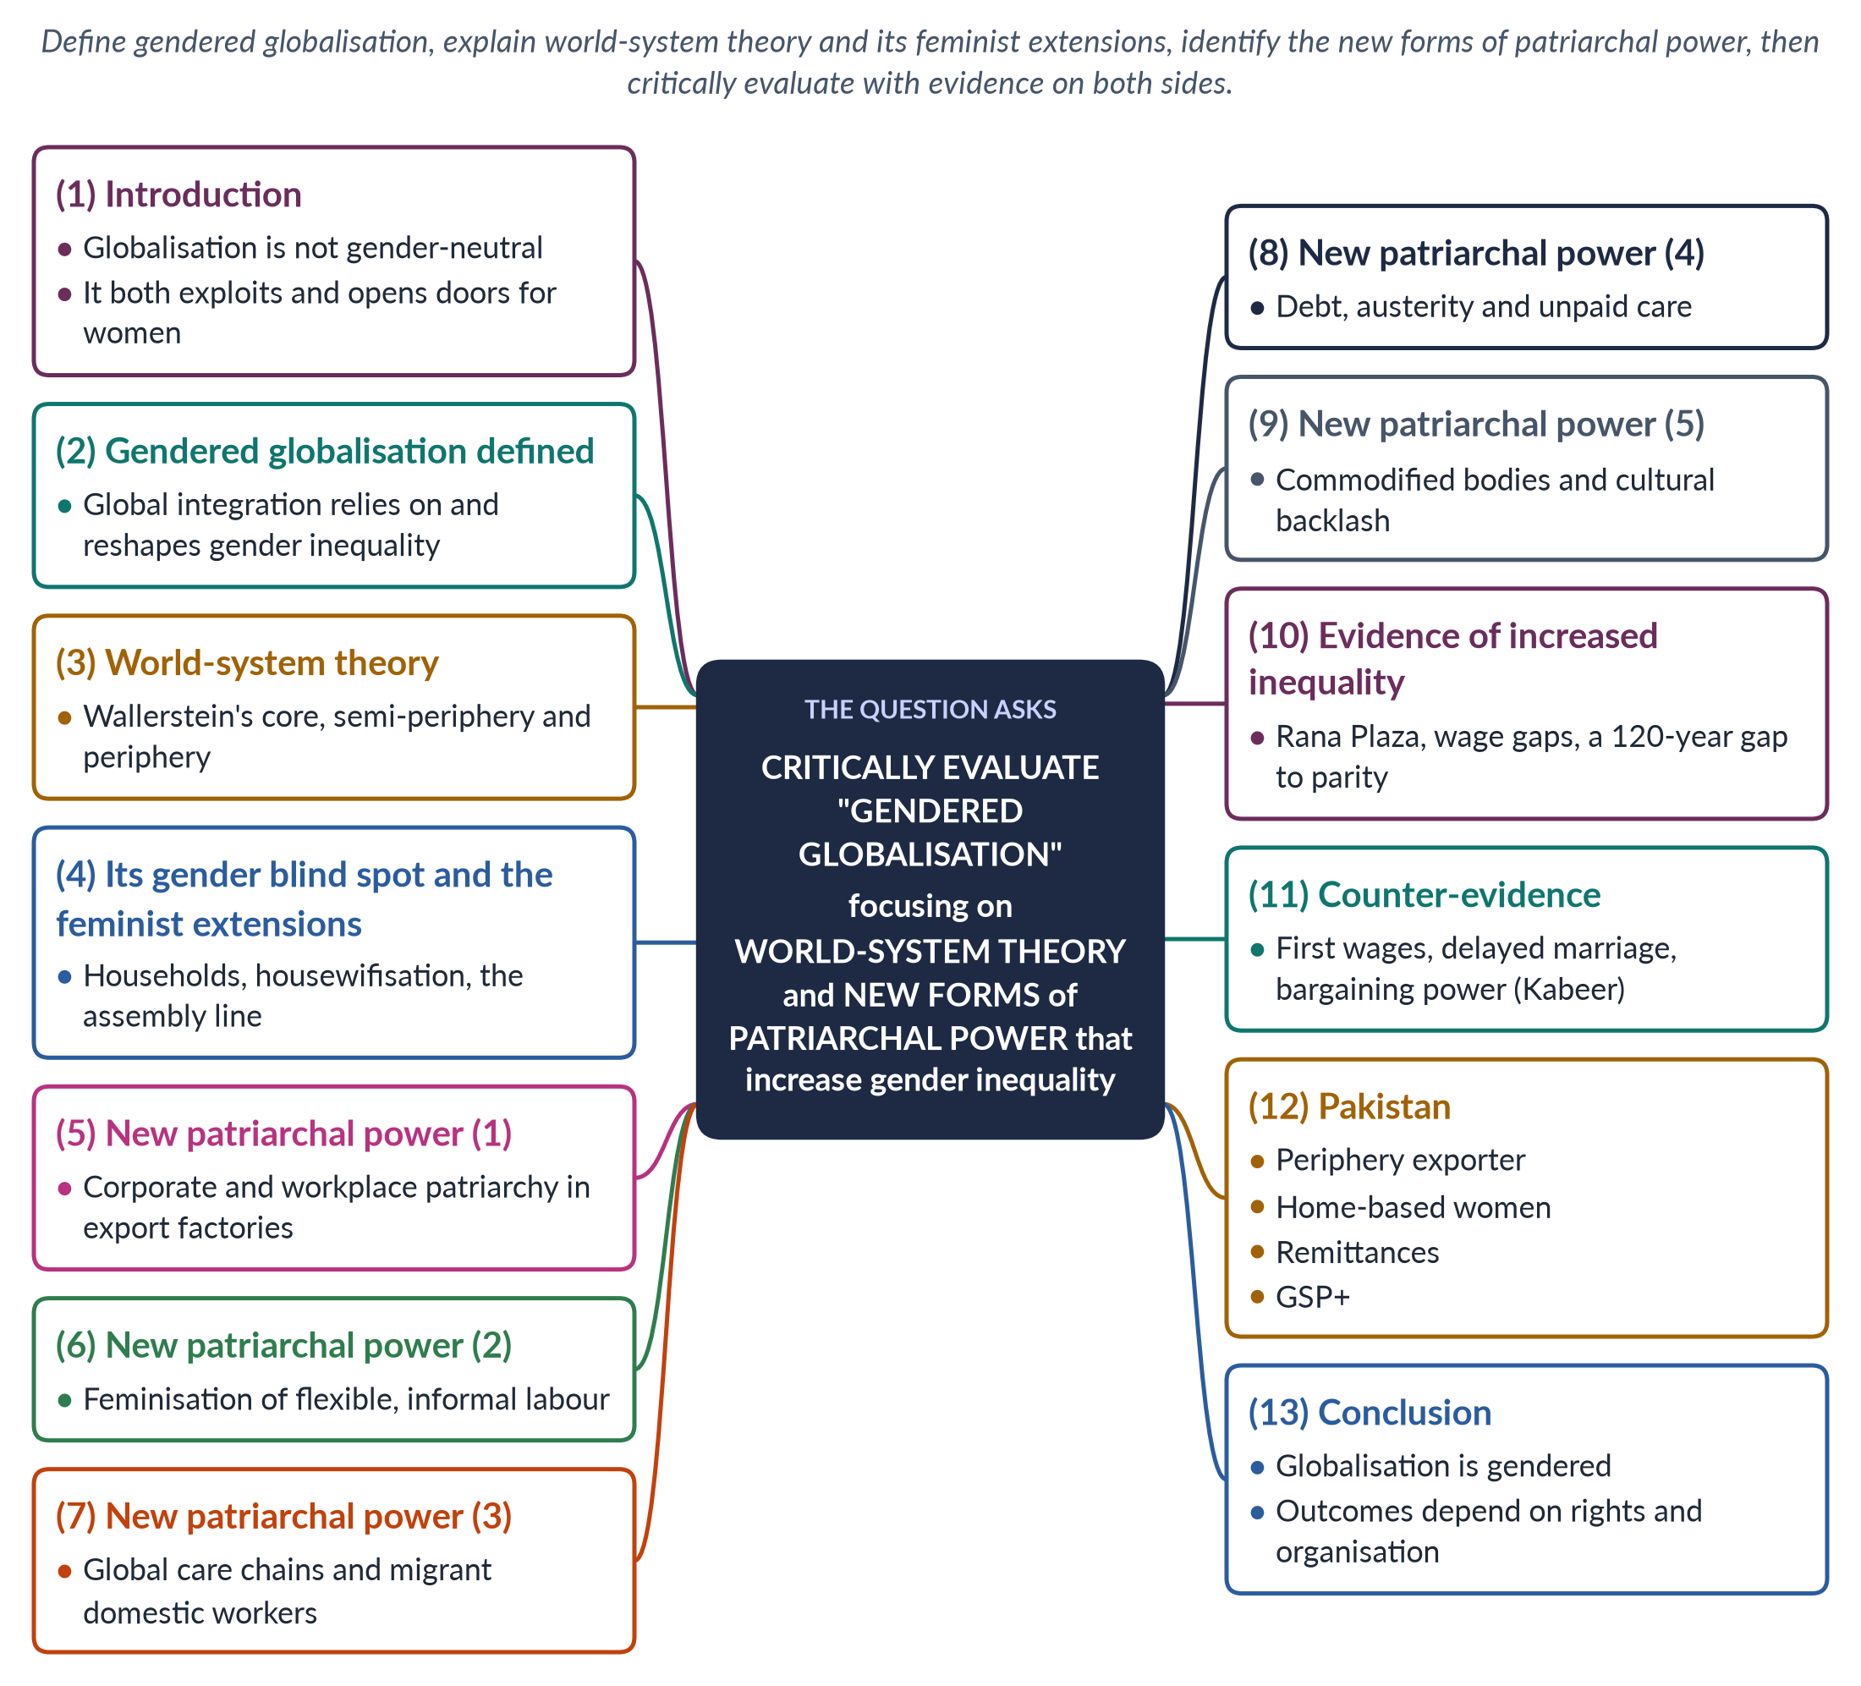
Figure 32 · The answer map: every branch is one numbered heading of the model answer below.

Decoding the question
"Critically evaluate" asks you to judge a concept: explain gendered globalisation, use world-system theory as the lens (it is named), show how global capitalism has created new forms of patriarchal power, and then weigh the claim that these increase gender inequality against evidence that globalisation also empowers some women. Name the feminist scholars who gendered world-system theory.

The model answer

1. Introduction

i) Definition
Globalisation is the integration of economies and societies through trade, investment, finance, technology and migration. Gendered globalisation is the idea that this integration relies on, reshapes and often deepens gender inequality — while also creating some new opportunities for women.

ii) The argument
World-system theory, once extended by feminists, shows that global capitalism depends on women's cheap and unpaid labour at the periphery. Globalisation has produced new forms of patriarchal power — in factories, labour markets, migration, debt and culture. Yet the evidence also shows gains for some women. The claim is therefore largely true but incomplete.

2. Gendered globalisation defined
Globalisation is "gendered" in three senses: it uses existing gender inequalities (women's lower wages and unpaid care) to cut costs; it reshapes gender relations (drawing women into paid work, sending men and women abroad); and it creates new inequalities and new forms of control. Economists and sociologists such as Joan Acker and Saskia Sassen have analysed globalisation in these terms.

3. World-system theory
Immanuel Wallerstein (The Modern World-System, 1974) argued that since the sixteenth century there has been one capitalist world-economy divided into the core (rich, industrial, controlling finance and technology), the periphery (poor, supplying raw materials and cheap labour) and the semi-periphery in between. Surplus flows from periphery to core through unequal exchange.

4. The gender blind spot and feminist extensions

i) The blind spot
Classic world-system theory spoke of states and classes, not women and men. It explained why the periphery was poor but not why, within the periphery, women were poorer than men and did most of the unpaid work.

ii) Households
Joan Smith and Immanuel Wallerstein (Creating and Transforming Households, 1992) showed that households survive by combining wages with unpaid work, subsistence farming and petty trade — allowing employers to pay below a living wage. The unpaid labour that fills the gap is mostly women's — cooking, caring, growing food and making things for sale.

iii) Housewifisation
Maria Mies (1986) argued that the world-system rests on the exploitation of nature, colonies and women, whose work is defined as "housework" and cheapened.

iv) The global assembly line
Annette Fuentes and Barbara Ehrenreich (Women in the Global Factory, 1983) and Kathryn Ward (1990) documented how firms moved production to the periphery and hired young women.
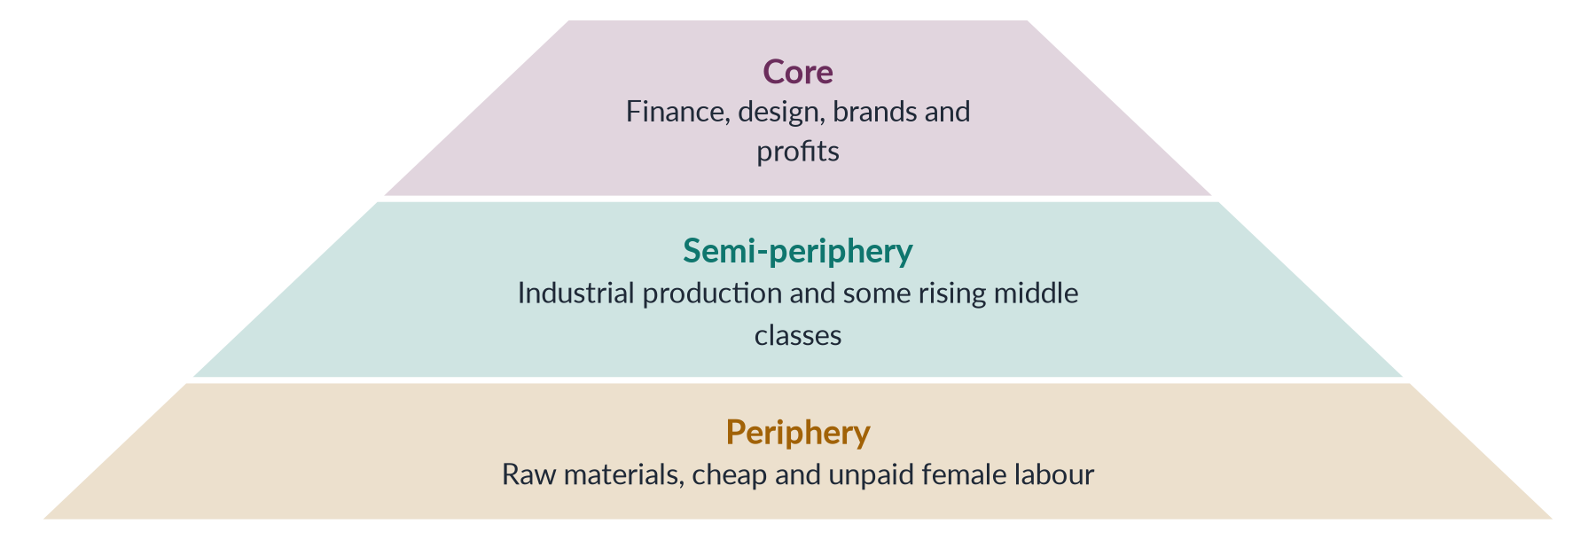
Figure 33 · The gendered world-system.

5. New patriarchal power (1): the workplace
In export factories, corporate managers control women workers through low wages, long hours, production targets, surveillance and harassment — a workplace patriarchy added to the family's. Unions are often discouraged in export processing zones, and young women are preferred precisely because they are seen as less likely to organise. Control that once belonged to fathers and husbands is now shared with supervisors and global brands.

6. New patriarchal power (2): feminised, flexible labour
Guy Standing (1989) described the feminisation of labour: jobs become flexible, informal and low-paid, and are increasingly filled by women. Global brands subcontract to home-based workers who have no contracts or social security. The home becomes a workplace where women earn piece rates while doing all the housework — patriarchy and capital meeting in the same room.

7. New patriarchal power (3): global care chains
Arlie Hochschild (2000) described global care chains: women from the periphery care for families in the core while their own children are cared for by relatives. Under sponsorship (kafala) systems, migrant domestic workers face confiscated passports, unpaid wages and abuse — control exercised by employers and states.

8. New patriarchal power (4): debt and austerity
Debt to core-controlled lenders brings austerity. Diane Elson (1991) showed that cuts treat women's unpaid labour as "infinitely elastic", shifting the costs of adjustment onto women.

9. New patriarchal power (5): bodies and backlash

i) Commodification
Global industries commodify women's bodies — trafficking, commercial surrogacy, and beauty industries selling skin-lightening products.

ii) Backlash
Rapid change can provoke cultural backlash: local patriarchs tighten control over women's dress, mobility and work in the name of protecting "our culture" from globalisation.

10. Evidence that inequality has increased
The Rana Plaza collapse in Bangladesh (24 April 2013) killed more than 1,100 garment workers, most of them women; the Ali Enterprises fire in Karachi (2012) killed about 260. Women remain concentrated in the lowest-paid segments of global value chains. The World Economic Forum estimated in 2026 that the global gender gap was only 69.2% closed, with parity 120 years away.

11. Counter-evidence
Yet globalisation also opened doors. Export jobs gave millions of young women in Bangladesh and elsewhere their first independent income. Naila Kabeer (The Power to Choose, 2000) found that garment work delayed marriage, increased women's say at home and was valued by the women themselves. Global norms (CEDAW, SDG 5) and trade conditions give activists leverage, and pressure after Rana Plaza produced the Bangladesh Accord on building safety (2013). World-system theory, by treating women as victims, can miss this agency — women workers' unions, cross-border campaigns and fair-trade networks.
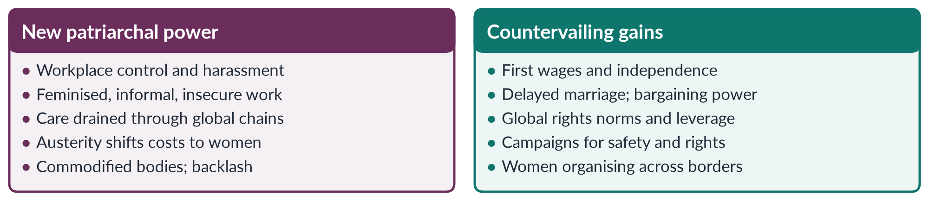
Figure 34 · Evaluating gendered globalisation.

12. The Pakistan angle
Pakistan sits in the periphery or lower semi-periphery, exporting textiles, cotton and rice and labour. Women are concentrated at the bottom of textile chains as home-based stitchers and cotton pickers; Sindh's Home-Based Workers Act 2018 began to protect them. Men's migration brought record remittances — more than 38 billion dollars in 2024–25 — leaving many women running households. The EU's GSP+ (from 2014) links trade access to CEDAW and labour standards. Female labour-force participation remains 24.4%.

13. Conclusion
Gendered globalisation is a powerful concept. Seen through a feminist world-system lens, global capitalism depends on women's cheap and unpaid labour and has created new forms of patriarchal power — in factories, informal chains, care migration, austerity and culture — that deepen inequality. But the claim is incomplete: globalisation has also given many women wages, voice and rights language. Whether it increases or reduces inequality depends on labour rights, social protection, state policy and women's own organising across borders.

Why this answer scores
- Defines gendered globalisation and uses world-system theory as instructed, with its feminist extensions.
- Identifies five new forms of patriarchal power, each with evidence.
- Critically evaluates with counter-evidence (Kabeer, the Bangladesh Accord).
- A pyramid and a compare figure, plus Pakistan, support a reasoned verdict.

Answer 18 · WID and GAD: Principles and Limitations (CSS 2025)
AT A GLANCE · CSS 2025 · Q7 · 20 MARKS
Critically analyze Women in Development (WID) and Gender and Development (GAD) models. Discuss their basic principles and limitations in addressing women's needs in developing countries.

The answer map
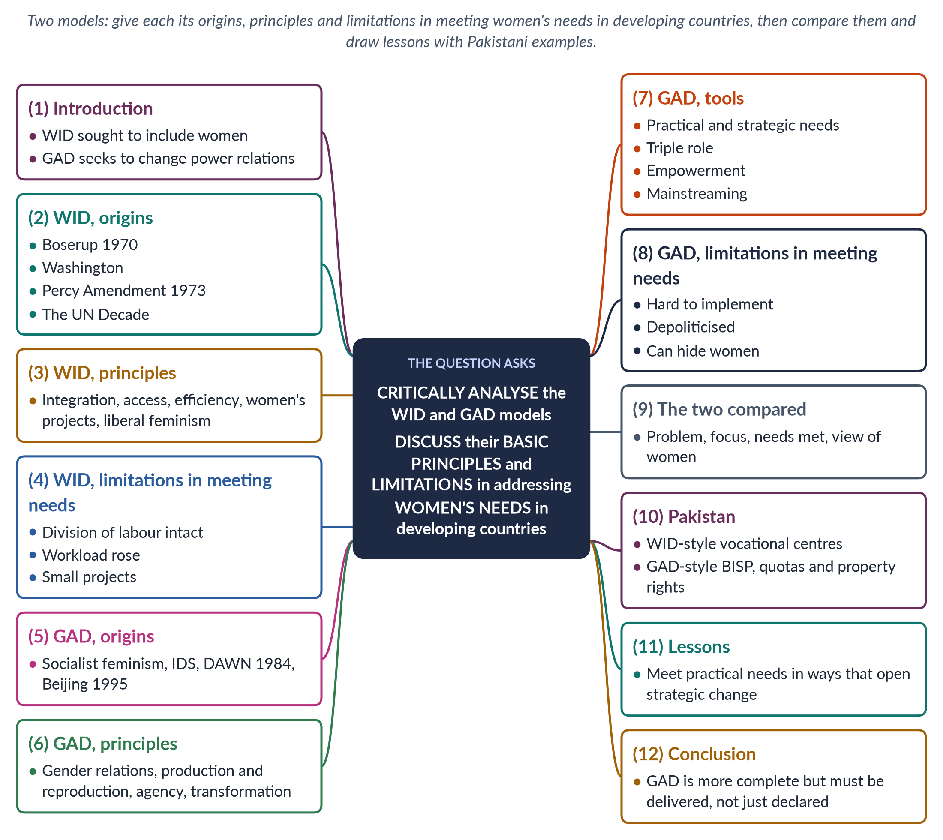
Figure 35 · The answer map: every branch is one numbered heading of the model answer below.

Decoding the question
Two models — WID and GAD — each needing basic principles and limitations, judged by how well they address women's needs in developing countries. "Critically analyse" requires strengths too, and a comparison. The phrase "women's needs" invites Molyneux and Moser's practical and strategic needs as the yardstick.

The model answer

1. Introduction

i) Definition
Women in Development (WID) and Gender and Development (GAD) are the two most influential models for addressing women in development policy. WID (1970s) sought to include women in development; GAD (1980s onwards) seeks to transform the power relations between women and men.

ii) The argument
WID met some of women's practical needs but left the gender division of labour and male power untouched. GAD offers a fuller analysis and tools to meet strategic interests, but it is harder to implement and often diluted in practice. The lesson for developing countries is to meet practical needs in ways that open strategic change.

2. WID — origins

i) Boserup
Ester Boserup's Woman's Role in Economic Development (1970) showed that women were major producers and that development projects had given land, technology and credit to men, marginalising women.

ii) Institutions
The term WID was coined by development professionals in Washington; the US Percy Amendment (1973) required aid to integrate women; the UN Decade for Women (1976–85) spread women's ministries worldwide.

3. WID — principles
1. Women have been left out of development.
2. The solution is integration through access to education, training, credit, technology and jobs.
3. Integration is justified by equity and increasingly by efficiency — women's work makes development more productive.
4. Delivery through women's projects and women's units in ministries.
5. The theory is liberal feminism, within a modernisation framework.

4. WID — limitations in meeting women's needs

i) The division of labour intact
WID took the sexual division of labour for granted. It added paid work to women's unpaid work, so their workload rose while care remained theirs alone.

ii) Practical, not strategic
It met practical needs — some income, skills, credit — but not strategic interests such as land, inheritance or political power.

iii) Women alone
It looked at women in isolation, not at men's power or at gender relations inside the household.

iv) Small projects
Sewing, handicraft and poultry projects were small, under-funded and marginal — a "women's ghetto". They often trained women in low-return "feminine" activities for markets that were already crowded.

v) Blind to class and global inequality
Its liberal model suited educated women better than the poorest, and ignored the global economy.

vi) Strengths
Still, WID made women visible in development, built institutions and won resources.

5. GAD — origins
GAD grew in the 1980s from socialist feminists (such as Kate Young at the Institute of Development Studies) and Southern networks, especially DAWN (1984), which called for development led by poor women's needs and empowerment. The Beijing Platform (1995) adopted its language of gender mainstreaming and empowerment.

6. GAD — principles
1. Focus on gender relations — the power relations between women and men — not on women alone.
2. Gender is socially constructed and can change.
3. Value both productive and reproductive work; look inside the household.
4. Treat women as agents of change.
5. Transform unequal structures — laws, property, institutions.
6. An active state that provides services and protects rights.

7. GAD — tools

i) Practical and strategic needs
Maxine Molyneux (1985) and Caroline Moser (1993) distinguished practical gender needs (water, health, income) from strategic gender interests (land, laws, power). GAD seeks both.

ii) The triple role
Moser showed that women carry productive, reproductive and community-managing work.

iii) Empowerment and mainstreaming
Naila Kabeer (1999) defined empowerment as the ability to make strategic life choices; gender mainstreaming assesses every policy for its effects on women and men.
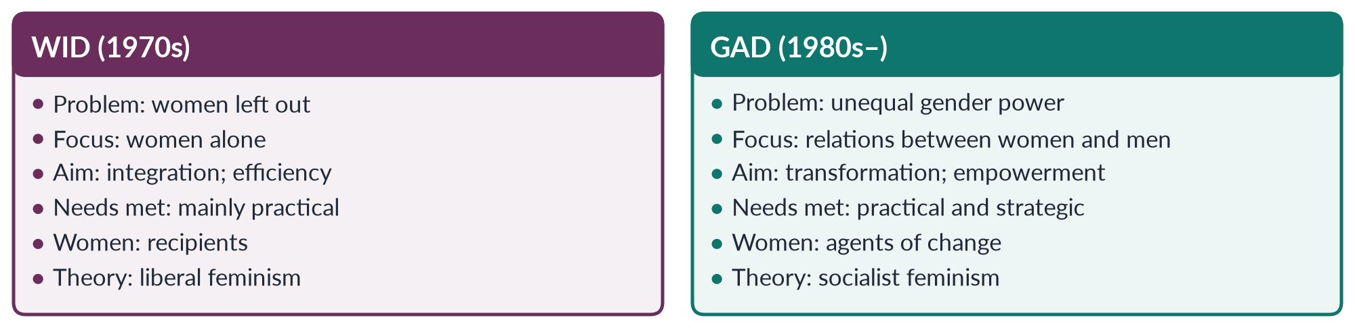
Figure 36 · WID and GAD compared.

8. GAD — limitations in meeting women's needs

i) Hard to implement
Transforming power is political; governments and agencies often reduce GAD to checklists, training workshops and gender units without authority.

ii) "Gender" can hide women
Talking of "gender" can be used to shift money away from women-specific programmes, even where women's disadvantage is severe.

iii) Mainstreamed away
When every department is responsible for gender, often no one is.

iv) Depoliticisation
Donor-driven, technocratic gender work can turn a struggle into a project.

v) Resistance and urgency
Men and elites resist strategic change — in land, inheritance and political power; and poor women's immediate needs can be neglected while planners pursue long-term goals. Some critics also see "gender" and "empowerment" as donor language, though much of it came from Southern networks.

9. The two compared
WID asked whether women receive a share of development; GAD asks whether power changes. WID treated women as recipients; GAD as agents. WID mostly met practical needs; GAD aims at strategic interests too. GAD is analytically stronger; WID was simpler to deliver. In practice many programmes described as GAD still work in WID ways — separate women's projects with little effect on power.

10. The Pakistan angle

i) WID in Pakistan
The Women's Division (1979), vocational and sewing centres and the First Women Bank (1989) followed WID — useful skills and some income, on a small scale.

ii) GAD in Pakistan
Gender budgeting pilots, the 10% quota in federal jobs, 60 reserved seats (2002), BISP (2008) paying cash to women, and the Enforcement of Women's Property Rights Act 2020 reflect GAD's strategic aims. Yet female labour-force participation remains 24.4%.

11. Lessons
The experience of developing countries suggests that the best programmes combine the two: meet practical needs — water, health, income — through women's own organisations, so that women gain confidence, resources and voice to press strategic demands. The Lady Health Worker Programme shows this: it meets practical health needs and has created a workforce of women who earn, travel and organise.

12. Conclusion
WID's principle was integration; its limitation was leaving the gender order intact, so that women worked more without gaining power. GAD's principle is transformation; its limitation is the gap between declaration and delivery. For women in developing countries, the answer is not to choose one model, but to use GAD's analysis with WID's practical delivery — meeting immediate needs in ways that shift power.

Why this answer scores
- Both models get origins, principles and limitations, judged against women's needs.
- Practical and strategic needs provide a clear yardstick.
- A compare figure and a Pakistan section show application.
- The lessons section turns critique into policy.

Answer 19 · Gendered Impacts of Floods and Heat Waves in Pakistan (CSS 2026)
AT A GLANCE · CSS 2026 · Q5 · 20 MARKS
Climate change has gendered impacts. Drawing on feminist environmentalism and ecofeminist perspectives, critically analyse how recent floods and heat waves in Pakistan have affected women differently.

The answer map
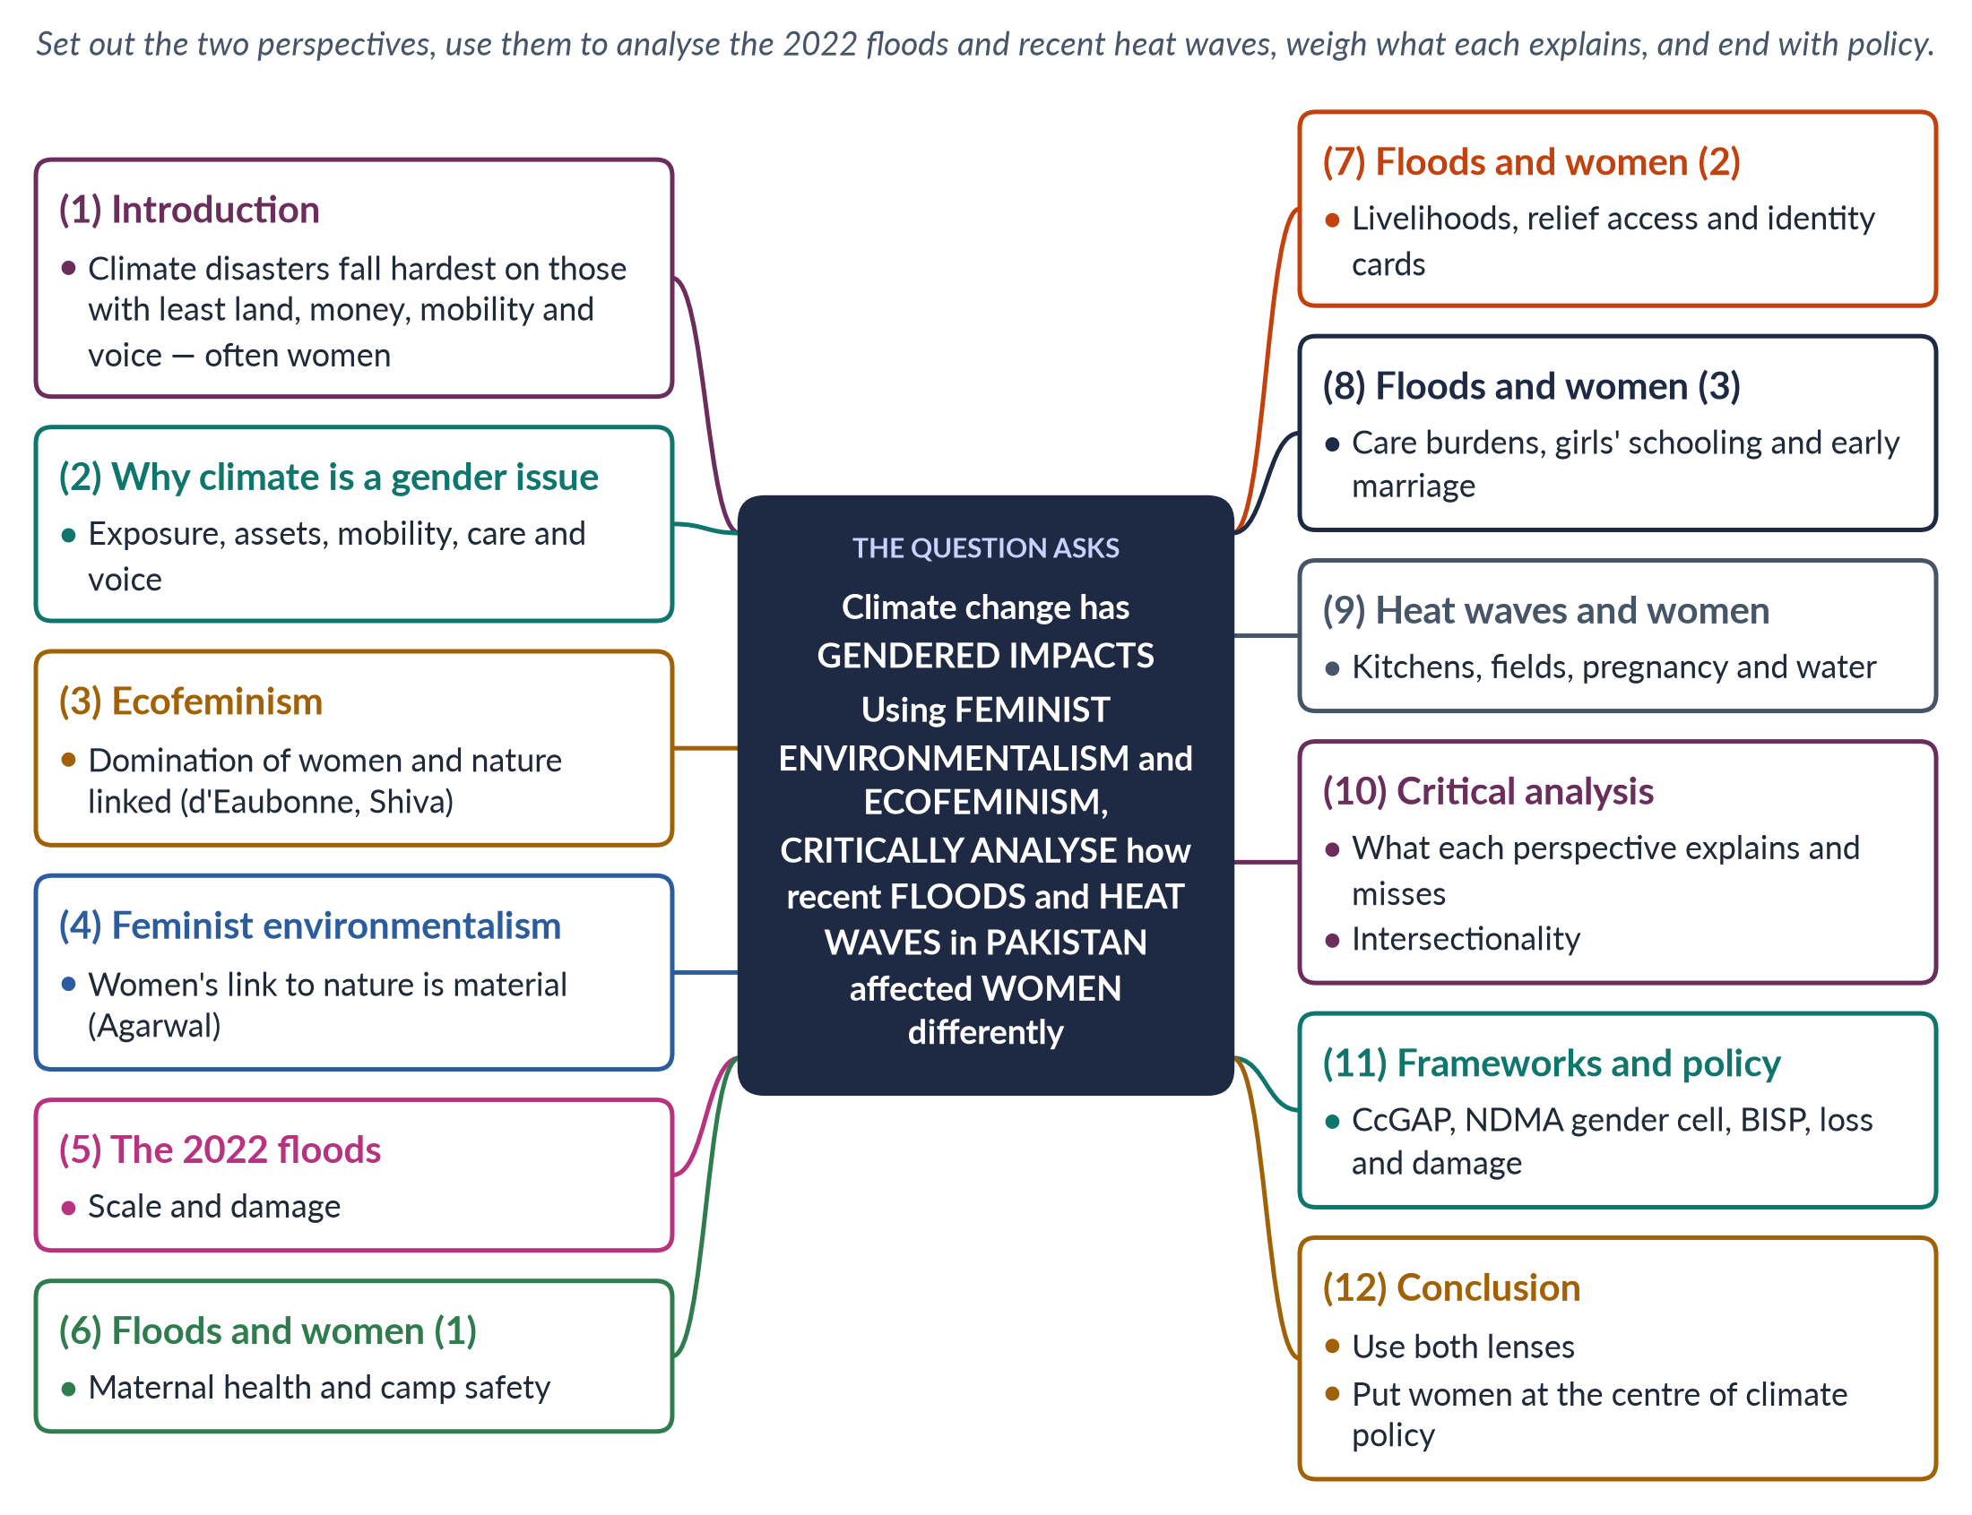
Figure 37 · The answer map: every branch is one numbered heading of the model answer below.

Decoding the question
The question names two perspectives — feminist environmentalism and ecofeminism — and a case: recent floods and heat waves in Pakistan. "Critically analyse" asks you to use both lenses to explain why women were affected differently, with evidence, and to judge which lens explains more. End with policy.

The model answer

1. Introduction

i) Definition
Climate change — long-term shifts in temperature and weather caused mainly by greenhouse-gas emissions — is making floods and heat waves more frequent and severe. Its impacts are gendered: women and men are exposed, affected and able to recover in different ways.

ii) The argument
Pakistan's 2022 floods and recent heat waves hit women harder because of their work, assets, mobility, care duties and lack of voice. Ecofeminism explains the shared logic of exploiting women and nature; feminist environmentalism better explains which women suffered most and why. Both are needed.

2. Why climate is a gender issue
Women in rural Pakistan depend daily on water, fuel, fodder and livestock; they own little land or savings; their mobility is often restricted; they carry most care for children, the sick and the elderly; and they have little say in planning and relief. Each of these turns a climate shock into a greater loss for women. Disasters do not create these inequalities; they expose and deepen them.

3. Ecofeminism
Ecofeminism holds that the domination of women and the domination of nature spring from the same patriarchal, profit-driven logic. The term was coined by Françoise d'Eaubonne (1974). Vandana Shiva (Staying Alive, 1988) argued that Western-style "maldevelopment" destroys forests, rivers and women's subsistence together, and that women are both the first victims and natural protectors of nature. Its symbols include the Chipko movement in India (1973).

4. Feminist environmentalism
Bina Agarwal ("The Gender and Environment Debate", 1992) criticised ecofeminism for suggesting women are naturally closer to nature. She argued that women's relation to the environment comes from their material reality — the gender division of labour, property and power. Women collect water and fuel because of their assigned work, and suffer from environmental damage because they lack land and resources. This is feminist environmentalism.
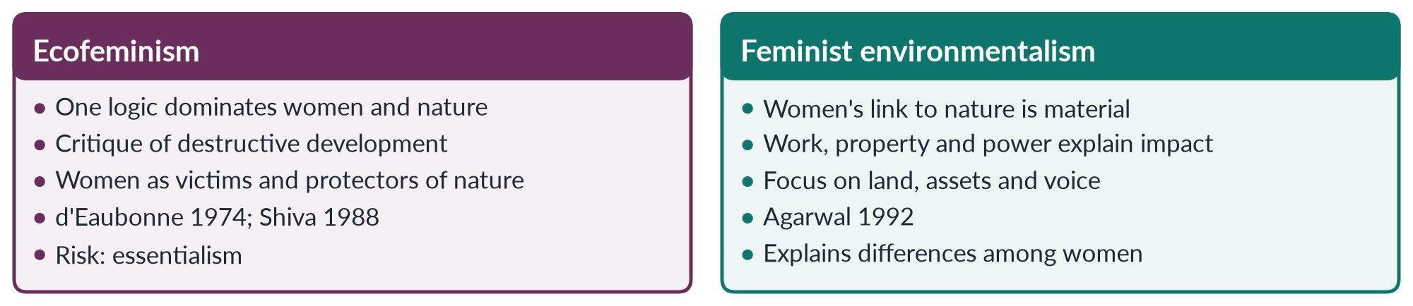
Figure 38 · Two feminist lenses on climate change.

5. The 2022 floods
The monsoon floods of 2022 affected about 33 million people and killed more than 1,700; about a third of the country was under water at the peak. The Post-Disaster Needs Assessment put damage and losses at about 30 billion dollars. UNFPA estimated about 650,000 pregnant women were in flood-affected areas.

6. Floods and women (1): health and safety

i) Maternal health
Clinics were destroyed or cut off; many women gave birth in camps or on roadsides without skilled help, and anaemia and malnutrition rose among pregnant women.

ii) Camp safety and privacy
Lack of separate toilets, bathing spaces and lighting exposed women and girls to harassment; many avoided eating and drinking to avoid open latrines. Menstrual hygiene supplies were scarce.

7. Floods and women (2): livelihoods and relief

i) Lost assets
Women lost livestock — often their main asset — kitchen gardens and home-based work, with little land or savings to recover.

ii) Relief access
Aid was often registered to male heads of household or required a national identity card (CNIC), which many rural women lacked; women-headed households struggled to reach relief.

8. Floods and women (3): care, school and marriage
Women nursed children and elders through outbreaks of malaria, diarrhoea and skin disease. Schools were destroyed or used as shelters, and girls were more likely to drop out. Relief agencies reported cases of families marrying daughters early to reduce costs or for "protection" — a known pattern after disasters.

9. Heat waves and women
Pakistan is among the world's most heat-exposed countries; Jacobabad in Sindh is regularly among the hottest cities on earth. Women cooking over open fires in poorly ventilated kitchens and working in fields — picking cotton, harvesting — face high heat stress; pregnant women face higher risks; water collection takes longer as sources dry; and dress and mobility norms can make it harder to reach cooler places. Home-based workers in hot, crowded homes lose income. Heat also increases the burden of caring for children and elders who fall ill, and power cuts during heat waves make kitchens and homes even hotter.

10. Critical analysis

i) What ecofeminism explains
It exposes the common logic of extractive development that damages both nature and women, and it gives moral force to women's leadership in environmental protection. Pakistan, producing less than 1% of global emissions, suffers from a global economy built on exploiting nature — an ecofeminist point about justice.

ii) Its limits
Its suggestion that women share a natural bond with nature is essentialist, and it can romanticise rural women's heavy burdens.

iii) What feminist environmentalism explains
It explains why particular women suffered most — those without land, savings, CNICs, mobility or voice — and points to concrete remedies.

iv) Intersectionality
Poor, rural, landless, minority and disabled women suffered far more than urban, educated women — so neither "women" nor "nature" is a single category. Women-headed households and widows, with no male relative to register for aid, were among the hardest hit.
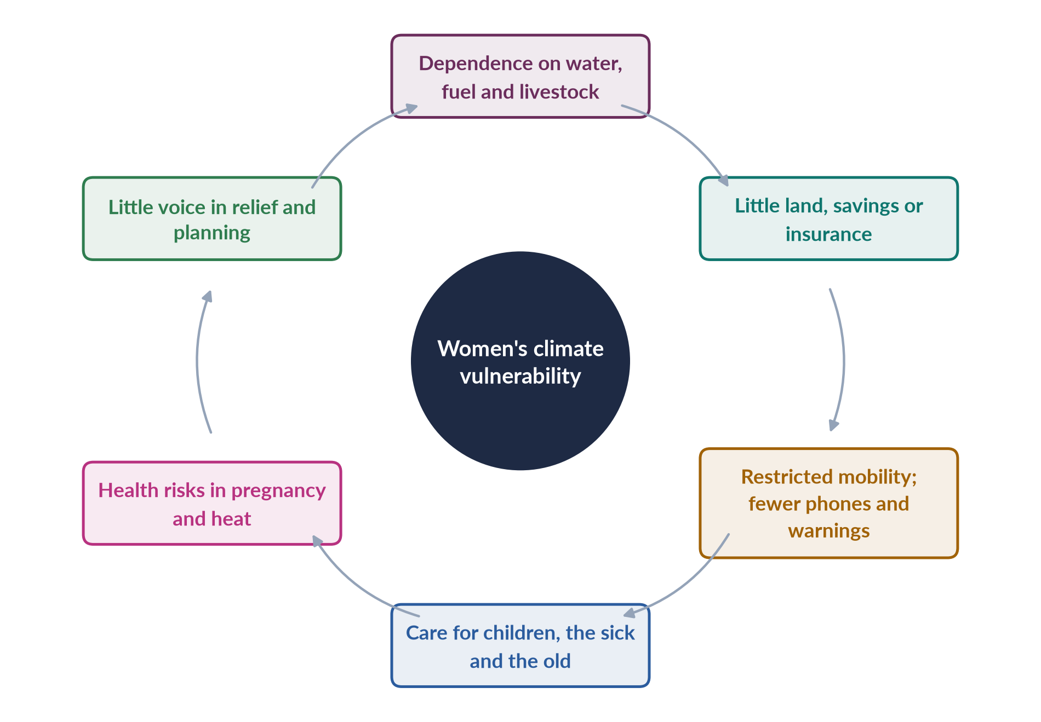
Figure 39 · Why floods and heat hit women harder.

11. Frameworks and policy

i) Frameworks
Beijing's critical area K (women and the environment); the UNFCCC Lima Work Programme on Gender (2014) and Gender Action Plan (2017); Pakistan's National Climate Change Policy (updated 2021) and Climate Change Gender Action Plan (2022); the NDMA Gender and Child Cell; and the loss and damage fund agreed at COP27 (2022).

ii) Policy
Collect sex-disaggregated data; put women in disaster management; provide women-friendly relief (separate toilets, lighting, female staff, maternal care); pay cash to women through BISP and help with CNICs; protect land and asset rights; send early warnings through channels women use, including Lady Health Workers; build heat-safe work and water near homes; and protect girls' schooling.

12. Conclusion
The floods and heat waves affected Pakistani women differently because climate shocks fall on an unequal society. Ecofeminism shows the shared roots of exploiting women and nature; feminist environmentalism shows how work, property and power decide who suffers. Used together, and with an intersectional eye, they point to one conclusion: climate policy in Pakistan must put women's needs, rights and leadership at its centre.

Why this answer scores
- Both named perspectives are explained and used, not just defined.
- The 2022 floods and heat waves are analysed with data and specific gendered impacts.
- The critical analysis weighs each lens and adds intersectionality.
- Two figures and a policy section turn analysis into recommendations.

